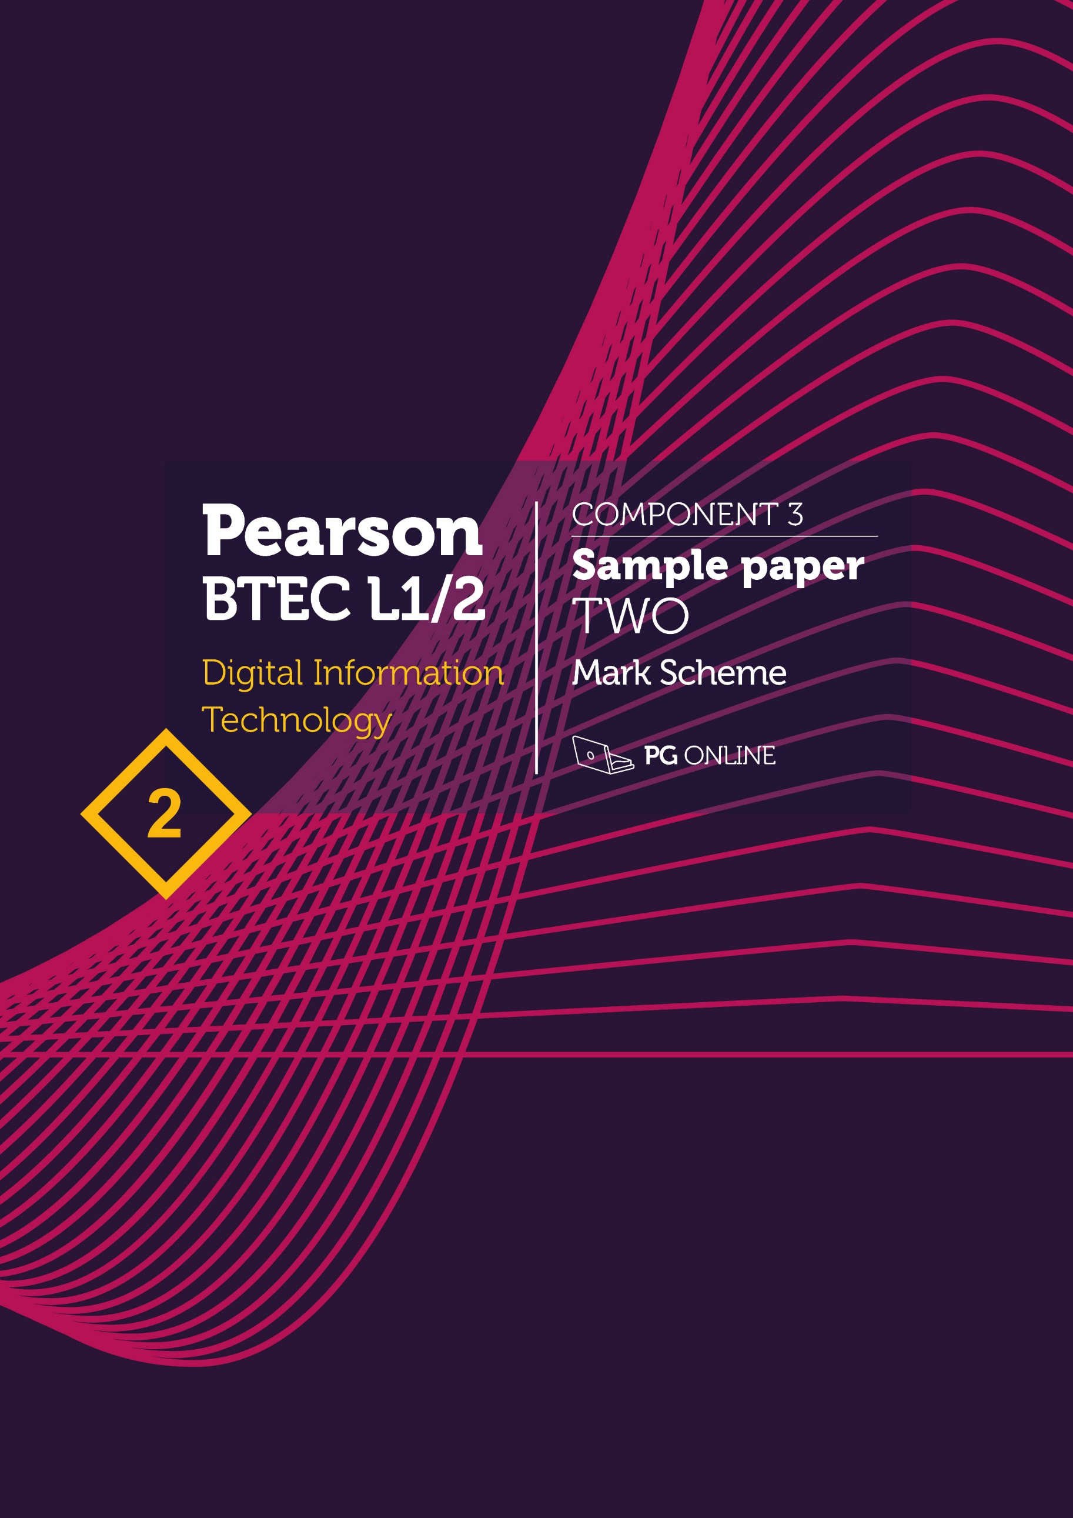

Copyright
© 2019 PG Online Limited
The contents of this pack are protected by copyright.
The pack and all the other associated files distributed with it are supplied to you by PG Online Limited under licence and may be used and copied by you only in accordance with the terms of the licence agreement between you and PG Online Limited. Except as expressly permitted by the licence, no part of the materials distributed with this pack may be used, reproduced, stored in a retrieval system, or transmitted, in any form or by any means, electronic or otherwise, without the prior written permission of PG Online Limited.

Licence agreement
This is a legal agreement between you, the teaching institution, and PG Online Limited. PG Online Limited grants to you a non-exclusive, non-transferable, revocable licence to use this supplement and all other associated files distributed with it in the course of teaching by your teachers and/or employees.
The materials distributed with this pack may be copied and used by your teachers and/or employees on a single site only in the course of their teaching. You warrant that you shall not, and shall procure that each of your teachers and/or employees shall not, share in any way any of the materials or part of the materials with any third party, including users on another site or individuals who are teachers and/or employees of a separate institution. You acknowledge and agree that the materials must remain with you, the teaching institution, and no part of the materials may be transferred to another institution. You also warrant that you shall not, and shall procure that each of your teachers and/or employees shall not, procure, authorise, encourage, facilitate or enable any third party to reproduce these materials in whole or in part without the prior permission of PG Online Limited.
In consideration of the licence granted to you, you shall indemnify PG Online Limited against all liabilities, costs, expenses, damages and losses (including but not limited to any direct, indirect or consequential losses, loss of profit, loss of reputation and all interest, penalties and legal costs and all other professional costs and expenses) suffered or incurred by PG Online Limited arising out of or in connection with the exercise by you of your rights granted under this licence.

BTEC Level 1/2 Component 3
Effective Digital Working Practices
Sample paper 2 mark scheme
This sample paper and mark scheme has been carefully compiled and checked to ensure that it contains questions using key words typically used in assessment, in approximately the same proportions as on a live examination paper.
Key terms typically used in assessment
The following table shows the key words which will be consistently used by Pearson in their assessments to ensure learners are rewarded for demonstrating the necessary skills.
The list below will not necessarily be used in every paper and is provided for guidance only.
Annotate the diagram to  explain how… | Label the diagram and provide an explanation for each identification
Assess | Give careful consideration of varied factors or events that apply and identify those that are the most important or relevant, and arrive at a conclusion.
Describe | Give an account of something, such as steps in a process or characteristics of something. and in some cases application, of relevant features and information. The response should be developed as they are often linked, but does not need a conclusion or justification.
Discuss | Identify the issue/situation/problem/argument that is being assessed in the question.Explore all aspects of an issue / situation / problem / argument by reasoning or argument.
Draw | Produce an annotated process either in the form of an information flow or data flow diagram or flowchart
Evaluate | Bring together all information and review it to form a conclusion, drawing on evidence, including strengths, weaknesses, alternative actions, relevant data or information.
Explain | An explanation that requires a justification / exemplification of a point. The answer must contain some element of reasoning/justification.
Give/State/Name | Requires recall of one or more pieces of information.
Identify | Usually requires some key information to be selected from a given stimulus / resource.
Table source: Pearson Edexcel
Task 1
No. | Answers |  | Mark
1(a) | Any two of:  - Use of passwords  - Use of removable storage media  - Use of equipment such as printers and consumables  - Data security measures  - Use of internet and email  - Privacy and data protection  - Use of mobile technologies  - Scope (who the policy applies to)  - Assets (equipment, documents, and knowledge covered by the policy)  - Acceptable behaviours  - Unacceptable behaviours  - Monitoring  - Sanctions  (other possible answers) | Answers such as the following are not topics but rather the detail within a topic, so are not mark-worthy.  - Not to tell anyone your password or allow anyone else to use your login details  - Not to access any form of chat program or website with unsuitable content, for example games sites, websites that contain obscene material  - Not to attempt to gain unauthorised access to restricted area of the system  - Not to introduce malware | 2
1(b) | - To establish the acceptable and unacceptable use of electronic devices and network resources in an organisation. (1) so that the network is less likely to be vulnerable to hackers (1)  - to encourage a culture of ethical and lawful behaviour, openness, trust, and integrity (1) so that the company is less likely to have internet hacking attempts / data breaches (1)  - to define the processes and potential sanctions if unacceptable behaviour occurs (1) so that employees are clear what will happen to them if they breach the policy / so that sanctions can be legally carried out (1)  Or other appropriate answer with an explanation. | Award one mark for a benefit and one mark for a linked explanation of that benefit  Benefit and explanation may be reversed.  Do not accept just benefits of cloud | 4

1(c) | Levels Based Mark Scheme – see below.  The discussion may consider:  New computer damage  - Mining and processing of new raw materials involves energy and water usage  - Fuel is required for electricity  - Parts/raw materials are needed for factories and machinery  - Transportation of new and old computers will cause pollution  Disposal damage  - If thrown onto landfill poisonous elements could leach into the water supply  - Rare metals do not have an infinite supply so should be conserved by recycling  - Components should be recycled to minimise the environmental damage caused by mining for replacement raw materials, which can mean cutting down forests, polluting the land and water supplies, potentially causing catastrophic damage | Note that this answer is not looking for alternatives such as upgrading the old computers | 4

1(d) | Solution 1  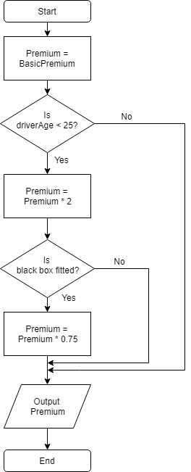 | One mark for each correct symbol, with correct labels “Yes” and “No”. Correct labels must be given for a decision to obtain the marks for that symbol  Accept statements such as “Double premium” and “Apply 25% reduction to Premium | 4

Level | Mark
 | 0 | No rewardable material
1 | 1-2 | - Demonstrates isolated elements of knowledge and understanding, with major gaps or omissions  - Few of the points made will be relevant to the context of this question  - Limited discussion which contains generic assertions rather than how the purchase and disposal of computers contributes to environmental damage
2 | 3-4 | - Demonstrates some accurate knowledge and understanding, with only minor gaps or omissions  - Some of the points made will be relevant to the context in the question, but the link will not always be clear  - Displays a partially developed discussion which considers some specific actions and some consideration of the purchase and disposal of computers contributes to environmental damage with content from across the specification
3 | 5-6 | - Demonstrates mostly accurate and detailed knowledge and understanding  - Most of the points made will be relevant to the context in the question, and there will be clear links  - Displays a well-developed and logical discussion which clearly considers the purchase and disposal of computers contributes to environmental damage and references other parts of the specification

Task 2
No. | Answers |  | Mark
2(a) | Once he tethers /connects his smartphone to his laptop…  A list of digital devices in the vicinity /the carriage will appear on his laptop screen. (1)  Sid selects his own phone from the list and then types his PIN / password (1) to connect to / pair the phone (1).  He can now work on his laptop via the mobile network rather than Wi-Fi (1) | No mark for saying he tethers / connects his smartphone to his laptop since this is stated in the question | 4
2(b) | The train may pass through a tunnel, (1) which will block the signal (1) from the nearest cell tower.  The train may pass through hilly or wooded terrain (1) where there is no cell tower/ mobile phone signal (1)  His mobile or laptop may run out of battery power (1) if not plugged in to the socket in the carriage. (1) |  | 2
2(c) | They can patent the drugs (1) to prevent other companies from making them / to protect the formula or method they are made (1)  They can trademark the names of the drugs (1) to prevent other companies from using the name (1) | Do not allow “copyright” | 2
2(d) | White hat | Although a grey hat hacker is a form of ethical hacker they are not employed for the purpose of penetration testing which is part of the scenario, so this is not an acceptable answer to this question | 1
2(e) | Security expert will search for / try to find and suggest actions to be taken for:  - Operating systems that are out of date  - Software that has not had security fixes applied  - Wi-Fi access points that are insecure  - Unencrypted hard disks and files  - Servers that have security holes  - Weak user passwords  - Users with too many security privileges  (1 mark for each point) |  | 3

2(f) | Firewall – software or hardware device which prevents attackers from accessing a network / creates a trusted network from attackers (1) by filtering/blocking data packets from some IP addresses (1) / preventing access to certain ports on a network (1) / packet inspection (1) | Any similar answer is sufficient | 2

Task 3
No. | Answers |  | Mark
3(a) | Images can have alt-text (1) which can be read by text-to-speech software (1) so that partially sighted can hear a description of an image (1)  The site should use a standard language such as HTML (1) so that it can be interpreted by a text-to-speech reader (1) which can read the text to those who have difficulties reading (1)  The site can allow users to adjust the text size (1) so that people can make it larger to read (1)  The site can make sure to use contrasting colours / not use text on images (1) so that it is easier to read  The site can make use of larger buttons (1) so that they are easier for people with limited hand movement to press (1) |  | 6
3(b) | So that everyone has equal access to procedures for applying for help, housing, etc when needed (1) So that no one has cause to complain about lack of available information (1)  Equal access and knowledge of leisure facilities, and other amenities (1) so that they can be used by everyone (1)  Because there are legal requirements / professional guidelines (1) regarding equal access which the council should adhere to (1)  It will be much more time-consuming/expensive for the council to have people ringing up for information (1) because they can’t access the information on the website(1) |  | 4
3(c) | Net neutrality - all internet service providers (ISPs) must treat all data and users equally (1).  The ISP cannot charge differently for different data or services (1)  They cannot provide a faster or better service to the data of companies that pay them (1) |  | 2

3(d) | Levels Based Mark Scheme – see below.  The discussion may consider:  Investigate – establish the type and severity of the attack, what hardware and software has been attacked, whether it should be reported to the Information Commissioner’s Office under the GDPR.  Respond – take appropriate action immediately, e.g. inform stakeholders/residents their account details have been hacked  Manage – contain the attack, disconnect computers from network/server if necessary / Apply disaster recovery procedures  Recover – use backups if appropriate to restore the system  Analyse – decide on measures to protect from an attack cannot happen again |  | 6

Level | Mark
 | 0 | No rewardable material
1 | 1-2 | - Demonstrates isolated elements of knowledge and understanding, with major gaps or omissions  - Few of the points made will be relevant to the context of this question  - Limited discussion which contains generic assertions rather than specific actions that would need to be taken
2 | 3-4 | - Demonstrates some accurate knowledge and understanding, with only minor gaps or omissions  - Some of the points made will be relevant to the context in the question, but the link will not always be clear  - Displays a partially developed discussion which considers some specific actions and some consideration of how they interrelate with content from across the specification
3 | 5-6 | - Demonstrates mostly accurate and detailed knowledge and understanding  - Most of the points made will be relevant to the context in the question, and there will be clear links  - Displays a well-developed and logical discussion which clearly considers specific actions and references other parts of the specification

Task 4
No. | Answers |  | Mark
4(a) | Lack of face-to-face communication between team members (1) may hamper productivity (1)  Lack of control over working hours (1) may mean that some employees do not meet targets (1)  Security on home computers may be lax (1) resulting in possible malware infection of cloud data and office network (1) |  | 4
4(b) | An assessment of the impact of cloud technologies on the company and employees  Assessment may consider:  Positives – Organisation  - The software will be installed and managed by a 3rd party company  - This will reduce the costs on the company / need to hire an IT technician  - Backups will be provided by the company  - Reducing the need to backup internally / saving costs  - If documents are stored in the cloud, the company will always have access to the latest version  - They will no longer have to manage their own email server  - Security will be managed by the 3rd party cloud provider – it is likely to be high quality as they will employ experts to manage it for all customers  - It will be easier to manage new phones  - The new software may not be compatible with other company systems  Negatives – Organisation  - The company will have less control over the software, how it is installed and administered  - They most likely will pay a monthly or yearly licence – which may work out more expensive in the long run  - The company may need to consider data protection laws if personal data is stored in another country  - They will need to consider the security of any personal data which will be harder to understand if it is run by a 3rd party  Positives – Staff  - Staff will be able to edit documents at the same time / in real time  - They will be able to access documents and software from any computer with an internet connection  - They will be able to move their phone to anywhere in the world as it will work on the internet (via VoIP) / as it works via their computer  Negatives – staff  - If the internet connection is lost then staff will no longer be able to access their files/programs (unless there is an offline mode)  - Software upgrades may be made automatically and slow staff down  - Staff may need training in the new software – they may be less productive while they become used to it  - The new cloud software may not be compatible with existing software used by staff  - Old files may not be compatible with the new software  Conclusion  This should include a summary of the impacts of cloud technologies on employees and the company, with an overall opinion as to whether the move is a good or bad one. |  | 9

Level | Mark
 | 0 | No rewardable material
1 | 1-3 | - Demonstrates isolated elements of knowledge and understanding, with major gaps or omissions  - Few of the points made will be relevant to the context of this question  - Limited discussion which contains generic assertions rather than considering the impacts and their relative importance, leading to a conclusion which is superficial or unsupported
2 | 4-6 | - Demonstrates some accurate knowledge and understanding, with only minor gaps or omissions  - Some of the points made will be relevant to the context in the question, but the link will not always be clear  - Displays a partially developed discussion which considers some of the impacts and their relative importance leading to a partially supported conclusion.
3 | 7-9 | - Demonstrates mostly accurate and detailed knowledge and understanding  - Most of the points made will be relevant to the context in the question, and there will be clear links  - Displays a well-developed and logical discussion which clearly considers the impacts and their relative importance, leading to a supported conclusion

