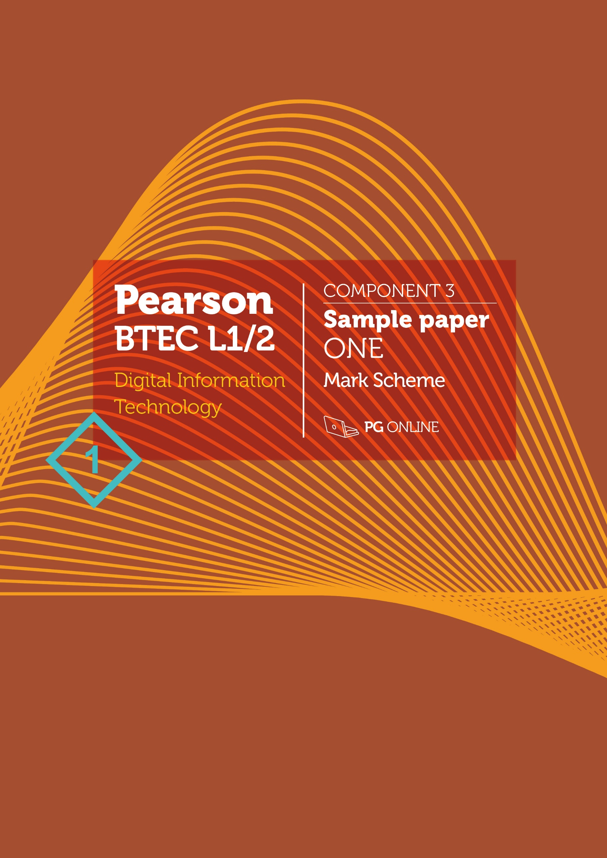

Copyright
© 2019 PG Online Limited
The contents of this pack are protected by copyright.
The pack and all the other associated files distributed with it are supplied to you by PG Online Limited under licence and may be used and copied by you only in accordance with the terms of the licence agreement between you and PG Online Limited. Except as expressly permitted by the licence, no part of the materials distributed with this pack may be used, reproduced, stored in a retrieval system, or transmitted, in any form or by any means, electronic or otherwise, without the prior written permission of PG Online Limited.

Licence agreement
This is a legal agreement between you, the teaching institution, and PG Online Limited. PG Online Limited grants to you a non-exclusive, non-transferable, revocable licence to use this supplement and all other associated files distributed with it in the course of teaching by your teachers and/or employees.
The materials distributed with this pack may be copied and used by your teachers and/or employees on a single site only in the course of their teaching. You warrant that you shall not, and shall procure that each of your teachers and/or employees shall not, share in any way any of the materials or part of the materials with any third party, including users on another site or individuals who are teachers and/or employees of a separate institution. You acknowledge and agree that the materials must remain with you, the teaching institution, and no part of the materials may be transferred to another institution. You also warrant that you shall not, and shall procure that each of your teachers and/or employees shall not, procure, authorise, encourage, facilitate or enable any third party to reproduce these materials in whole or in part without the prior permission of PG Online Limited.
In consideration of the licence granted to you, you shall indemnify PG Online Limited against all liabilities, costs, expenses, damages and losses (including but not limited to any direct, indirect or consequential losses, loss of profit, loss of reputation and all interest, penalties and legal costs and all other professional costs and expenses) suffered or incurred by PG Online Limited arising out of or in connection with the exercise by you of your rights granted under this licence.

BTEC Level 1/2 Component 3
Effective Digital Working Practices
Sample paper 1 mark scheme
This sample paper and mark scheme has been carefully compiled and checked to ensure that it contains questions using key words typically used in assessment, in approximately the same proportions as on a live examination paper.
Key terms typically used in assessment
The following table shows the key words which will be consistently used by Pearson in their assessments to ensure learners are rewarded for demonstrating the necessary skills.
The list below will not necessarily be used in every paper and is provided for guidance only.
Annotate the diagram to  explain how… | Label the diagram and provide an explanation for each identification
Assess | Give careful consideration of varied factors or events that apply and identify those that are the most important or relevant, and arrive at a conclusion.
Describe | Give an account of something, such as steps in a process or characteristics of something. and in some cases application, of relevant features and information. The response should be developed as they are often linked, but does not need a conclusion or justification.
Discuss | Identify the issue/situation/problem/argument that is being assessed in the question.Explore all aspects of an issue / situation / problem / argument by reasoning or argument.
Draw | Produce an annotated process either in the form of an information flow or data flow diagram or flowchart
Evaluate | Bring together all information and review it to form a conclusion, drawing on evidence, including strengths, weaknesses, alternative actions, relevant data or information.
Explain | An explanation that requires a justification / exemplification of a point. The answer must contain some element of reasoning/justification.
Give/State/Name | Requires recall of one or more pieces of information.
Identify | Usually requires some key information to be selected from a given stimulus / resource.
Table source: Pearson Edexcel
Task 1
No. | Answers |  | Mark
1(a) | An explanation such as:  - Accesses the Internet using a browser (1)  - Loads / navigates to / enters address (URL) of the Cloud Accounts website (1)  - Enters his user ID and password (1) | Must mention Internet access or website for 2 marks, not just “logs in to his account” | 2
1(b) | Any two from the following:  - Software and data available from anywhere in the world 24/7, (1) so Bill can work from home / while commuting / in a different office / on holiday (1)  - Software updates installed automatically by provider (1) so he does not need to buy /install upgrades to his software (1)  - Backups done by provider (1) …so no need to backup data held on computers at the shop and no danger of losing data in a local catastrophe (1)  - Only pay for the storage that is required / flexible (1) – can use and pay for as much storage as required so easy to expand storage without needing to purchase new hard disk (1)  - No need for maintenance (1) so there is no need to employ IT staff (1)  - Support available (1) so that technical issues can be resolved quickly (1) | Award one mark for a benefit and one mark for a linked explanation of that benefit  Benefit and explanation may be reversed.  Do not accept just benefits of cloud | 4
1(c) | - Minimum length of characters  - Include at least one lowercase letter  and at least one uppercase letter  - Include at least one symbol  - Do not use whole words found in a dictionary  - Change password regularly  - Do not write passwords down where  they may be seen | 1 mark for each point to a max of 2 marks | 2

1(d) | Levels Based Mark Scheme – see below.  The discussion may consider:  Advantages and disadvantages to Bill’s shop  - Large number of users on social media  - Can use filters to target adverts at certain groups of people – such as those who are active/like sports  - Can target adverts at people who live in the same area as the shop  - More personalised advertising could be more effective than broadcast mediums or mass mailings  - Can have a conversation and get customer feedback  - Customers may write comments which are negative  - Certain customer types may not be on social media  Advantages and disadvantages to Bill  - Bill may need to learn how to use social media  - A campaign that isn’t delivered in the correct manner may backfire causing bill stress  - Bill may find it hard to separate his work/life balance if he has to answer customer queries/comments all the time  - Bill may gain satisfaction from genuine feedback  - Bill may gain useful feedback that allows him to improve his business |  | 6

Level | Mark
 | 0 | No rewardable material
1 | 1-2 | - Demonstrates isolated elements of knowledge and understanding, with major gaps or omissions  - Few of the points made will be relevant to the context of this question  - Limited discussion which contains generic assertions rather than considering the advantages and disadvantages to Bill and his business
2 | 3-4 | - Demonstrates some accurate knowledge and understanding, with only minor gaps or omissions  - Some of the points made will be relevant to the context in the question, but the link will not always be clear  - Displays a partially developed discussion which considers some different changes and some consideration of the advantages and disadvantages to Bill and his business from across the specification, but not always in a sustained way
3 | 5-6 | - Demonstrates mostly accurate and detailed knowledge and understanding

Task 2
No. | Answers |  | Mark
2(a) | Use an https website / secure http / SSL / TLS (1) which means that all data transmissions are encrypted. (1) so they cannot be read by a hacker / man-in-the-middle attack (1) |  | 2
2(b) | Something the user knows (1) such as password / security question / PIN (1)  Something the user has (1) such as a card and card reader / lookup table (1)  Something the user is / biometric (1) such as retina scan / fingerprint reader (1)  Two-factor authentication must use methods from two of these types (1)  OR example combinations such as:  Password (1) and fingerprint (1)  ID card (1) and password (1) |  | 4
2(c) | Text which can be magnified (1) to make it easier to read (1)  Good colour contrast between text and background (1), for example, not putting a photograph behind text (1).  Options to have text on screen read out (1) so that Hari can listen to the text instead of reading it (1) |  | 4

Task 3
No. | Answers |  | Mark
3(a) | Check social media posts (1) which may give her ideas about current affairs or about how social media is used, to express opinions / distribute news / biased opinions (1)  Use email to contact people /organisations (1) who have a story to tell about experiences/ events (1)  Read digital versions of newspapers (1) to find stories about events / people which can be developed into a feature (1) | 1 mark for each method, 1 mark for explanation of how it relates to scenario | 4
3(b) | Data stored in cloud can be shared / edited / written by any authorised user (1) meaning that there is no need for different versions / old versions being viewed. (1)  People may post comments / suggest edits (1) which are instantly available to other users. (1)  The files can be accessed from remote locations (1) meaning that people can access the files while working at home / away from the office / abroad (1)  Photographers may post a selection of photos in the cloud (1) so that the writers / picture editor and features editor can agree on which to use for a particular story. (1) | 1 mark for each method, 1 mark for explanation of how it relates to scenario | 4
3(c) | Levels Based Mark Scheme – see below.  The discussion may consider:  Advantages:  Less frequent commuting saves time and travelling expense.  She will feel more in control of her own schedule.  She can organise her work time around other commitments such as school run, doctor’s appointments.  Better work-life balance, more time for other activities if she does not have to commute  Disadvantages:  Many distractions at home may hamper concentration /make it difficult to schedule worktime  May feel isolated if used to working in a busy office, may not be able to pick up ideas for features from colleagues in informal chats over lunch, etc.  Internet connection may be slow if she does not have fast broadband at home.  She may have to spend a subscription to a fast broadband service  There may be other people using the Internet connection at home, e.g. streaming a video, which could slow down uploading and downloading. |  | 6

Level | Mark
 | 0 | No rewardable material
1 | 1-2 | - Demonstrates isolated elements of knowledge and understanding, with major gaps or omissions  - Few of the points made will be relevant to the context of this question  - Limited discussion which contains generic assertions rather than considering different aspects and their relative advantages
2 | 3-4 | - Demonstrates some accurate knowledge and understanding, with only minor gaps or omissions  - Some of the points made will be relevant to the context in the question, but the link will not always be clear  - Displays a partially developed discussion which considers some different aspects and some consideration of how they interrelate with content from across the specification
3 | 5-6 | - Demonstrates mostly accurate and detailed knowledge and understanding  - Most of the points made will be relevant to the context in the question, and there will be clear links  - Displays a well-developed and logical discussion which clearly considers different viewpoints and references other parts of the specification

Indicative content:
Indicative content listed is provided to illustrate points that students may make about the examples given in the question, which would demonstrate their understanding of the issues.
Task 4
No. | Answers |  | Mark
4(a) | (i) Bar chart (1)  (ii) Flow chart (1)  (iii) Table (1) | (i) Accept line chart / graph  (ii) Accept diagram / pseudocode  (iii) Accept chart with figures labelling each point/bar/category | 3
4(b) | Benefit to organisation:  An accurate picture of each customer’s shopping habits is built up. (1)  This is used by the store which uses software to personalise and target their advertisements, special offers, money off coupons, based on their shopping habits. (1)  Alternatively, give an example:  e.g. if a customer regularly buys cat food, they might be sent a “money off” coupon for cat food. (1)  This increases the likelihood of the customer coming to the store to use the coupon, and at the same time spend money on other items. (1)  If they get the customer’s permission, they may be able sell data on customers satisfying particular criteria to other organisations who want to build a mailing list, (1) e.g. vets, pet insurance companies. (1) | Award one mark for an identification and one mark for  a linked justification | 4
4(c) | A cookie is a small data file (1) that is passed to a user’s browser when they visit a website. (1) The information collected is stored on the user’s computing device. (1) It can be used to track users / keep users logged in. (1) |  | 2
4(d) | Cookies can be used to remember information about a user such as who is logged in / shopping cart information (1) which saves them needing to log in each time they use the site (1)  Cookies can be given by third party sites (1) which can then be used to track users through the internet / advertise products to users based on their history (1) (which may give inappropriate adverts / reveal a present they are buying) |  | 4
4(e) | Levels Based Mark Scheme – see below.  An evaluation of the threats and their impacts  The discussion may consider:  Impacts:  Denial of service  - A successful denial of service attack would cause the website to become unavailable  - This would mean that customers would not be able to purchase goods online  - Customers also might not be able to contact the company via email and other online methods  - Delivery vans may not know where to deliver products to if they rely on the website access  Ransomware  - A ransomware attack would first need to get onto the system via a method such as email attachment or security vulnerability  - It would then proceed to lock and (probably) encrypt all data on the IT systems  - This could affect both web system and IT systems such as tills / electronic point of service and also self service  - Potentially, no customers could buy products on or offline and head office could also be affected  - Even though payment could be made to unencrypt hard drives, it is not guaranteed to work  - Backups are essential to restoring systems  Phishing emails and phone calls  - This type of attack could result in many types of malware getting onto the network  - Sensitive information such as passwords to company systems could be compromised  - This could lead to a large breach of the network and files being leaked or compromised  - Personal data could be leaked which would create problems for customers and the potential for ID theft  - There could be issues with the data protection act if data is compromised  - There could be a loss of reputation resulting in lower sales/profit  Evaluation  e.g. Ransomware should first be addressed by the supermarkets. If systems aren’t backed up there is potentially no way to recover the data which is lost. This type of attack could potentially affect all systems too. Installing and testing a reliable backup system could be done quickly compared to training staff to prevent phishing or implementing systems to prevent DoS.  The evaluation could decide that other threats should be dealt with first. These are acceptable if they are justified. For instance, a candidate may decide that training to reduce phishing emails and phone calls is more important as this is the method by which ransomware often gains access to the system.

Level | Mark
 | 0 | No rewardable material
1 | 1-3 | - Demonstrates isolated elements of knowledge and understanding, with major gaps or omissions  - Few of the points made will be relevant to the context of this question  - Limited evaluation which contains generic assertions leading to a conclusion that is superficial or unsupported
2 | 4-6 | - Demonstrates some accurate knowledge and understanding, with only minor gaps or omissions  - Some of the points made will be relevant to the context in the question, but the link will not always be clear  - Displays a partially developed evaluation that considers some different competing points, although not always in detail, leading to a conclusion which is partially supported
3 | 7-9 | - Demonstrates mostly accurate and detailed knowledge and understanding  - Most of the points made will be relevant to the context in the question, and there will be clear links  - Displays a well-developed and logical evaluation that clearly considers different aspects and competing points in detail, leading to a conclusion that is fully supported

