# Section 1

1. Two types of user interfaces are menu-based interfaces and GUIs (Graphical User Interfaces). [2]

Give **two** other types of user interface:

|  |
| --- |
|  |

2. The following photo shows a graphical user interface (GUI) on a tablet computer. [3]

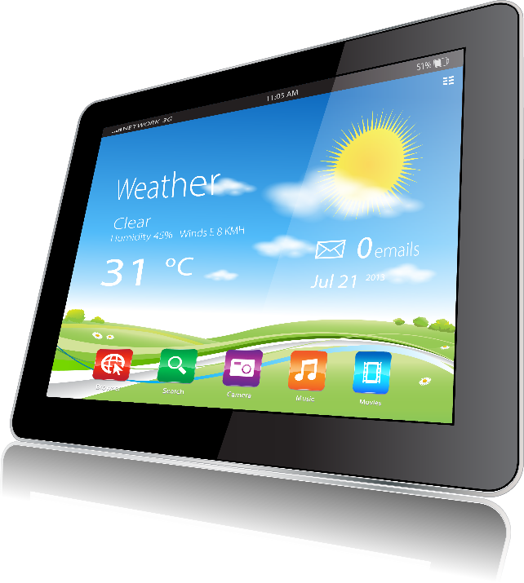

State **three** features of this interface.

| Feature 1 |  |
| --- | --- |
| Feature 2 |  |
| Feature 3 |  |

3. A delivery company makes use of a handheld device for   
scanning packages when they are sent to customers.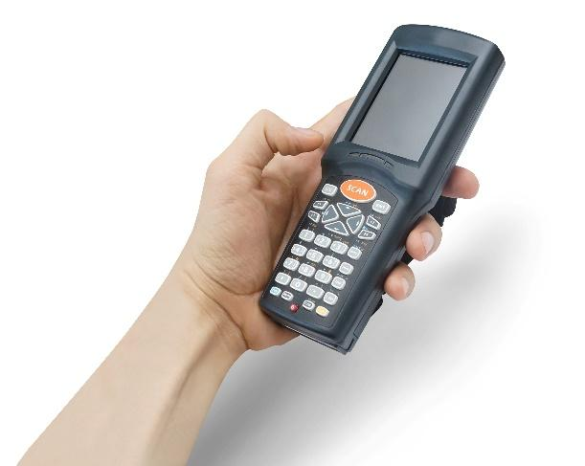

They are deciding whether to use a GUI, menu based   
user interface.

(a) Complete the table below to show two advantages   
and disadvantages of using a menu based user  
interface or a GUI. [4]

|  | **Advantages** | **Disadvantages** |
| --- | --- | --- |
| Menu-based interface |  |  |
|  |  |
| GUI |  |  |
|  |  |

(b) Now make an assessment of which handheld device the delivery company should use.

For your assessment you should compare the advantages and disadvantages to decide which are more important. You should also provide a conclusion. [3]

|  |
| --- |

4. Name **three** domestic appliances that have a user interface built in. [3]

|  |
| --- |
|  |
|  |

Section 1

[Total 15 marks]

# Section 2

# A company sells high-end coffee machines to businesses.

They have the design for the machine finished,   
but are considering whether to use a menu-based   
interface controlled with buttons or a GUI and a   
touch-screen.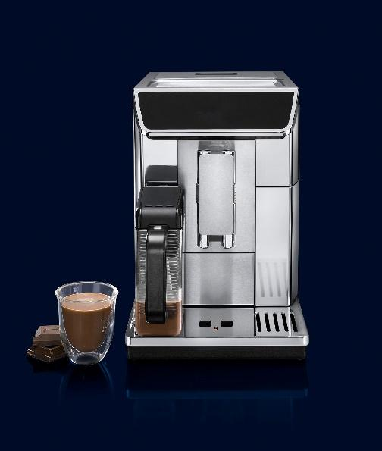

(a) ***Other than the input and output devices***, explain   
two other higher specification hardware components   
that will be required if a GUI interface is used. [4]

| Component 1 |  |
| --- | --- |
| Component 2 |  |

(b) The company has begun their assessment of the two different choices of user interface.

Read the assessment on the left of the table below and on the right identify if each part   
of the assessment shows an assessment, conclusion, advantage or disadvantage. [4]

| A graphical user interface (GUI) will be more intuitive for people to use. The ease of use will give a better customer experience. |  |
| --- | --- |
| However, the components, such as touch screen will cost more. |  |
| As these are high-end coffee machines, we can charge a lot extra if a touch screen and GUI is added. |  |
| Therefore, we suggest using a GUI as the interface. |  |

[Total 8 marks]

# Section 3

1. A number of icons are shown below. The icons are used on a car buying website.

Using your past experience, state what functions each of them are likely to have. [5]

| **Icon** | **Likely meaning on a car buying website** |
| --- | --- |
| New Post icon |  |
| Phone icon |  |
| British Pound icon |  |
| Speed icon |  |
| Filter icon |  |

2. A cartoon app has been made for children aged 3-6.

The developers of the app have created the following video player template.



(a)State **four** features that the video player is likely to have based on your past experience of such interfaces. [4]

| Feature 1 |  |
| --- | --- |
| Feature 2 |  |
| Feature 3 |  |
| Feature 4 |  |

(b) The app owners have said that they don’t feel that the video player will be accessible for the age group.

Complete the table below to give **three** features that young children may   
have difficulty accessing and then given **three** ways that the interface could   
be improved. [6]

| **Weaknesses of the interface** | **Improvements that could be made to the interface** |
| --- | --- |
|  |  |
|  |  |
|  |  |

[Total 15 marks]

# 

# 

# 

# 

# 

# 

# 

# 

# 

# 

# 

# 

# 

# 

# 

# Section 4

Name the following GUI components. [3]

| **GUI component** | **Name** |
| --- | --- |
|  |  |
|  |  |
|  |  |

2. WaveMotion is a family-owned, friendly and professional recording company that record music events around the world.

They have just asked a web design company to provide a design template for their new website.

(a) Explain why a sans-serif font has been chosen for the website. [2]

|  |
| --- |

(b) The table below shows a number of features that an interface or web page can   
have. Tick whether each feature is, or is not present. The first row has been completed for you. [3]

| **Feature** | **Present in the interface** | **Not present in the interface** |
| --- | --- | --- |
| A navigation menu | ✔ |  |
| Related components are grouped together |  |  |
| Lots of whitespace is given |  |  |
| There is consistency throughout the page |  |  |

(c) Explain **one** negative of the use of colour on this design and **one** improvement. [4]

| Negative | Improvement |
| --- | --- |
|  |  |

[Total 12 marks]

# Section 5

1. Look at the following examples of two interfaces and answer the questions that follow.

| **Text based interface** | **GUI** |
| --- | --- |
| C:\Documents\Counter>systeminfo  Host Name: PG-JOE-MAIN-PC OS Name: Microsoft Windows 10 Pro OS Version: 10.0.19041 N/A Build 19041 OS Manufacturer: Microsoft Corporation OS Configuration:Standalone Workstation OS Build Type: Multiprocessor Free Original Install Date: 20/08/2020, 12:19:14 System Boot Time: 04/02/2021, 09:00:18 System Manufacturer: LENOVO System Type: x64-based PC Processor(s): 1 Processor(s) Installed. [01]: Intel64 Family 6 Model 158 Stepping 9 GenuineIntel ~3912 Mhz Windows Directory: C:\Windows System Directory: C:\Windows\system32 |  |

(a) For each interface, give **two** benefits of the colours that have been used. [4]

**Text based interface**

|  |
| --- |
|  |

**GUI**

|  |
| --- |
|  |

(b) A basic search field is given in the GUI interface. Users are finding it hard to use.   
Give three ways that it could be improved to help retain user attention. [3]

|  |
| --- |
|  |
|  |

2. The following shows the interface of a new banking app.

(a) Explain how consistency in the design has helped it to be intuitive to use. [2]

|  |
| --- |

(b) Give one reason why green has been chosen as the primary colour for the app. [1]

|  |
| --- |

(c) Explain one way that symbols and graphics have been used to enhance the user perception of the app. [ 2]

|  |
| --- |

[Total 12 marks]

TOTAL MARKS AVAILABLE

62