Therapy Pack

Edexcel A GCSE Geography

Paper 3

UK Challenges

**8.1 - The UK’s resource consumption and environmental sustainability challenge**

Changes in the UK’s population in the next 50 years and implications on resource consumption.

The UK’s population is predicted to increase over the next 50 years due to

* Economic migration
* Natural increase

The statistics of net migration (the difference between inward migration immigration and outward migration or emigration) are difficult to track as:

* Some migrants enter and leave in the same year (e.g. seasonal migrants who work in tourism or farming) so are not counted
* Data collected on migrants tends to be every 10 years (census) – many people leave and arrive in that time.
* Some migrants enter illegally and are not documented

Migration is neccessary for the UK economy:

* It provides high skilled employment in education, medicine and research which helps to contribute to the economy as the tax base (the amount of money that a country makes from the incomes of its citizens) is high
* It meets skills shortages in low skilled employment too – people may migrate to help in arable areas of the UK such as Lincolnshire, harvesting crops to meet the UK’s food demand and to supply their trading partners.

1. Define net migration

.......................................................................................................................................

1. Study table 1: Describe the change in the UK’s population between 2025 and 2050 (3)

.......................................................................................................................................

.......................................................................................................................................

.......................................................................................................................................

1. Study Table 1 : Calculate the percentage increase in the UK’s population between 2025 and 2050 (2)

Give your answer to one decimal place.

You must show you working out in the space below (2)

.......................................................................................................................................

1. As the population increases our demand for food resources increases
2. As the population increases, our demand for water increases.
3. As the population increases, there are more cars on the road.
4. As the population increases, our demand for energy increases.
5. As the population increases, more ecosystems are cleared to make room for houses

Use the above statements as you first point then use the SO, SO method to explain how it could have an impact on resource consumption.

**Pressures of growing populations on the UK’s ecosystems.**

How are UK ecosystems under threat by our rising population?​

1. Greenfield sites are increasingly being built on

2. Ecosystems are destroyed and biodiversity declines.

3. The supply of water decreases

4. More food needs to be produced on a large scale, this is known as agribusiness

5. Demand for energy increases. Use of energy produces more carbon emissions which causes air pollution and global warming

Using figure 5b, suggest which areas of the UK will experience most threat to ecosystems (1)​

2.Explain one impact on ecosystems this area might face (3)

**Range of national sustainable transport options for the UK.**

Sustainable transport is needed because.

**CO2 (carbon dioxide) emissions** are high, they contribute to climate change, global warming and more extreme weather in the UK – with social, economic and environmental consequences​.

**Traffic congestion** results in people being late to work, idling of engines etc which have health and economic consequences​.

**Health** – Options like bicycles improve both fitness and air pollution (social and environmental)

**Match the sustainable transport method to the description**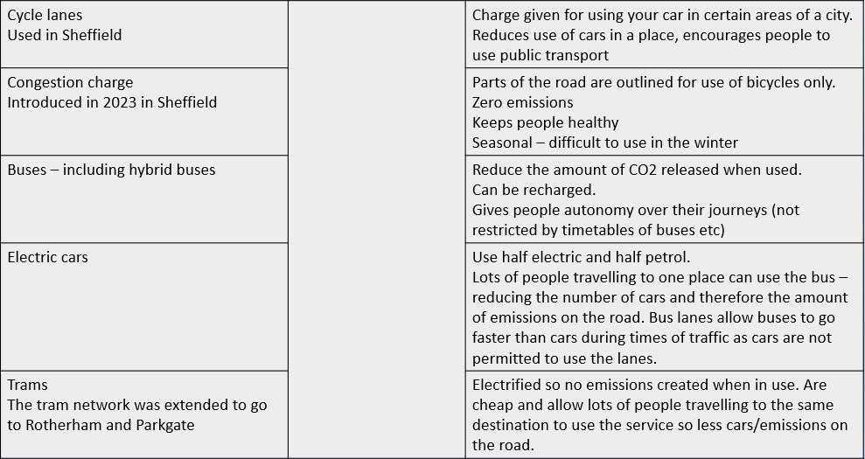

* 1. **The UK settlement, population and economic challenges**

The ‘two-speed economy’ and options for bridging the gap between south east and the rest of the UK.

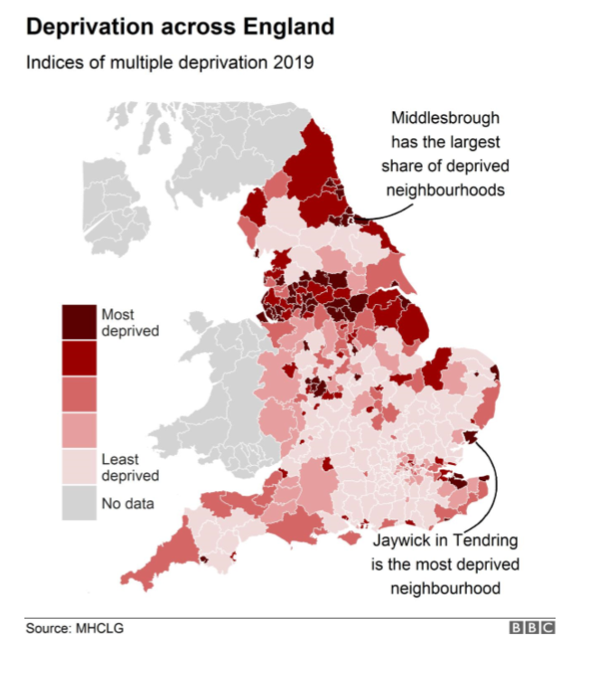

1. Describe the distribution (spread) of deprivation in the UK.
2. Suggest one social reason for this trend.
3. Suggest one economic reason for this trend.
4. Suggest one physical reason for this trend.
5. Suggest one political reason for this trend.
6. Deprivation is higher in the north
7. Quality of education is better in the South
8. Number of people going to university is higher in the South
9. Number of people in high paid, high skilled jobs in the South
10. Number of transport links are higher in the South
11. A screenshot of a computer

    AI-generated content may be incorrect.House prices are higher in the South

Solutions to the two-speed economy

**Levelling up**​

- more funding for North of England​

- Increased regeneration in deindustrialised towns and cities.  ​

​

**Northern Powerhouse**​

* Raise education and skill level in the north​
* Grow businesses​
* Increase transport links​

**HS2**​

* Increase transport links connecting the north to the south and areas in the north to each other. ​
* This project is now stopping at Birmingham. The 'Network North' project aims to improve transport in the north

Match up the negatives of the above solutions

**Costs and benefits of greenfield development and the regeneration of brownfield sites.**

* **Greenfield site** - an area of land that has not been developed previously
* **Brownfield site** - an old industrial or inner-city site that is cleared for a new building development

Highlight whether they are social, economic or environmental. They could be a mixture.

**UK net migration statistics and their reliability and values and attitudes of different stakeholders towards migration.**

A stakeholder is somebody who has an interest or involvement in an change/cause. They include residents of areas, government, businesses, environmental groups. Below are the views from stkeholders in migration.

**TASK – Summarise what they do/don’t like about migrations below their statement. Do they support or oppose migration?**

Farmers use migrant labour to support their businesses. Many people in the UK do not want to do manual labour as their job, but some migrants do – so it gives the migrants the job and allows the farmer to trade more.

Sumarise farmer’s views on migration –

.......................................................................................................................................

.......................................................................................................................................

.......................................................................................................................................

NHS - Many people believe that the NHS is stretched due to our growing population and international migrants can put more pressure on the NHS. However, NHS workers from overseas make up 15% of the workforce – so the NHS themselves like migrants as they make up a lot of the work force.

Summarise NHS views on migration –

.......................................................................................................................................

.......................................................................................................................................

.......................................................................................................................................

Government – Different governments have varying opinions on international migration. It can be seen as a positive due to people of working age coming to the country. They can fill gaps in the job market that others cannot or won’t fill and boost the amount of tax collected. However, an increase in migrant populations can put pressure on services such as healthcare and education

Sumarise the government’s view on migration

.......................................................................................................................................

.......................................................................................................................................

.......................................................................................................................................

**Two speed economy**

A ‘two-speed economy’ refers to the uneven growth of the UK economy, with the South East developing fastest.

* There is greater employment opportunities in the South of England
* Quality of life and life expectancy is better in the South of England
* Educational outcomes are much better in the South of England
* However, it is more expensive to buy a house in the South of England

A possible solution to help close the gap between the South East and the rest of the UK the Northern Powerhouse which attempts to do the following;

* Invest in transportation so people can live in the north and commute to their employment in the south. An example of this is HS2, but this was halted in 2022.
* Invest in education for people in the North, an example would be UTC and the Universities.
* Give the North of England more power to govern itself by appointing Mayors who have power to make decisions about how and where money is spent in the local area for example in Manchester, huge developments in their tram network attracted more foreign investment to the city, improving it and making it a competitor with London for high skilled employment.

Define the two speed economy (1)

.......................................................................................................................................

Suggest two ways that the two speed economy can be tackled (4)

.......................................................................................................................................

.......................................................................................................................................

.......................................................................................................................................

**The UK’s landscape challenges**

The UK’s natural environment is under threat due to population increase, sea level rise, climate change and development.

* Sea level rise decreases the amount of land to build on. So rural inland areas are developed on.
* Population increase leads to a higher demand for built on areas, decreasing biodiversity
* Climate changes leads to the development of renewable energy which can take up a lot of natural space e.g. a solar farm.
* Population increase leads to a higher demand for food and self sufficiency through agribusiness (large scale farming). So, more arable and pastoral land is needed, replacing wild areas.
* Climate change leads to animals leaving hibernation early, increasing competition between species, reducing the biodiversity and disrupting food chains.
* Climate change also leads to the introduction of non native species who can survive in the UK’s altered climate. So this leads to competition between species, disrupting food chains and causing extinction of native species e.g. the red squirrel is rare in the UK, despite being a native species.

**National parks** are important areas that cover 10% of the land in the UK. They protects vital landscapes and wildlife habitats. They may contain sights that hold significance in terms of history and culture. National parks are also home to communities and are where around 400,000 people live and work. They are biodiverse areas protected by law for the benefit of the nation.

**Benefits of national parks –**

TASK - Add whether they are social, economic or environmental benefits.

Reduce climate change - sequester carbon dioxide​ .............................

Rich in biodiversity .............................

Leisure and recreation .............................

Tourism – Creates jobs and generates income within the national park. .............................

Provide habitats for animals .............................

Many people work in National parks .............................

Provide spaces of renewable energy​ .............................

Are greenfield sites- but could be used to build houses .............................

Enables the local tax income to increase so the local government/council can invest in schools,  
  
 healthcare and social services. .............................

Conservation of national parks

We can conserve national parks by promoting sustainable use of the natural resources of the area. To promote understanding and enjoyment of the special qualities of the area by the public.​

**Footpath creation and protection**

To protect the natural landscape and wildlife, designated routes have been provided so that tourists do not damage fragile areas.

**Education**

Educating visitors about the importance of the landscape so that tourists are more aware of their actions and less likely to drop litter, damage things or disturb the environment.

**Regeneration**

Encouraging local farmers to convert old farm buildings into tourist accommodation to reduce the need to build additional facilities on the natural landscape, these look natural and in keeping with the look of the area and also avoid the need to build on greenfield sites while allowing the economy to benefit.

Development of national parks

We can develop national parks by being aware of and developing the needs of those in them by providing housing for those who live in them and the growing populations while not services/employment) while minimising disruption for people who live and visit the national park in sustainable ways.

Development in national parks of critical infrastructure such as renewable energy, also leads to changes in the protected area.

Stakeholders in National Parks

The park is managed by the National Parks Authority (NPA), which attempts to balance the conflicting priorities of different park users. For example:

* The protection of the park's environment, wildlife and natural features which are at risk from excessive tourism and are powerfully lobbied for by conservation and wildlife groups.
* Tourists who come to enjoy the park need roads, parking, accommodation, shops and restaurants which are not necessarily good for the countryside.
* Local businesses may want to encourage more and more visitors.
* Farmers may be concerned about damage to fences and livestock by walkers and their dogs.
* Local residents may be worried about congestion, littering, noise pollution and the erosion of footpaths.

If these competing interests are not carefully balanced, the result could be damage to the environment, local people becoming upset or even hostile and tourists being deterred from visiting the park.

1. Approaches to managing river and coastal UK flood risk.

Impacts of flooding

Social – People can be injured, and their property can be destroyed leaving them homeless or unable to travel.

Economic – Homes and businesses can be destroyed that need to be repaired/rebuilt.

Environmental – plants become oversaturated leading to them being uprooted. Animals are inundated by flood water e.g. burrowing species.

Ways to manage/lessen impacts of **RIVER FLOODING**

**Task - Decide whether these are HARD or SOFT engineering.**

**Evacuate people**

We call this *zoning* when it is done permanently and when only certain building types are allowed by the river. Land close to rivers at risk of floods is often fields/farmland to avoid the risk of houses and businesses being damaged. It also allows for water to soak into the ground instead of impermeable surfaces such as roads/car parks.

This is ............................. engineering

**Build a high wall to stop the river from bursting** We call this a *flood wall. It increases the capacity (how much it can hold) of the river, making it less likely the river will burst its banks and flood.*

This is ............................. engineering

**Plant trees which will absorb and slow the flow of water into the river**

We call this *afforestation. Trees slow the flow of water through interception, this is when rain hits the tree and makes it way to rivers slower. Without trees the rain falls directly onto the floor and gets to the river quicker, decreasing lag time and preventing surface run off. They also help to hold more water in the soil mean less sediment enters the rivers which also increases flood risk.*

This is ............................. engineering

**Keep an eye on the river**

We call this *monitoring. It enables people to prepare and predict when flooding may occur and act accordingly.*

*Dams and Reservoirs*

*These hold back the water and slow the water flow. They can often be controlled to increase or decrease the amount of water passing though them.*

This is ............................. engineering

Ways to manage/lessen impacts of **COASTAL FLOODING**

**Hard engineering**

### Sea walls

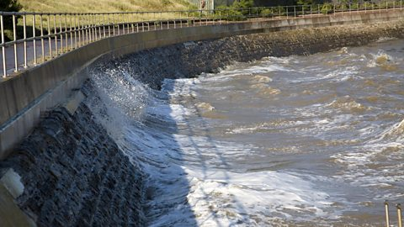

Concrete walls that are placed at the foot of a cliff to prevent erosion. They are curved to reflect the energy back into the sea.

#### Advantages

* Effective at protecting the base of the cliff.
* Sea walls usually have promenades so people can walk along them.

#### Disadvantages

* Waves are still powerful and can break down and erode the sea wall.
* Expensive

### Rock armour

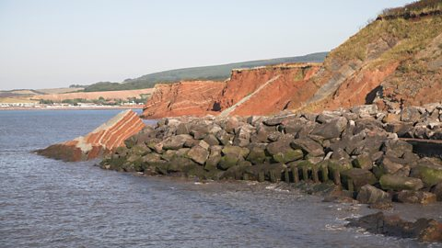

Rock armour on a beach

Large boulders placed at the foot of a cliff. They break the waves and absorb their energy.

#### Advantages

* Cheaper than a sea wall and easy to maintain.
* Can be used for fishing.

Disadvantages

* They look different to the local geology, as the rock has been imported from other areas.
* The rocks are expensive to transport.

### Groynes

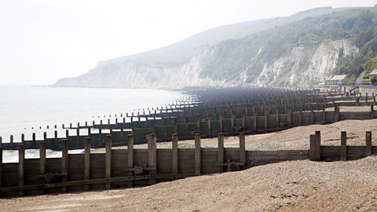

Wooden groynes on a beach in Sussex

Groynes are wooden or rock structures built out at right angles into the sea.

#### Advantages

* Builds a beach - which encourages tourism.
* They trap sediment being carried by longshore drift.

#### Disadvantages

* By trapping sediment, it starves beaches further down the coastline, increasing rates of erosion elsewhere.
* They look unattractive.

**SOFT ENGINEERING**

### Beach nourishment

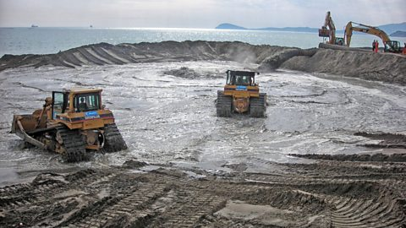

Bulldozers moving sand during beach nourishment

Sand is pumped onto an existing beach to build it up.

#### Advantages

* Blends in with the existing beach.
* Larger beaches appeal to tourists.

#### Disadvantages

* Needs to be constantly replaced.
* The sand must be brought in from elsewhere.

### Sand Dune nourishment

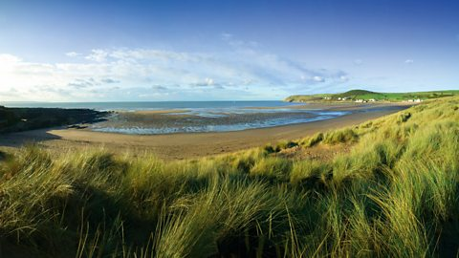

Marram grass

Marram grass planted on sand dunes stabilises the dunes and helps to trap sand to build them up.

#### Advantages

* Relatively cheap.
* Maintains a natural-looking coastline.

#### Disadvantages

* Can be damaged by storm waves.
* Areas must be zoned off from the public, which is unpopular.

Managed retreat

Allowing areas of the coastline (usually low land value areas like farmland) to naturally erode and not attempting to control or protect the coast.

* 1. **The UK’s climate change challenges**

**Human causes of climate change**

* **Industry** requires energy.
* Energy is generally produced using fossil fuels such as natural gas in the UK.
* Burning fossil fuels releases CO2 which is a greenhouse gas.
* Higher concentrations of CO2 in the atmosphere causes more heat to be trapped
* This causes the enhanced greenhouse effect and leads to climate change and global warming
* **Agriculture** such as commercial cattle farming, as a growing population means a higher demand for food, especially meat.
* Cows release methane which is a greenhouse gas.
* It causes the enhanced greenhouse effect and traps heat in the atmosphere.
* Deforestation also occurs to create open land for crops and cattle. This releases carbon and lowers the effect of photosynthesis absorbing carbon.
* Agricultural vehicles and food miles also contribute to carbon emissions.
* **Transport** such as lorries, cars, planes and trains often use petrol or diesel (produced from oil)
* This is a fossil fuel and when burnt produces CO2
* This is a greenhouse gas and contributes to global warming and climate change
* The UK’s wealth is increasing meaning more people own cars increasing the impact on the concentration of CO2.
* Transport accounts for around a quarter of all CO2 production in the UK.

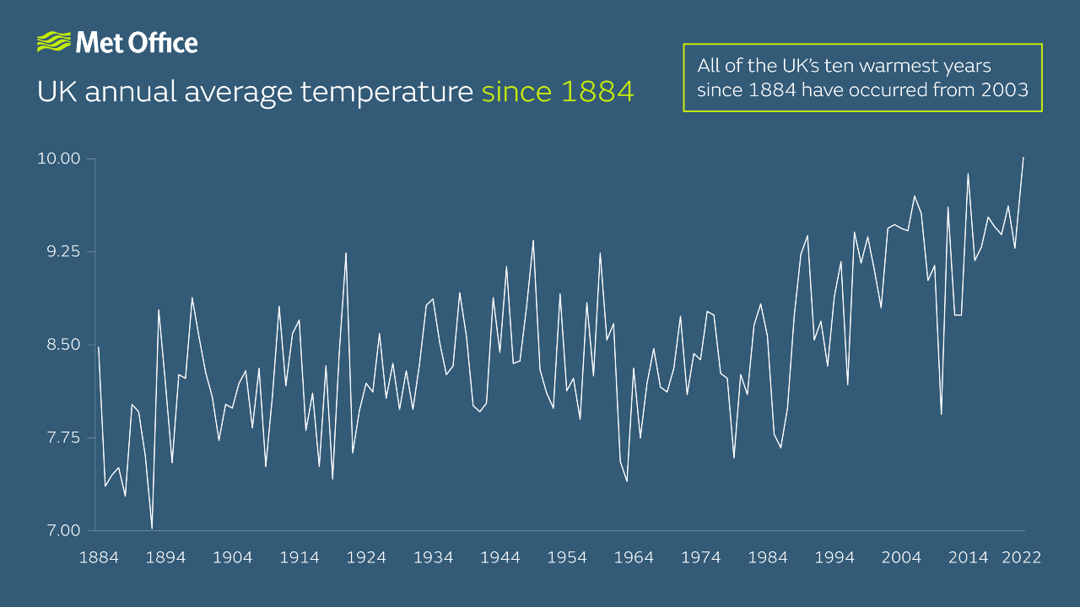

Describe how the UK annual average temperatures have changed since 1884.

Use data in your answer.

(2)

__________________________________________________________________________________________________________________________________________________________________________________________

Highlight the positive and negatives impacts of climate change.

Highlight which of the impacts are social, economic and environmental.

There are a range of responses to climate change in the UK at a local and national scale.

**Mitigation** – stopping climate change

* Reduction of the use of fossil fuels – use more wind, HEP
* Encouraging more sustainable transport
* Signing international agreements to reduce fossil fuel usage

Using renewable energies, such as solar, wind, HEP, will lower the amount of fossil fuels that are used. This will lower the amount of carbon emissions and lessen the impact of global warming and climate change.

**Adaptation** – Changing altering practice or doing something to stop the impacts. Accepting there will be impacts and acting to prevent the impacts having as big of an effect.

* Drought resistant crops
* Growing crops that are more suited to the warmer climates that we receive

The UK is also signing international agreements to:

* Pay low income countries to help them to respond to the impacts of climate change
* Share technology with low income countries such as renewable energy tech

A range of stakeholders influence our action on climate change, these include:

* Individuals who feel reluctant to change their habits to reduce the impacts of climate change (e.g. pay initially more expensive, renewable only energy tariffs, install heat pumps, install energy efficient windows and doors)
* Individuals who feel strongly about the impact climate change has e.g. Just Stop Oil protestors
* Businesses who want to keep profits down, so want to use more non renewable energy, although this has changed recently as the prices of oil and gas have increased due to global conflict
* The government themselves who need to provide a combination of high skilled jobs (e.g. in renewables and finding solutions to climate change through quaternary sector research opportunities) and low skilled employment in mining for oil, coal and gas.

The 12 mark question

Plus 4 marks SPaG.

Throughout the paper you have been given resources to work with to help you to answer the questions.

This final question will ask you to draw on the resources to ‘discuss’ a problem.

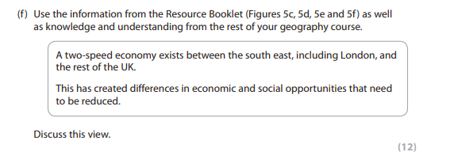

Here is a good framework to use:

Paragraph 1 - Figure ...shows... All about the resources, the 2 most relevant in detail

Paragraph 2 - Topic - the general topic, breadth - causes, effects, impacts etc

Paragraph 3/4 - answer the question and link to wider learning (more challenging)

Paragraph 4/5 - conclusion - In conclusion I agree/disagree/somewhat because...

Look at the figures and then at the student response.

Highlight where they have talked about the figure

Highlight where they have used their own knowledge (general topic information)

Highlight where they have linked to other learning including other UK challenges that are related

Highlight where they have used the words ‘agree’ and ‘disagree’

