Therapy Pack
Edexcel A GCSE Geography
Paper 2


Resource management

This GCSE requires you to:
AO1 15% – Demonstrate knowledge of locations, places, processes, environments and different scales.
AO2 25% - Demonstrate geographical understanding of:
Concepts and how they are used in relation to places, environments and processes (e.g. trade, urbanisation)
Inter-relationships between places, environments and processes
AO3 35%– Apply knowledge and understanding to interpret, analyse and evaluate geographical information and issues and to make judgements
AO4 25% - Select, adapt and use a variety of skills and techniques to investigate questions and issues and communicate findings

The Global Development section of the paper will always:
- Be section C of paper 2
- Be worth 30 marks
- Have low mark questions (1m-4m)
- Have an initial section about resources in general – this can include questions about food, water and energy.
- Have optional sections on energy and water. You need to answer the energy section as that is what you’ve studied in class.
- Have an 8m question at the end of the paper

How to guide.
Command word, marks and time. | What you need to include in your answer. | For example…
State/identify  1 mark, 1 min | Name something, no detail needed, often a one-word answer | Name the country with the highest coal reserves on figure 2a. (1) USA
Describe  1,2,3 or 4 marks  No more than 4mins | Say what something is, no reason needed.  1 mark per correct statement  GEOG or TEA | Describe the distribution of energy consumption shown in figure 2b. (3)  The general pattern is uneven, for example the southern hemisphere is lower with the odd one out being Australia with the greatest being in Europe and North America.  The trend is an uneven consumption pattern, most countries above the Equator consume more than those beneath it for example European countries and the USA have high levels of energy consumption, the anomaly is Australia who consumes a lot of energy per person.
Outline  2,3 or 4 marks  2 – 4mins | Same expectations as EXPLAIN – see below. | Outline one cause of the trend shown in figure 1a (4)  One cause is the accessibility of resources (1_, for example countries with resources such as coal or oil tend to use more of it in their energy mix (1) these for money (1) this is because they don’t have to import energy from other countries so it is cheaper (1)
Explain  2,3 or 4 marks  2-4mins | Say why something is happening, using conjunctions such as so because, this means that… this results in…  An explain question for 3 marks needs 1 reason explained in depth  An explain question for 4 marks needs 2 reasons, both explained clearly. | Explain the effects of an increased use of fossil fuels for energy (4)  One effect is air pollution (1) from the burning of fossil fuels so the air quality reduces (1). Another effect is higher global temperatures (1) due to fossil fuels releasing greenhouse gases so energy from the sun is trapped, heating the earth (1).
Assess  8 marks  10-12mins | Paragraph 1 – you must use show breadth about the topic of the question. General information about this.  Paragraph 2/3 – Answer the question, including at least 2 ideas/options and case study knowledge (7+ offer an alternative to what the questions is asking)  Paragraph 3/4 – Conclusion, a JUDGEMENT answering the question, which is the best/worst/most important/largest/smallest. | Assess role of individuals and organisations in deciding the energy mix (8)  P1 – In the UK/Germany/China, individuals have led to energy mix changes because … In the UK/Germany/China, organisations have led to energy mix changes because  P2/3 – One example of individual’s having an impact on the energy mix is… the impact was… this led to … One example of organisations having an impact on the energy mix is… the impact was… this led to … there are other alternative determinants of a countries energy mix such as accessibility  P4 – In conclusion it is organisations who play the biggest role in energy mix…
Evaluate  8 marks  10-12mins | Paragraph 1 – you must use show breadth about the topic of the question. General information about this.  Paragraph 2/3 – Answer the question, must include positives/negatives or costs/benefits. case study knowledge (7+ offer an alternative to what the questions is asking)  Paragraph 3/4 – Conclusion, a JUDGEMENT answering the question, which is the best/worst and why. | Evaluate the success of strategies used to sustainably manage energy supply.  P1 – Sustainable energy supply is… it is needed because…  P2/3 – One strategy has been….so…for example…  Another strategy has been…. therefore…for example…  P4 – In conclusion I think the strategies have/have not been successful because…

Geographical Vocabulary: using these words throughout you answers is essential for grade 7 and above

 | Geographical vocabulary | Definition | In a sentence
Natural resources | Biotic | Living resources obtained by the biosphere that are capable of reproduction | Animals such as cows and plants such as potatoes are biotic resources
 | Biosphere | Anywhere on earth where life can exist (includes the lithosphere, ecosphere, hydrosphere and atmosphere) | Humans exploit the biosphere for resources.
 | Abiotic | (non-living) resources are obtained from the  lithosphere, atmosphere and hydrosphere | Soil, sunlight and water are biotic resources, meaning that solar power is an abiotic energy resource
 | Lithosphere | The part of the biosphere that includes the rigid outer layer of earth | You would find oil, uranium, coal and gas in the lithosphere
 | Ecosphere | The part of the biosphere that includes plants and animals | The ecosphere is exploited for food and timber.
 | Atmosphere | The part of the biosphere that includes the envelope of gases that surround the earth | Solar energy comes from the atmosphere, as does wind power.
 | Hydrosphere | The part of the biosphere that includes rivers and seas | Wave energy is taken from the biosphere.
 | Mineral | A naturally occurring substance | Iron is a mineral.
 | Renewable | Energy that is infinite and cannot run out | Renewable resources are more sustainable than non-renewable ones.
 | Non-renewable | Energy that is finite and will run out
 | Deforestation | The removal of trees on a large scale for profit | Deforestation threatens biodiversity and causes soil  erosion. Palm oil plantations disrupt ecosystems such as those  in Malaysia.
 | Oil extraction | The removal of oil from the lithosphere | In oil extraction, toxic water pollutes rivers that indigenous  peoples rely on for washing, cooking and fishing.
 | Overfishing | When the extraction of fish out of the hydrosphere exceeds the reproduction of fish, resulting in a net loss of fish | Fishing provides a source of protein and jobs,  But due to overfishing cod numbers have fallen in the North Sea.
 | Farming | The activity of growing crops (arable farming as in East Anglia) or raising livestock as in Scotland and Wales | Intensive farming including agribusiness (large scale farming) reduces biodiversity.
Distribution and consumption of natural resources | Distribution | The spread of something e.g. population, availability etc | The distribution of oil reserves is uneven globally.
 | Consumption | The use of a resource. | Consumption of energy resources is higher in industrialised and industrialising nations
 | Surplus | Having a lot of a resource (resources to spare) | Russia has a surplus of gas.
 | Deficit | Not having enough of a resource. | Saudi Arabia has a deficit of water.
 | Fossil fuels | A natural fuel such as coal, oil and gas formed by the remains of living organisms | Fossil fuels are running out (finite)
 | Fertile soil | Soil capable of sustaining life including growing large amounts of plants. | Fertile soil in Europe, means that food resources are in surplus
Renewable and non renewable resources | Solar power | Energy that is generated from heat from the sun | Solar energy is used as part of Germany’s energy mix.
 | Wind power | Energy generated from kinetic energy from wind | Wind power is a common renewable energy source in Europe, which is situated in the Ferrel cell – a windier part of the world.
 | Wave power | Energy generated from waves. | Wave power is an example of renewable energy.
 | Hydroelectric power | Energy generates from water being forced through a small gap, turning a turbine. | Hydroelectric dams make up part of China’s sustainable energy transition such as Three Gorges Dam
 | Uranium | An element involved in the development of nuclear power. | Uranium in an energy mix is a more sustainable solution to other non renewables such as coal, oil and gas
 | Fracking | A new technology that uses water to extract shale gas from sedimentary rock. | Fracking is a controversial way of extracting energy.
Energy mix | Energy mix | The % of energy being used by a country. | It is beneficial to have an energy mix as it ensures that a country is not relying on one type of energy.
 | Population | The number of people who live in a place | High populations result in a higher energy demand.
 | Wealth | How much money a person or a place has. | High wealth nations can afford to invest in the start up costs of renewable technology.
 | Availability | The extent to which resources are accessible to a place. | The availability of coal in China, results in them using high proportion of coal as part of their energy mix.
 | Demand | What you want | The demand for energy is higher in nations who are industrialising (making lots of products)
 | Supply | What you have | The supply of oil is high in the Middle East.
 | Local | Small scale – e.g. regions. | Local responses to sustainable energy may include putting solar panels on the roof of your house
 | National | Countrywide | National responses to sustainable energy management might include reducing the imports of fossil fuels.
 | International | Global | International responses to sustainable energy might include signing agreements to invest in renewable technology.
 | Sustainable management | Managing the supply of a resource to ensure that the needs of people are met now and into the future whilst also keeping costs low (economic sustainability) and protecting the ecology of a place (environmental sustainability) | Sustainable management is difficult for countries with large populations who have less wealth as the demand is high.
Management | Attitudes | The views of people. | Attitudes towards sustainable energy can depend on the cost of the energy
 | International agreements | Agreements signed between countries. | The Paris Agreement in 2015 encouraged countries to reduce global heating by using less fossil fuels for energy.
 | TNCs | Transnational companies that operate in more than one country, they aim to maximise profit. | TNCs may want to appear more sustainable by using more renewable energy to produce goods, but the cost of using the energy can sometimes by higher, putting them off.
 | Governments | Elected officials in charge of decision making. | Governments who are more ‘left wing’ tend to care more about the environmental consequences of having fossil fuels as part of their energy mix e.g. the Green Party in the UK and Germany.

A natural resource is any feature or part of the environment that can be used to meet human needs.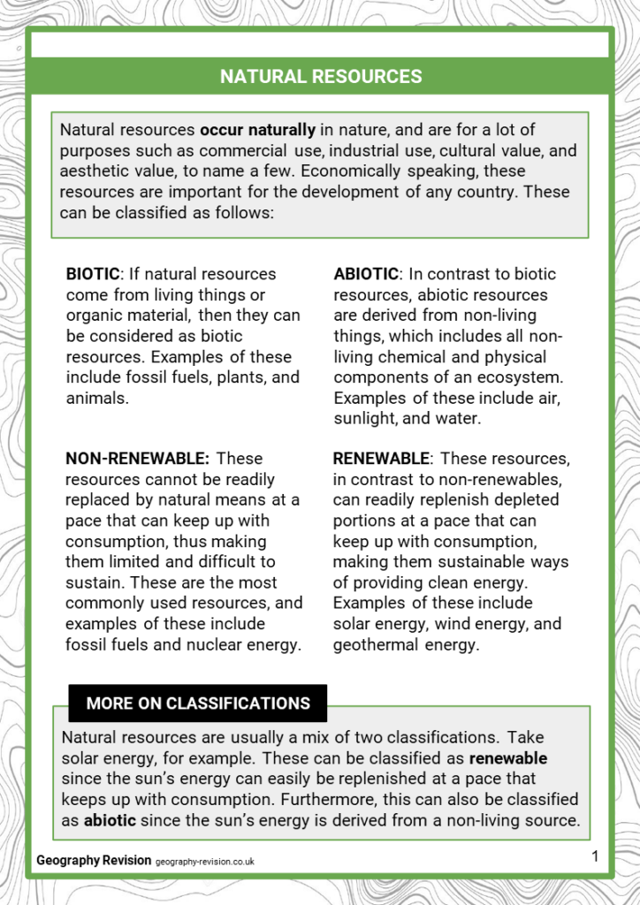

Using the definitions of biotic and abiotic, sort the resources into biotic and abiotic.
Timber / water/ corn / soil / oil/ coal/ wind | Biotic | Abiotic

Using the definitions of biotic and abiotic, sort the resources into renewable and non renewable.
Coal/ wind/ nuclear / gas/ solar / biomass | Renewable | Non renewable

People exploit and can change environments in order to obtain natural resources.
(i) Define the term abiotic.
(1)
........................................................................................................................................... ...........................................................................................................................................
Answer the question with a cross in the box you think is correct . If you change your mind about an answer, put a line through the box and then mark your new answer with a cross .

(ii) Identify one abiotic resource.
(1)
A animals
B birds
C plants
D oxygen
People exploit and can change environments in order to obtain natural resources.
Define the term renewable resource.
(1)
........................................................................................................................................... ...........................................................................................................................................
The environment provides natural resources that can be used to meet human needs.
Explain one reason why fossil fuels are non-renewable.
(2)
........................................................................................................................................... ........................................................................................................................................... ........................................................................................................................................... ...........................................................................................................................................

Examiner's Report
Q1.
(i) The majority of candidates were able to provide a correct definition for the term 'abiotic'.
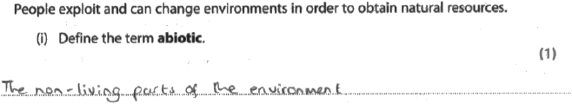
Results Plus: Examiner Comments
This response was awarded one mark.
The candidate has written a correct definition using the phrase 'non-living', scoring one mark on this question.

Q2.
In this question, candidates were asked to define the term 'renewable resource'. This item was answered well by most candidates, with many scoring the full 1 mark.
Most candidates stated that renewable energy can be defined as something that can be reused again or will never run out. However, it is worth noting that several candidates failed to score any marks as they provided an example of renewable energy instead of a definition.
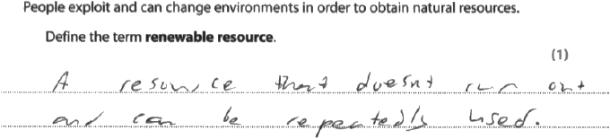
Results Plus: Examiner Comments
This response scores the 1 mark. The candidate has correctly defined the term.
Q3.
About 40.7% of candidates achieve full marks for this question.
- most students know that fossil fuels are finite (run out)
- most people explain this as being due to not being able to re-use them because of the length of time involved in their formation
- some people refer to the fact that we are using up these resources at a faster rate than they can be replaced.
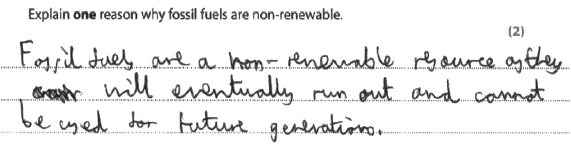
Results Plus: Examiner Comments
eventually run out (1).
For the second mark, there needs to be some further development of this idea, for example the fact that fossil fuels take such a long time to form in the first place.

Exploitation of resources

Humans exploit resources.
Human exploitation of resources include:
- deforesting the ecosphere for the timber and to extract mineral and resources from the ground
- fishing – overfishing to meet the demand of the growing global population
- farming – large agribusiness companies removing resources such as crops to meet the demand of the growing population or meat for growing global markets.
- Extracting energy from the lithosphere (oil, coal, gas, uranium)
- Extracting energy from the hydrosphere (wind, hydro and wave power)
The resulting impacts include soil erosion, which reduces the amount of fertile soil which can be used for future resource extraction and increasing the flood risk as the ground becomes impermeable, increase greenhouse gas emissions which increases global heating, and monocultures- produced when the same plant is planted for its removal for profit, reducing biodiversity.

The distribution and demand for natural resources varies around the world.
Study Figure 3 in the Resource Booklet.
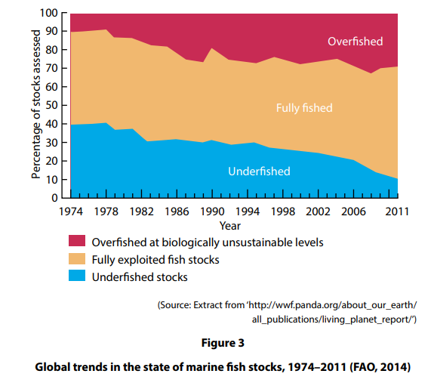
(i) Identify the percentage of stock that was overfished in 2011.
(1)
A 28%
B 58%
C 78%
D 98%
(ii) Calculate the difference between the percentage of total stock underfished between 1974 and 2011.
(1)
........................................................... %
(iii) Suggest one reason for the trend in the percentage of stocks underfished shown in Figure 3.
(2)
............................................................................................................................................
........................................................................................................................................................................................................................................................................................................................................................................................................................................................................................................................................................................................................................................................................................................................................................................................................................................................................
(iv) Suggest two ways the trends shown in Figure 3 would impact on this environment.
(4)
1 .........................................................................................................................................
........................................................................................................................................... ........................................................................................................................................... ...........................................................................................................................................
2 .........................................................................................................................................
........................................................................................................................................... .......................................................................................................................................... ...........................................................................................................................................
There are a number of reasons why deforestation (tree loss) is taking place in different global regions.
Study Figure 3 in the Resource Booklet.
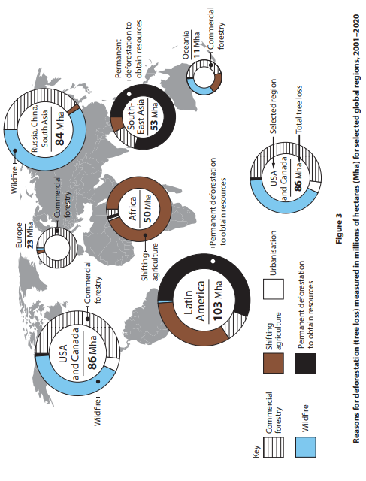
(i) Identify the main causes of deforestation in USA and Canada.
(1)
A commercial forestry and shifting agriculture
B permanent deforestation and wildfire
C urbanisation and permanent deforestation
D wildfire and commercial forestry
(ii) Name the global region where shifting agriculture was the main cause of deforestation.
(1)
...........................................................................................................................................
(iii) Permanent deforestation to obtain resources was the cause of 56% of Latin America's total tree loss.
Calculate the area (Mha) of tree loss due to permanent deforestation in Latin America.
Write your answer to one decimal point.
You must show your working in the space below.
........................................................... Mha
(iv) Explain why deforestation could lead to soil erosion and reduced biodiversity.
(4)
Soil erosion
........................................................................................................................................... ........................................................................................................................................... ........................................................................................................................................... ...........................................................................................................................................
Reduced biodiversity
......................................................................................................................................................................................................................................................................................
........................................................................................................................................... ...........................................................................................................................................

(Total for question = 6 marks)

Q3.
Study Figure 3 in the Resource Booklet. 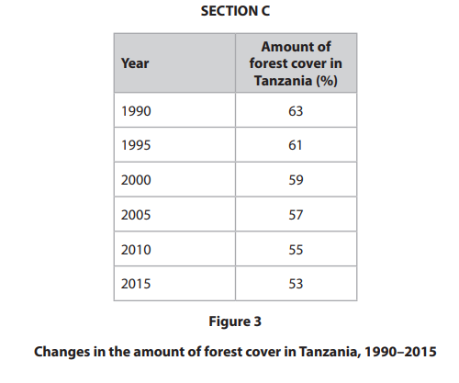
(i) Identify the amount of forest cover in 2020 if the trend shown on Figure 3 continues.
(1)
A 51%
B 53%
C 55%
D 57%
(ii) Calculate the mean amount of forest cover shown on Figure 3.
Answer to one decimal place.
You must show your workings in the space below.
(2)
........................................................... %
(iii) Name one type of graph that could be used to present the data shown on Figure 3.
(1)
.............................................................................................................................................
(iv) State one possible reason for the trend shown on Figure 3.
(1)
.............................................................................................................................................
.............................................................................................................................................
(v) Explain two ways in which the trend shown on Figure 3 could impact on the environment.
(4)
1 .........................................................................................................................................
...........................................................................................................................................
...........................................................................................................................................
...........................................................................................................................................
2 .........................................................................................................................................
...........................................................................................................................................
...........................................................................................................................................
...........................................................................................................................................

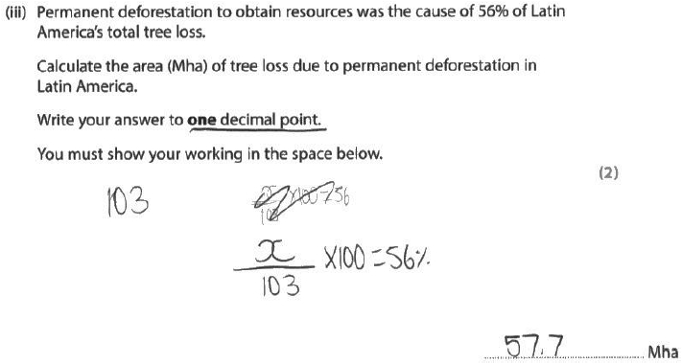
Results Plus: Examiner Comments
Incomplete working (0) + correct answer (1) = 1 mark.

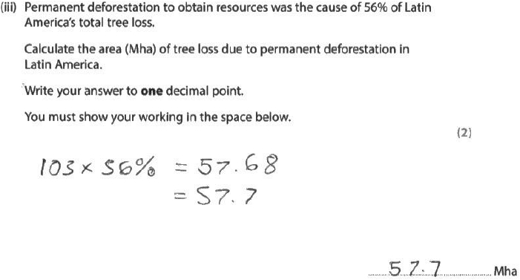
Results Plus: Examiner Comments
Incomplete working (0) + correct answer (1) = 1 mark.

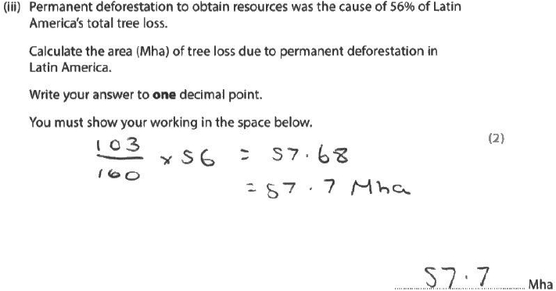
Results Plus: Examiner Comments
Complete working (1) + correct answer (1) = 2 marks

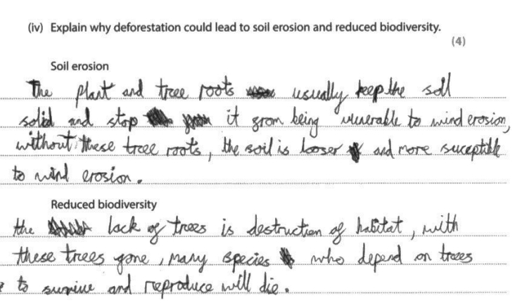
Results Plus: Examiner Comments
Two developed points (1+1) + (1+1) = 4 marks.

Results Plus: Examiner Tip
4-mark 'explain' questions always require two developed points for full marks.

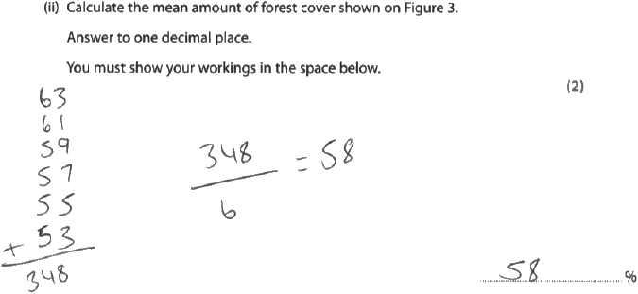
Results Plus: Examiner Comments
This response scores 1 mark. The candidate has correctly demonstrated how to calculate the mean amount of forest cover but was unable to write the final answer to one decimal place.

Results Plus: Examiner Tip
Read the question carefully. If you are asked to show workings, you will lose marks if you just write the final answer. Similarly, if you are asked to write the answer to one decimal place, you will lose marks if you fail to do so.

(iii)
This question required candidates to name one type of graph that could be used to present the data given in Figure 3. This item was answered well by most candidates, with bar graph/line graph being the most popular answers. Some candidates who did not gain a mark for this question often incorrectly chose scatter graphs or pie charts as their answer.
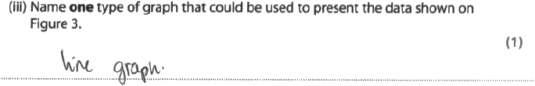
Results Plus: Examiner Comments
This response scores the 1 mark. The candidate has correctly identified a line graph as one type of graph that could be used to present the data shown on Figure 3.

(iv)
This question targets AO3 and requires candidates to give a reason, relating to a source in the Resource Booklet, which shows the changes in the amount of forest cover decreasing in Tanzania since 1990 – 2015. The most popular answer was 'deforestation' and for building infrastructure, like roads. A small number of candidates gained a mark by mentioning illegal logging, but a few candidates left this item unanswered.
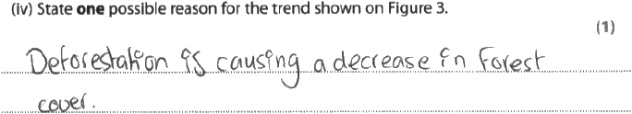
Results Plus: Examiner Comments
This response scores the 1 mark. The candidate has correctly identified 'deforestation' as a possible reason for the trend shown on Figure 3.

(v)
In this 4-mark, open response question, candidates were asked to 'explain' two ways in which the trend in Figure 3 could impact on the environment. Overall, this item was answered very well with many candidates scoring the full 4 marks.
Almost all candidates attempted, and were able to access, the question as most of them could understand the data. Many candidates focussed on the idea of deforestation as they understood that the amount of forest cover was decreasing. The best responses recognised that a loss of trees leads to soil erosion, and the most common correct answers were linked to the loss of habitats, which would lead to a loss in animal biodiversity.
The most common mistakes were for describing the data rather than explaining it, and for candidates not developing their points. Also, it was noted that some candidates unnecessarily spent time re-wording the question, for example, 'the other way that this could impact on the environment is', and then writing an answer but failing to develop it.
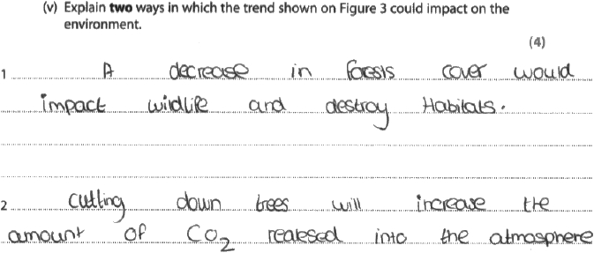
Results Plus: Examiner Comments
This response scores 2 marks. The candidate has correctly identified two impacts related to destroying habitats and increasing CO₂ in the atmosphere, but neither point has been developed through further explanation.

Q1.Name one mineral.
(1)
.............................................................................................................................................

Q2.The environment provides natural resources that can be used to meet human needs.
Name one area of the UK where most of the agriculture is arable farming (growing crops).
(1)
.............................................................................................................................................

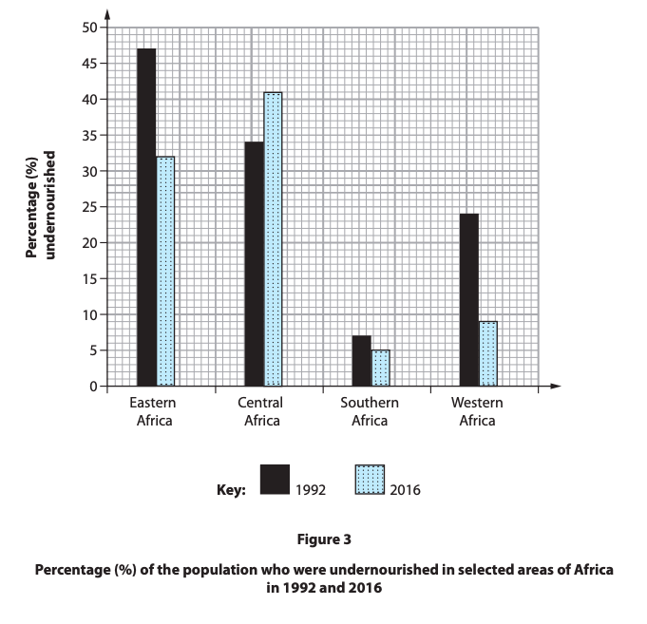
Q3.The pattern of consumption of natural resources is changing.
Study Figure 3 in the Resource Booklet.
(i) Identify the region of Africa that has had an increase in the percentage of the population who are undernourished.
(1)
A Southern Africa
B Eastern Africa
C Central Africa
D Western Africa
(ii) Calculate the range of the percentage of the population who were
undernourished in 2016.
(1)
........................................................... %
(iii) The total population of Southern Africa in 2016 was 64 million.
Calculate the total number of undernourished people in Southern Africa
in 2016.
Answer to one decimal place.
You must show your workings in the space below.
(2)
........................................................... million
(iv) Suggest one negative environmental impact of farming in many African
countries.
(4)
.............................................................................................................................................
.............................................................................................................................................
.............................................................................................................................................
.............................................................................................................................................
.............................................................................................................................................
.............................................................................................................................................
.............................................................................................................................................
.............................................................................................................................................
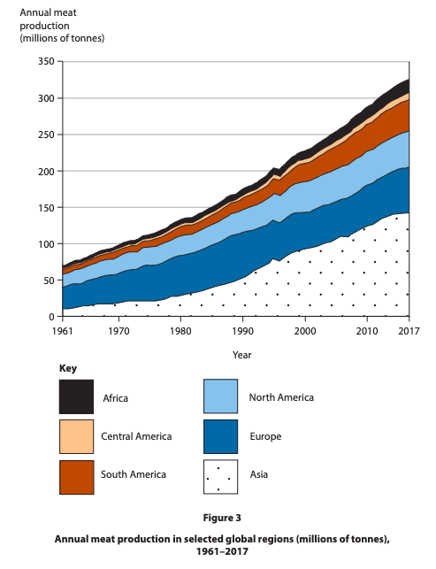
Q4.Study Figure 3 in the Resource Booklet.

(i) Name the region with the highest annual meat production in 1961.
(1)
............................................................
(ii) Describe the overall change in meat production in Asia.
Use data in your answer.
(2)
.............................................................................................................................................
.............................................................................................................................................
.............................................................................................................................................
.............................................................................................................................................
(iii) Suggest one reason for the differences in meat production between Europe and Asia.
(3)
.............................................................................................................................................
.............................................................................................................................................
.............................................................................................................................................
.............................................................................................................................................
.............................................................................................................................................
.............................................................................................................................................

Q5.Study Figure 3 in the Resource Booklet.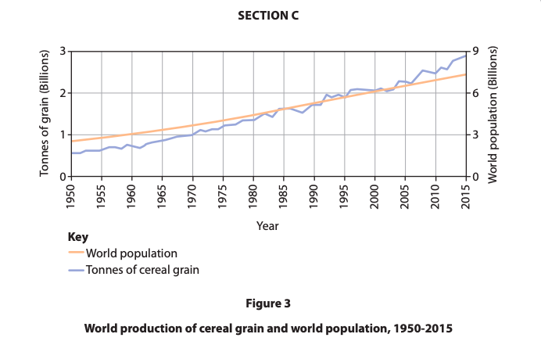
(i) Compare the trends shown in Figure 3.
(2)
.............................................................................................................................................
.............................................................................................................................................
.............................................................................................................................................
.............................................................................................................................................
(ii) Suggest two negative impacts on the environment of the trend in cereal grain production.
(4)
1 ..........................................................................................................................................
.............................................................................................................................................
.............................................................................................................................................
.............................................................................................................................................
2 ..........................................................................................................................................
.............................................................................................................................................
.............................................................................................................................................
.............................................................................................................................................
(iii) One type of information that could be used to investigate the impact of
farming on the environment is a website.
Describe one technique that could be used to process this information.
(2)
.............................................................................................................................................
.............................................................................................................................................
.............................................................................................................................................
.............................................................................................................................................

Global energy supply
Different countries have the potential to exploit different amounts and types of energy. In general:
- Saudi Arabia, Russia and the USA produce the most oil. Around 50% of known oil reserves are found in the Middle East. As technology improves, new supplies can be discovered and accessed more easily. There are huge, barely tapped reserves in South America, Africa and the Arctic.
- The USA, Russia and Australia have the largest coal reserves. Around 80 countries have coal reserves and there is enough coal left to last for another 130 years.
- Russia, Iran and Qatar have the largest natural gas reserves. At present, just under half of the UK's natural gas comes from the North Sea, although production has decreased as profits have fallen. Globally, there is enough natural gas to last for around 50 years.
- Kazakhstan, Canada and South Africa have the largest uranium reserves. Uranium is a non-renewable resource used to generate nuclear power. Uranium reserves are expected to last for another 80 years.
- The potential to generate renewable energy is determined by a country's location. Islands have the potential for wave power and tidal power, windy places can generate wind power, sunny countries can generate solar power, wet places with steep relief can generate hydroelectric power (HEP) and countries close to plate boundaries can generate geothermal power.

Global energy consumption

- It is estimated that global energy consumption will increase by 27% between 2020 and 2040. The growth in energy consumption will largely take place in developing countries.

Reasons for increasing energy consumption

Global energy consumption is rising. There are four main reasons for this:
- Affluence - emerging countries like China are seeing the biggest growth in energy consumption. This is because the standard of living in these countries is improving and so more people are buying things like technology for the home and cars. Energy use in developed country is high, but stable as populations are steady and new technologies help to conserve energy.
- Population - global population is increasing. It reached 7.9 billion people in 2022 and it is estimated to reach 9.7 billion around 2050. Everyone uses energy and so this leads to a greater consumption of energy.
- Technology - the development of new technologies means that more people are using energy. The use of mobile devices and computers has increased and these all require energy to power them.
- Economic reasons - factories and offices are run using energy. As countries develop economically, they build more factories and offices for people to work in.

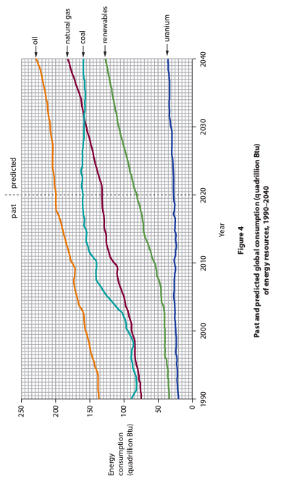
Different resources are being developed to meet the growing demand for energy.
Study Figure 4 in the Resource Booklet

(i) Identify the energy resource that had a consumption of 100 quadrillion Btu in 2005.
(1)
A natural gas
B oil
C renewables
D uranium

(ii) Calculate the increase in consumption of coal (quadrillion Btu) between 1990 and 2020.
(1)
A 30
B 70
C 110
D 150
(iii) Name the energy resource with a predicted increase of 30 quadrillion Btu.
(1)
.............................................................................................................................................
(iv) State one possible reason for the predicted trend in consumption of renewables between 2020 and 2040.
(1)
.............................................................................................................................................
.............................................................................................................................................
The increasing demand for energy is being met by different types of energy resource.
Study Figure 4 in the Resource Booklet.
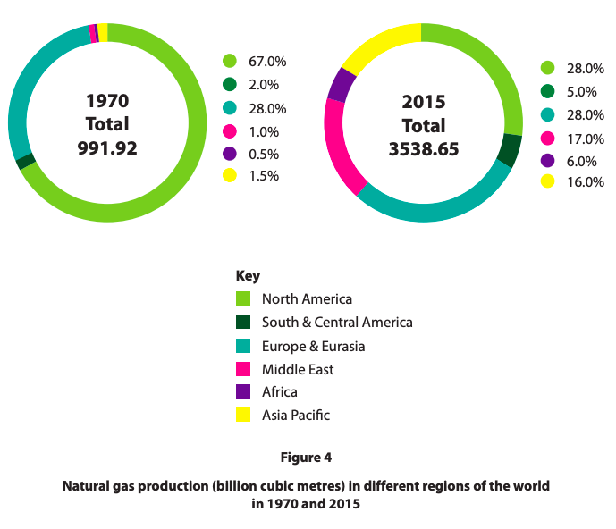
(i) Identify the increase in Africa's percentage of natural gas production from 1970 to 2015.
(1)
A 3.5%
B 5.5%
C 7.5%
D 9.5%
(ii) Identify the region with the smallest percentage change in natural gas production between 1970 and 2015.
(1)
.............................................................................................................................................
(iii) State two possible reasons for the change in the Middle East's natural gas production shown on Figure 4.
(2)
1 ..........................................................................................................................................
.............................................................................................................................................
2 ..........................................................................................................................................
.............................................................................................................................................

Q4.
State one reason why the global demand for energy is increasing.
(1)
.............................................................................................................................................
.............................................................................................................................................

Q5.
Study Figure 4 below.
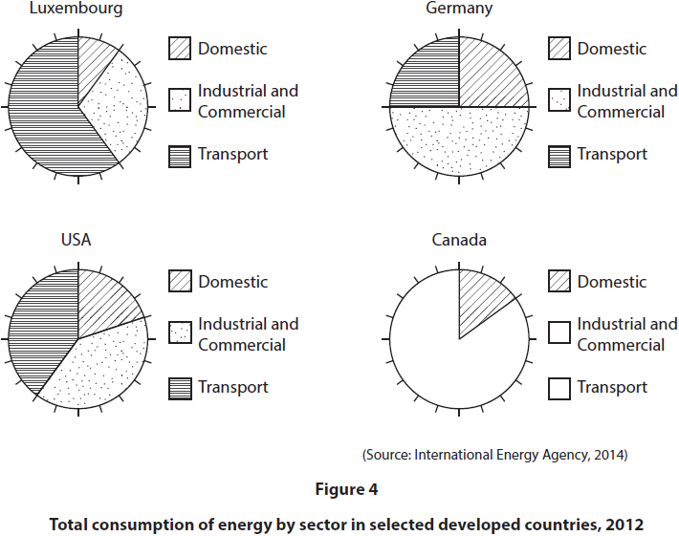
(i) Plot the data for Canada given in the table below by completing the pie chart on Figure 4.
(2)
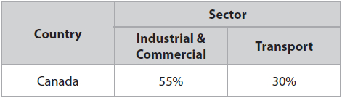
(ii) Identify which country's transport sector consumes the most energy.
(1)
A Germany
B USA
C Luxembourg
D Canada
(iii) State two reasons why the domestic sector's energy consumption varies in Figure 4.
(2)
1
.............................................................................................................................................
.............................................................................................................................................
2.............................................................................................................................................
.............................................................................................................................................
There are many different ways of developing energy resources.
Assess the reasons why the global demand and supply for energy resources has changed over the past 100 years.
You should use named examples and statistics in your answer
(8)
.............................................................................................................................................
.............................................................................................................................................
.............................................................................................................................................
.............................................................................................................................................
.............................................................................................................................................
.............................................................................................................................................
.............................................................................................................................................
.............................................................................................................................................
.............................................................................................................................................
.............................................................................................................................................
.............................................................................................................................................
.............................................................................................................................................
.............................................................................................................................................
.............................................................................................................................................
.............................................................................................................................................
.............................................................................................................................................
.............................................................................................................................................
.............................................................................................................................................
.............................................................................................................................................
.............................................................................................................................................
.............................................................................................................................................
.............................................................................................................................................
.............................................................................................................................................
.............................................................................................................................................
.............................................................................................................................................

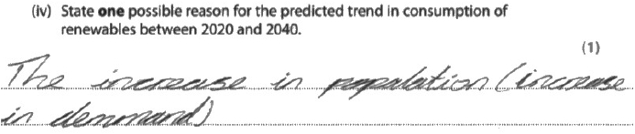
Results Plus: Examiner Comments
'population increase' = 1 mark.

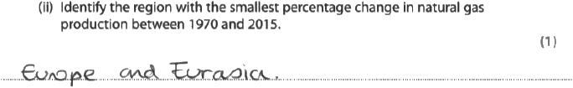
Results Plus: Examiner Comments
This response scores the 1 mark. The candidate has correctly identified Europe and Eurasia as the region with the smallest percentage change in natural gas production between 1970 and 2015.

Results Plus: Examiner Tip
When using a resource, always read the key and title carefully before you attempt the question.

(iii)
In this question, candidates were asked to state two possible reasons for the change in the Middle East's natural gas production, as shown in Figure 4, for 2 marks.
This item was generally well answered with most candidates achieving 1–2 marks. The most popular responses included new locations discovered, better technology to obtain natural gas (i.e. more advanced technology so it is becoming easier to extract), population increase/increased demand and other types running out with particular reference to oil.
Some candidates implied that other forms of energy had taken over from natural gas, therefore production had naturally declined. Others related the change to the government emphasis now being on the development of renewable energy resources, such as solar panels and wind turbines. Occasionally, candidates used statistical evidence to describe the changes in natural gas production in the Middle East from 1970 to 2015.
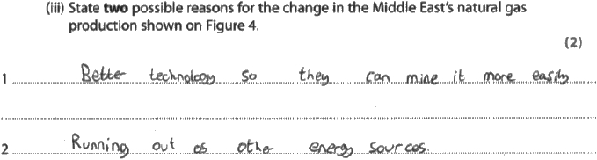
Results Plus: Examiner Comments
This response scores the full 2 marks. The candidate has correctly stated two possible reasons (AO3).

Q4.
The majority of candidates were able to state one reason (e.g. population is rising, people are getting wealthier) and thus scored one mark on this question.
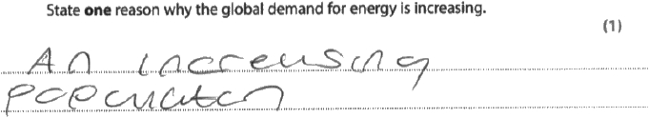
Results Plus: Examiner Comments
This response was awarded one mark.
Please note that on a 'state one...' question, no development is required.

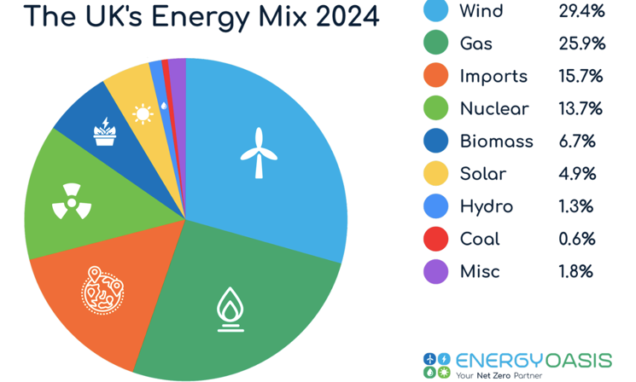
A case study of a developed country trying to manage energy sustainably: UK
The UK has been reliant on fossil fuels for many years. Global supplies of fossil fuels were once thought to be running out. However, as technology improves, new supplies can be discovered and accessed more easily. There are huge, barely tapped reserves in South America, Africa and the Arctic.
It is estimated that gas will last another 50 years and coal another 112 years. Around 40% of the UK's gas supply currently comes from domestic supplies (the North Sea) and many jobs in Scotland rely on this. However, UK supplies of fossil fuels could run out within just 5 years. The UK is currently looking at new technologies like fracking. There is pressure by TNCs to extract gas as it is a cheaper fuel – this helps them to maximise profits. Some politicians believe that extracting more fossil fuels has short term employment advantages, but other politicians believe that investing in renewables will have a longer term benefit to the economy, environment and health of the nation. Individuals mainly want to keep their energy bills down, but most people (individuals) in the UK believe that the threat posed by climate change is a reason to reduce fossil fuel usage.
The UK is using more nuclear power as part of its energy mix, importing uranium from Finland and Turkieye.

Renewable fuels make up less than 10% of the UK's energy mix. The government needs to increase this figure to 15% by 2030 to meet its European Union target (international agreement). The UK has a lot of potential for generating renewable energy:
- Over 50% of all renewable energy generated in the UK comes from wind farms such as the London Array Most of this is from onshore turbines, but the number of offshore turbines is increasing. This is due to the UK’s position within the Ferrel Cell where warm and cool air mixes, causing wind, and its maritime location (an island with a large prevailing wind from the Atlantic) allowing it to harness energy in this way.
- The amount of UK electricity generated through hydroelectric power (HEP) has remained the same since 2012. This will not increase unless new dams are built. Most dams are found in the North and North West of England.
- Less than 0.01% of UK energy is generated through tidal power. The UK is an island nation and could generate around 20% of its electricity using waves and tides but there are concerns about the disruption to marine life.
- Solar panels are becoming more common, particularly on peoples' homes. The UK government think that 4% of our electricity could come from solar power by 2030. This is a local scale, individual response to a large scale challenge. Intermittent sunlight hours limits this energy source’s potential.

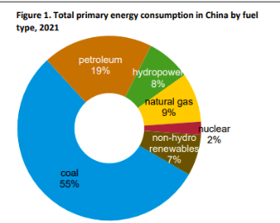
A case study of a developing or emerging country trying to manage energy sustainably: China
China's energy mix is heavily reliant on coal, but the country is also rapidly investing in renewable energy sources like solar and wind power to reduce its carbon footprint and dependence on fossil fuels, this is because it has signed up to international agreements to reduce its carbon emissions. China needs cheap and reliable energy to continue to produce 1 in 5 of the world’s products (TNCs who operate here have a strong view on trying to increase profits and reduce costs so like the idea of a cheap energy source). It has a growing population who need work – fossil fuel extraction provides low skilled jobs for these people. Finally, the population (individuals) of China do not vote in democratic elections so individuals with a clear view about the environmental threat of fossil fuel consumption cannot vote freely for officials who seek to change that. China remains heavily dependent on coal, which accounted for nearly 61% of its electricity generation in 2023, it has 35% of global supply. China is rapidly expanding its renewable energy capacity, particularly in solar and wind power. Renewable sources, including hydro, solar, and wind, contributed to a little more than 30% of China's electricity generation in 2023. China generated 37% of global wind and solar electricity in 2023. China is on track to double its wind and solar capacity by 2030. Nuclear power also plays a growing role in China's energy mix. China has 55 nuclear plants in operation, with more under construction and planned. About 5% of electricity in China comes from nuclear energy.
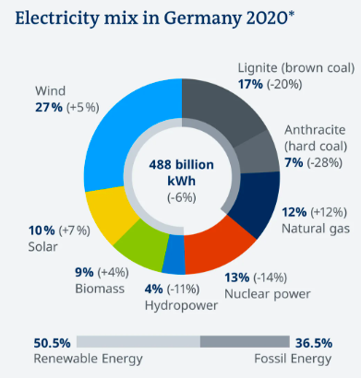
A case study of a developed country trying to manage energy sustainably: Germany
Germany has access to lots of coal and gas. The coal is has, brown, lignite coal, is the most polluting type of coal. Concerns about acid rain by individuals in the country limited the country’s exploitation of this resource. Germany went on an energy transition or ‘energywende’ to try to reduce its reliance on these fossil fuels after the Black Forest experienced tree decay caused by the acid rain which was caused by the air pollution from fossil fuel combustion. As part of this energy transition, Germany began focusing on the development of nuclear energy as a cleaner alternative to other finite resources like oil, coal and gas, it also developed an agreement with Russia to import gas from them. Due to global conflict, Germany no longer relies of Russia for gas, and due to a nuclear leak in Japan, fears about the ability to store nuclear waste products safely, meant that the German government decided to move away from using nuclear. Germany now focuses on two renewable energy sources primarily for its energy supply they are solar and wind. Germany’s unique position within the Ferrel cell makes it windy, resulting in this energy being able to be harnessed.
Assess the views held by organisations and governments on the management of energy resources.
(8)
.............................................................................................................................................
.............................................................................................................................................
.............................................................................................................................................
.............................................................................................................................................
.............................................................................................................................................
.............................................................................................................................................
.............................................................................................................................................
.............................................................................................................................................
.............................................................................................................................................
.............................................................................................................................................
.............................................................................................................................................
.............................................................................................................................................
.............................................................................................................................................
.............................................................................................................................................
.............................................................................................................................................
.............................................................................................................................................
.............................................................................................................................................
.............................................................................................................................................
.............................................................................................................................................
.............................................................................................................................................
.............................................................................................................................................
.............................................................................................................................................
.............................................................................................................................................
.............................................................................................................................................
.............................................................................................................................................
Assess the following statement.
(8)
............................................................................................................................................
.............................................................................................................................................
.............................................................................................................................................
.............................................................................................................................................
.............................................................................................................................................
.............................................................................................................................................
.............................................................................................................................................
.............................................................................................................................................
.............................................................................................................................................
.............................................................................................................................................
.............................................................................................................................................
.............................................................................................................................................
.............................................................................................................................................
.............................................................................................................................................
.............................................................................................................................................
.............................................................................................................................................
.............................................................................................................................................
............................................................................................................................................
.............................................................................................................................................
.............................................................................................................................................
.............................................................................................................................................
.............................................................................................................................................
.............................................................................................................................................
.............................................................................................................................................
.............................................................................................................................................
.............................................................................................................................................
.............................................................................................................................................
.............................................................................................................................................
.............................................................................................................................................
.............................................................................................................................................
.............................................................................................................................................
.............................................................................................................................................
.............................................................................................................................................
.............................................................................................................................................

The increasing demand for energy is being met by different types of energy resource.
Assess the reasons why the UK and other countries use a mix of different energy resources.
(8)
.............................................................................................................................................
.............................................................................................................................................
.............................................................................................................................................
.............................................................................................................................................
.............................................................................................................................................
.............................................................................................................................................
.............................................................................................................................................
.............................................................................................................................................
.............................................................................................................................................
.............................................................................................................................................
.............................................................................................................................................
.............................................................................................................................................
.............................................................................................................................................
.............................................................................................................................................
.............................................................................................................................................
.............................................................................................................................................
.............................................................................................................................................
.............................................................................................................................................
.............................................................................................................................................
.............................................................................................................................................
.............................................................................................................................................
.............................................................................................................................................
.............................................................................................................................................
.............................................................................................................................................
.............................................................................................................................................
.............................................................................................................................................
.............................................................................................................................................
The carbon footprint measures the amount of greenhouse gases that are generated by human activities.
Assess the reasons why individuals and organisations may have different views about the sustainable use of energy resources.
(8)
............................................................................................................................................
.............................................................................................................................................
.............................................................................................................................................
.............................................................................................................................................
.............................................................................................................................................
.............................................................................................................................................
.............................................................................................................................................
.............................................................................................................................................
.............................................................................................................................................
.............................................................................................................................................
.............................................................................................................................................
.............................................................................................................................................
.............................................................................................................................................
.............................................................................................................................................
.............................................................................................................................................
.............................................................................................................................................
.............................................................................................................................................
............................................................................................................................................
.............................................................................................................................................
.............................................................................................................................................
.............................................................................................................................................
.............................................................................................................................................
.............................................................................................................................................
.............................................................................................................................................
.............................................................................................................................................
.............................................................................................................................................
.............................................................................................................................................
.............................................................................................................................................
.............................................................................................................................................
.............................................................................................................................................
.............................................................................................................................................
.............................................................................................................................................
.............................................................................................................................................
.............................................................................................................................................

Define the term energy mix.
(1)
.............................................................................................................................................
.............................................................................................................................................

Evaluate different approaches used by either a named developing or emerging country to manage and use energy resources in a sustainable way.
(8)
.............................................................................................................................................
.............................................................................................................................................
.............................................................................................................................................
.............................................................................................................................................
.............................................................................................................................................
.............................................................................................................................................
.............................................................................................................................................
.............................................................................................................................................
.............................................................................................................................................
.............................................................................................................................................
.............................................................................................................................................
.............................................................................................................................................
.............................................................................................................................................
.............................................................................................................................................
.............................................................................................................................................
.............................................................................................................................................
.............................................................................................................................................
.............................................................................................................................................

Countries use energy resources in different proportions to meet demand.
Evaluate how two countries at different levels of development have managed their energy resources.
(8)
Named country 1 ...........................................................
Named country 2 ...........................................................
.............................................................................................................................................
.............................................................................................................................................
.............................................................................................................................................
.............................................................................................................................................
.............................................................................................................................................
.............................................................................................................................................
.............................................................................................................................................
.............................................................................................................................................
.............................................................................................................................................
.............................................................................................................................................
.............................................................................................................................................
.............................................................................................................................................
.............................................................................................................................................
.............................................................................................................................................
.............................................................................................................................................
.............................................................................................................................................
.............................................................................................................................................
.............................................................................................................................................
.............................................................................................................................................
.............................................................................................................................................
.............................................................................................................................................
.............................................................................................................................................
.............................................................................................................................................
.............................................................................................................................................
.............................................................................................................................................
.............................................................................................................................................
.............................................................................................................................................
.............................................................................................................................................

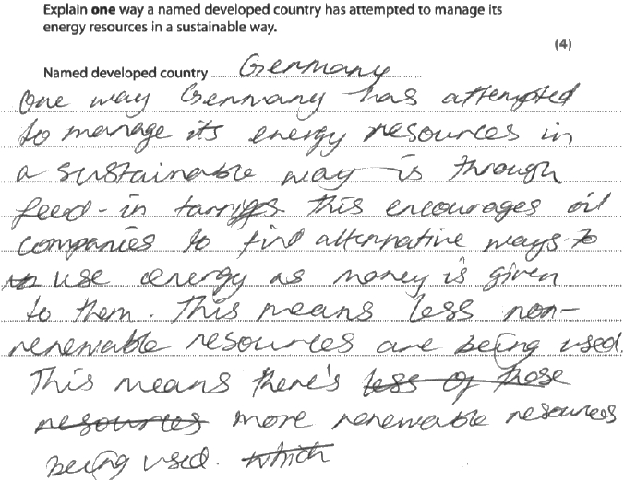
Results Plus: Examiner Comments
This response scores the full 4 marks. The candidate has successfully double-developed one idea and has included some clear exemplification to support the answer.

Results Plus: Examiner Tip
Do not be tempted to list a range of ideas if the question requires you to 'explain one'.
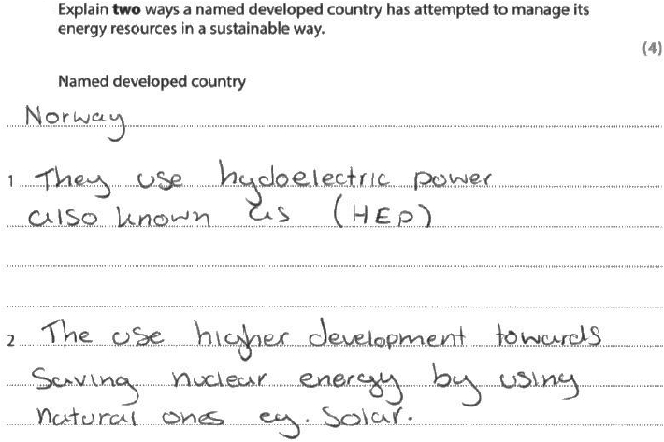
Results Plus: Examiner Comments
Despite naming a developed country, this candidate has not offered any place-specific detail = a maximum of 2 marks for two legitimate strategies used to manage energy resources.

Now you try to do a better answer:
Explain two ways a named developed country has attempted to manage its energy resources in a sustainable way.
(4)
Named developed country
.............................................................................................................................................
1 ..........................................................................................................................................
.............................................................................................................................................
.............................................................................................................................................
.............................................................................................................................................
2 ..........................................................................................................................................
.............................................................................................................................................
.............................................................................................................................................
.............................................................................................................................................
Study Figure 4a and Figure 4b in the Resource Booklet.
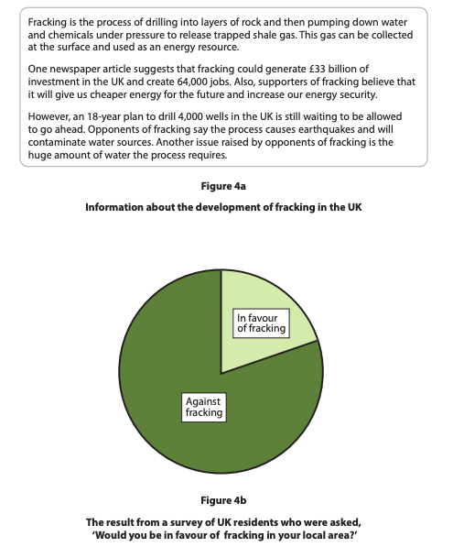
(i) State one advantage of fracking.
Only use evidence from Figure 4a in your answer.
(1)
.............................................................................................................................................
.............................................................................................................................................
(ii) Identify the percentage (%) of UK residents in Figure 4b who are in favour of fracking in their local area.
A 20%
B 40%
C 60%
D 80%
(iii) Suggest one reason for the viewpoint held by the majority of the residents who took part in the survey.
Only use evidence from Figures 4a and 4b in your answer.
(4)
.............................................................................................................................................
.............................................................................................................................................
.............................................................................................................................................
.............................................................................................................................................
.............................................................................................................................................
.............................................................................................................................................
.............................................................................................................................................
.............................................................................................................................................
.............................................................................................................................................
.............................................................................................................................................
.............................................................................................................................................
.............................................................................................................................................

There are many different ways of developing energy resources.
State one reason why energy resources require sustainable management.
(1)
.............................................................................................................................................
.............................................................................................................................................

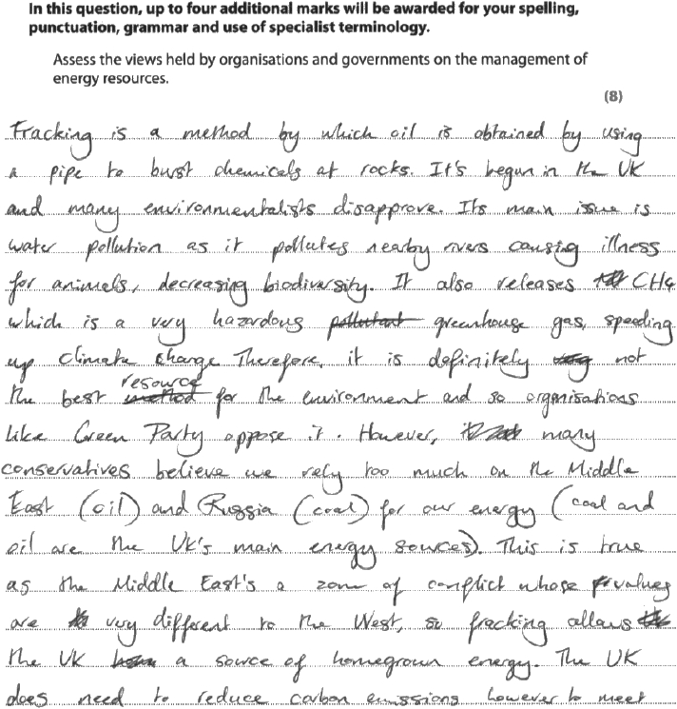
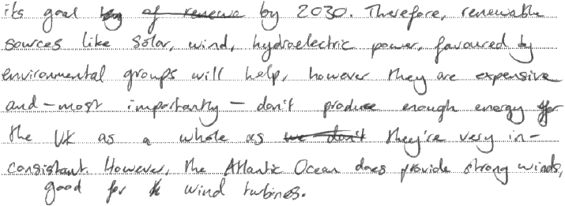
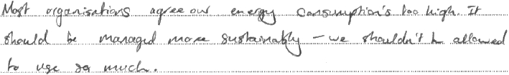
Results Plus: Examiner Comments
This response was awarded 6 marks
The candidate has attempted to assess the views of governments and organisations and makes some valid explained points about different views and actions.
The response does stray from the question at times, but overall a good attempt has been made to explain the views of different stakeholders although 'assessment' of these views is very weak, and needs to be more coherent for level 3.

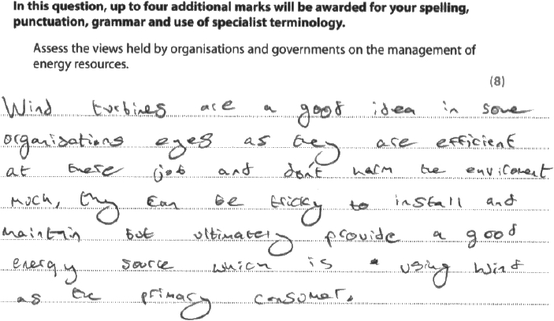
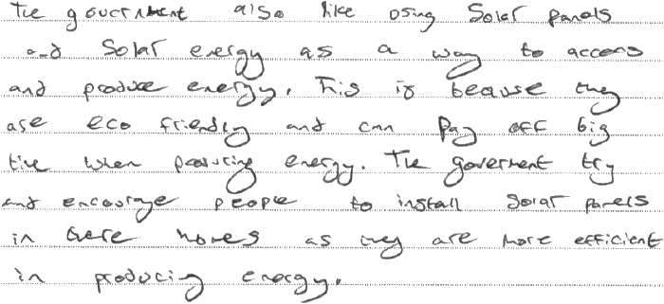
Results Plus: Examiner Comments
This response was awarded 2 marks
The candidate includes some basic points about energy resources and why governments may choose to develop them (AO2); however, there is a lack of AO3 (explanation and assessment) which limits this response to mid level 1.

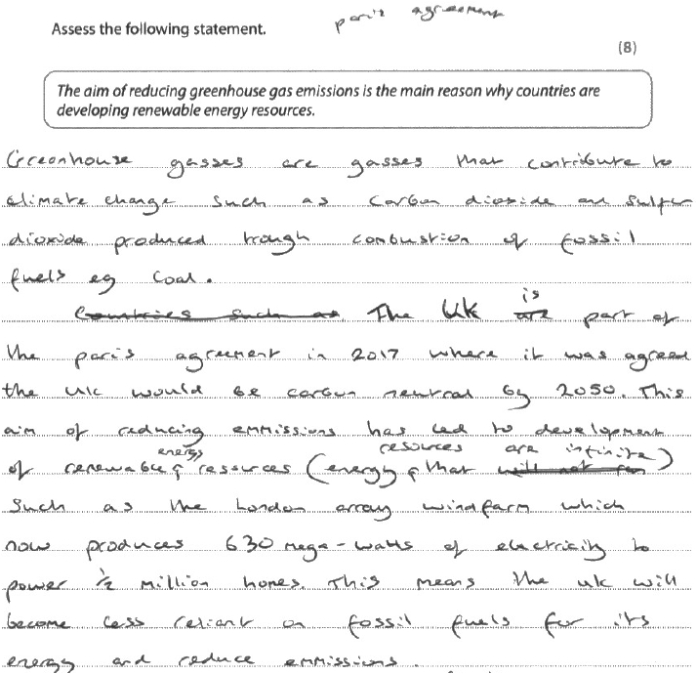
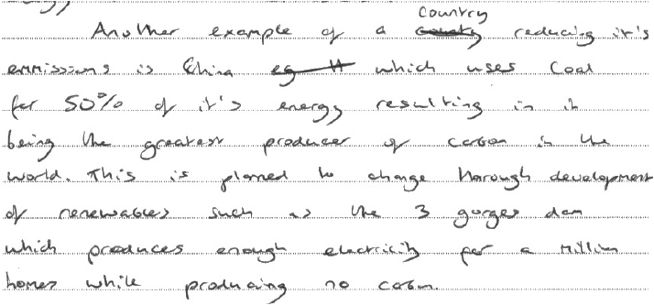
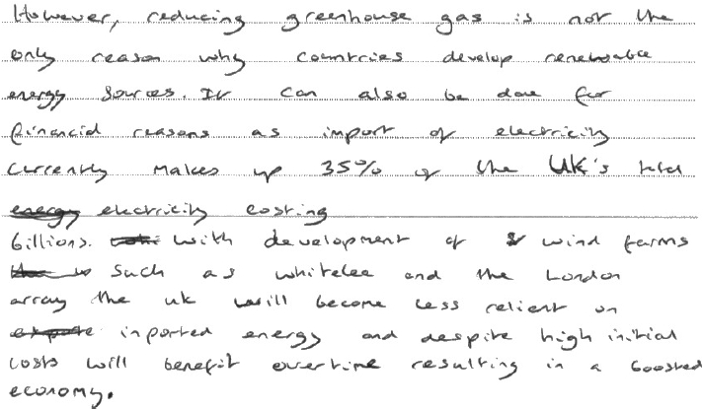
Results Plus: Examiner Comments

The candidate was awarded 4 marks (just into Level 2) as a result of some partial explanation about why renewable energy resources are being developed – but generally the response focussed on the aim of reducing greenhouse gases as the reason for this. A broader range of ideas about why countries are developing renewable resources would have lifted this response to the top of Level 2.

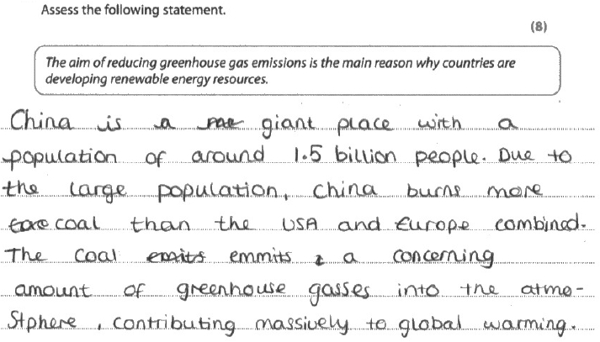
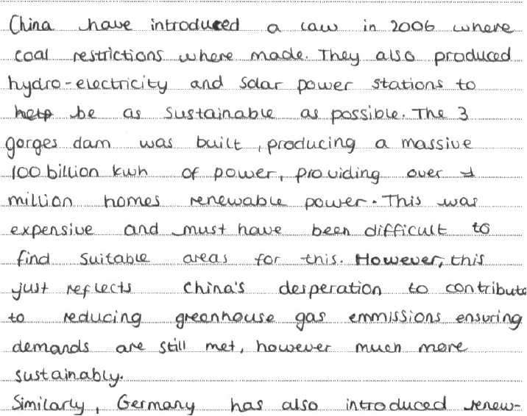
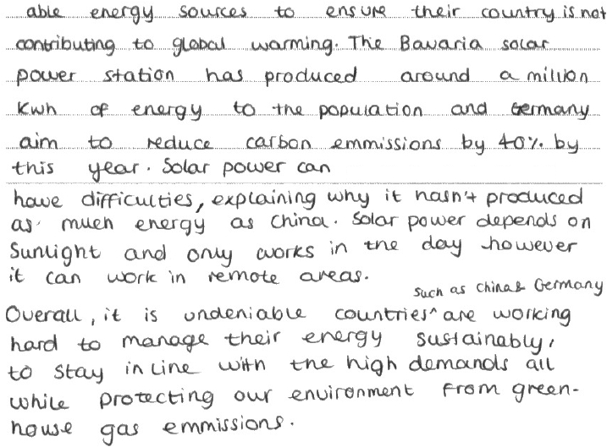
Results Plus: Examiner Comments
The candidate was awarded 6 marks (top of Level 2) for this response as they had gone beyond just considering a reduction in greenhouse gases to explain why some countries are developing renewable energy. The inclusion of place-specific detail is helpful and strengthens the response – but for Level 3, one expects a broader range of ideas to counter the statement (as the argument presented by this candidate is imbalanced / one-sided in favour of the view presented by the statement in the question).

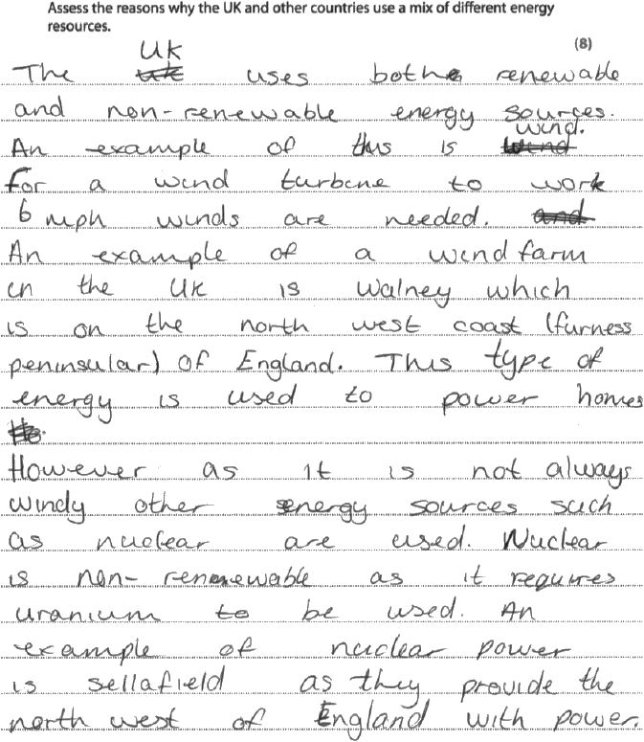
Results Plus: Examiner Comments
This response is awarded Level 1 and scores 3 marks. The candidate has provided some information about energy resources used in the UK, but has not really got to grips with the thrust of the question about reasons for 'energy mix', which is expected for Level 2.

Results Plus: Examiner Tip
Be able to define all key terms cited in the specification. Many candidates struggled with this question as it was clear they did not fully understand the concept of 'energy mix'.

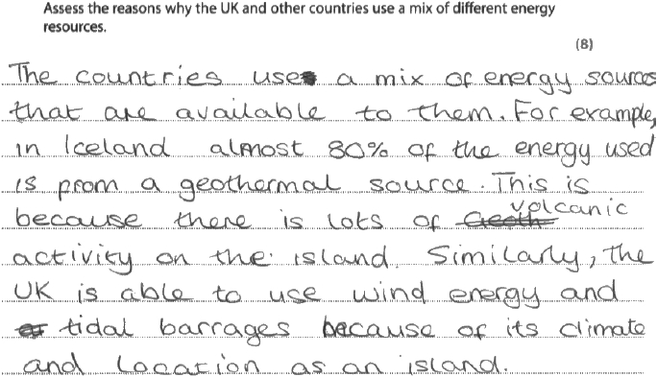
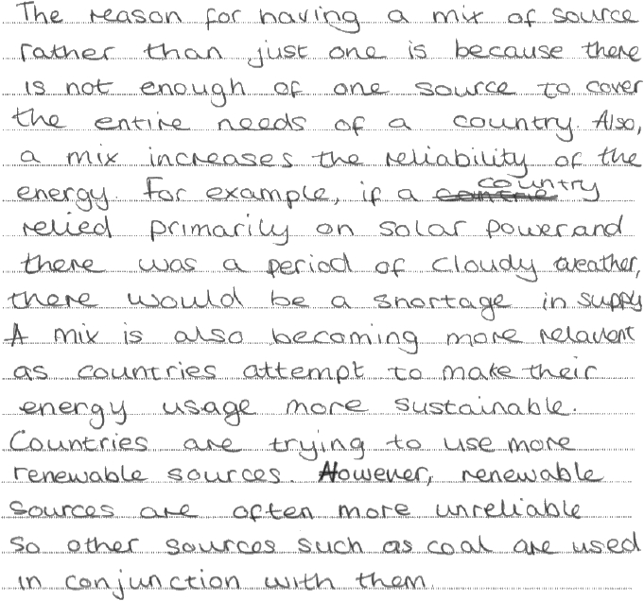
Results Plus: Examiner Comments
This response is awarded Level 2 and scores 6 marks. The candidate has provided some information about energy resources used in Iceland for AO2, accompanied by some explanation and analysis for AO3. For Level 3, a greater range of evidence, including some details about UK energy mix, would be required.

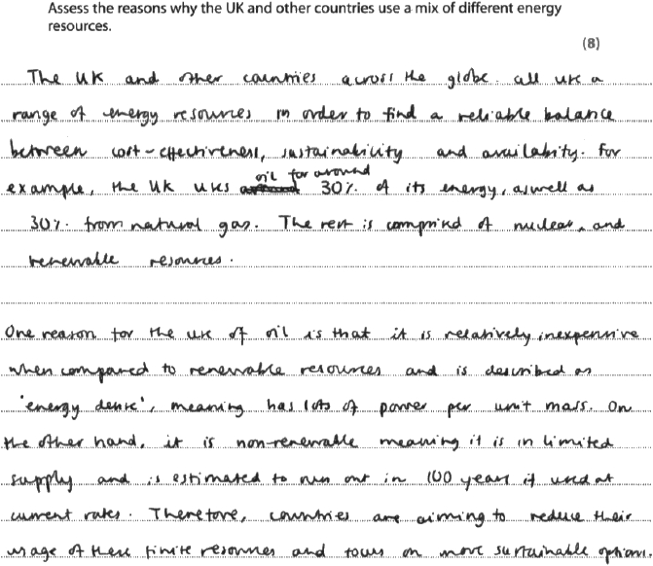
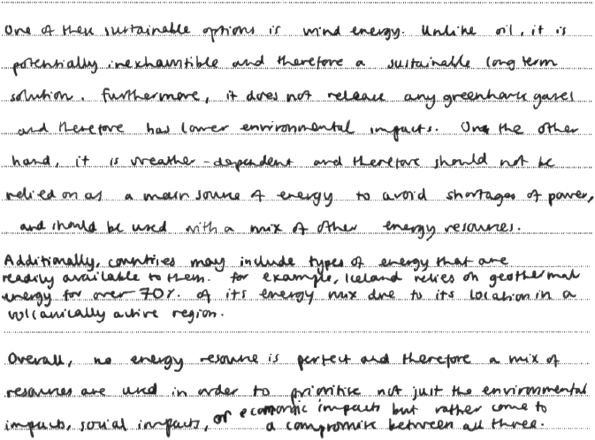
Results Plus: Examiner Comments
This response is awarded Level 3 and scores the full 8 marks and a further. This candidate has provided a good range of information about energy resources used in the UK and other countries for AO2, with a balance of AO3 throughout. Crucially, the candidate has addressed the command word, 'assess' by considering which reasons are most important for the energy mix used by a country.

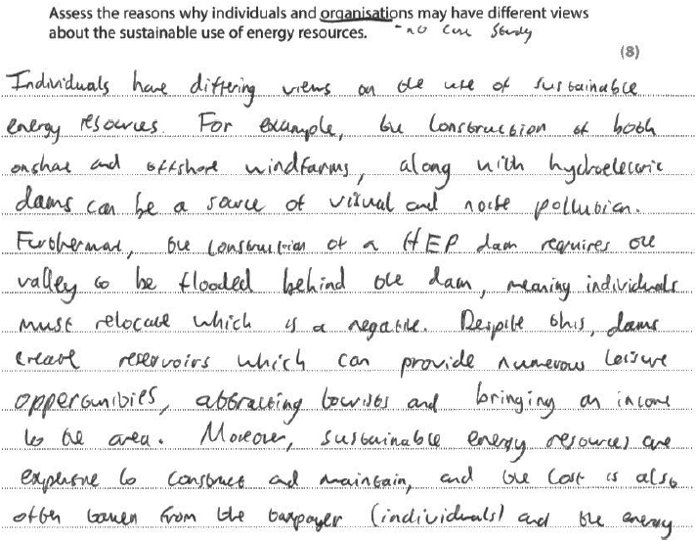
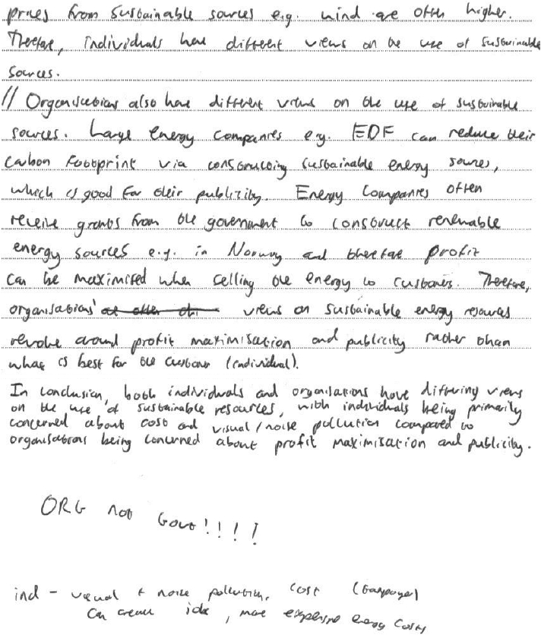
Results Plus: Examiner Comments
This response was awarded full marks (8). The candidate has included a range of contrasting viewpoints from organisations and individuals, offering some good explanation.

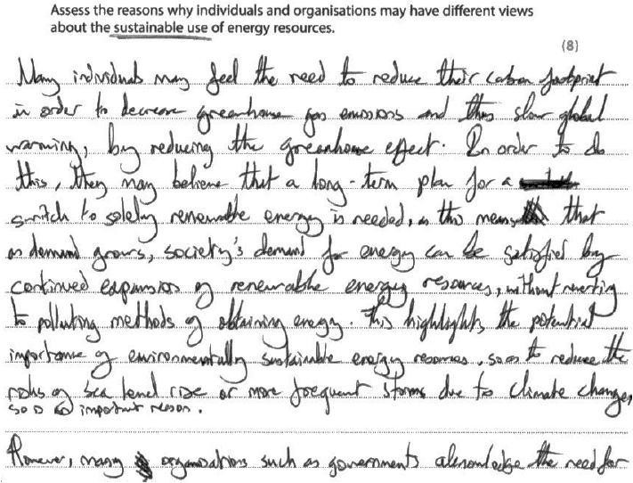
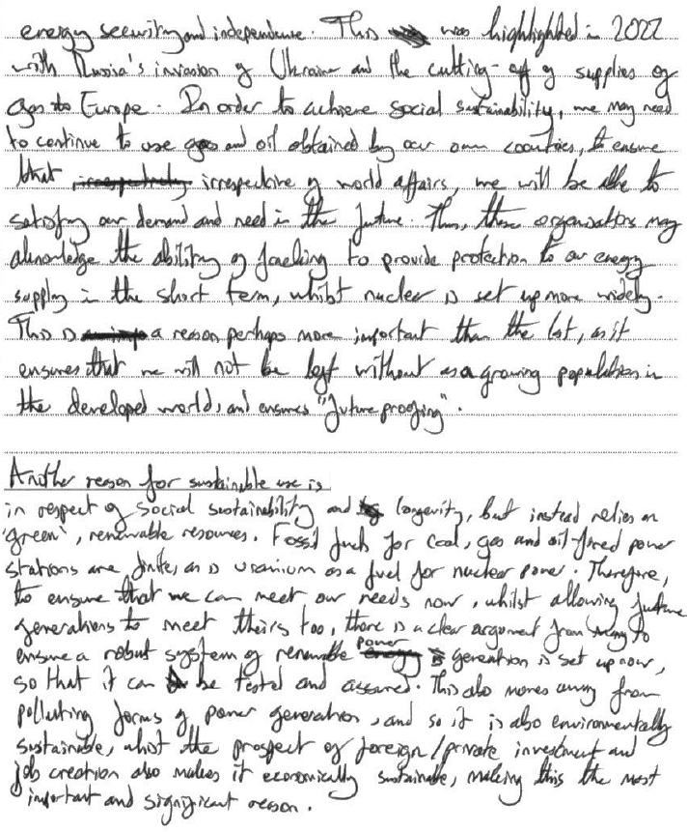
Results Plus: Examiner Comments
This response was awarded 7 marks (i.e. just into Level 3). The candidate has demonstrated an accurate understanding that individuals and organisations have contrasting viewpoints and they have offered some good explanation about why these different stakeholders hold their view. For top of Level 3, some further detail about why some viewpoints might been relatively more or less important/significant would be required.

