Therapy Pack
Edexcel A GCSE Geography
Paper 1



Ecosystems, Biodiversity and Management

Large-scale ecosystems are found in different parts of the world and are important.
Large-scale ecosystems (biomes) are found in different parts of the world.
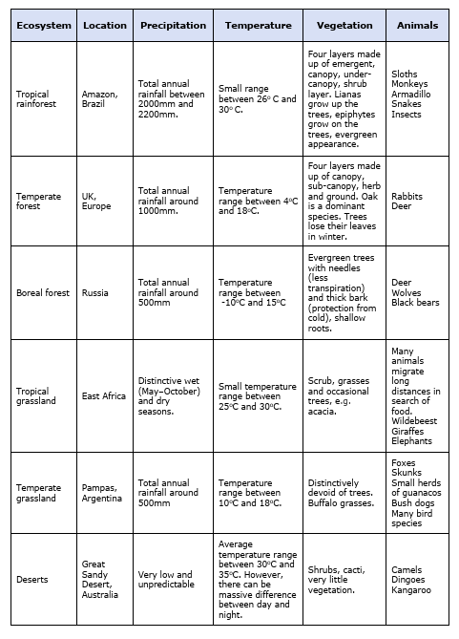

Tundra biome – Within the Arctic circle, the Sun gives off little energy and there is little precipitation. For example, northern Canada.  (highest latitude) | Boreal biome – Mostly pine forests at higher latitudes where the Sun’s rays are weaker. For example, Canada  (high latitude 50-65'N/S) | Temperate forests – Deciduous forests with seasonal variations, losing their leaves in the winter. For example, the UK  40-50'N/S | Temperate grasslands – Hot in summer and very cold in winter, with rainfall in late spring and summer. For example, mid-USA.  25-55'N/S
Desert biome – Close to the tropics, the Sun’s energy is concentrated, making it hot during the day. For example, the Sahara in North Africa.  20-30'N/S | Tropical grassland – mostly in the tropics – hot all year but always with a dry season. For example, Kenya.  5-20'N/S | Tropical rainforest – Found within the tropics where it is hot and wet. For example, the Brazilian rainforest  Equator (0’)

Climate.
Temperature – Growing seasons are much longer in warmer locations; the further you move away from the Equator the shorter they become.
Precipitation – The global circulation system influences precipitation. For example, low pressure found between the Hadley cells where warm air rises causing rain.
Sunshine hours – Lower amounts of sunshine towards the Poles at certain times of the year means less sunlight for photosynthesis.
Local factors: PADORS
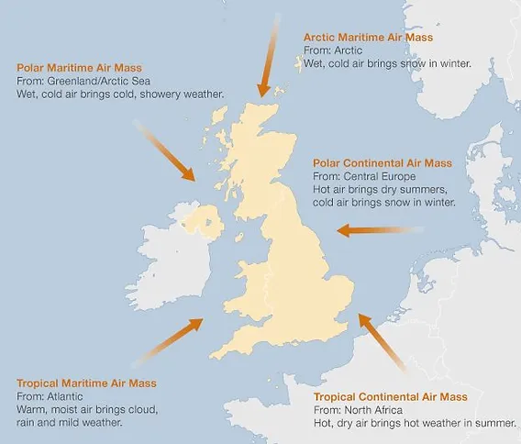
Prevailing wind - Winds blowing across oceans will bring moisture and rainfall, whereas winds blowing across warmer continents bring warm dry air.
Altitude – The higher the altitude, the lower the temperature. This means that different plants can grow within the same ecosystem.
Distance from the sea - Land heats and cools faster than the sea. Therefore, coastal areas have a lower temperature range than areas inland. On the coast, winters are relatively mild and summers are cool. Inland, temperatures are higher in the summer and colder in the winter.
Ocean currents - Warm ocean currents, especially in the North Atlantic, moderate the land temperatures of cold areas.
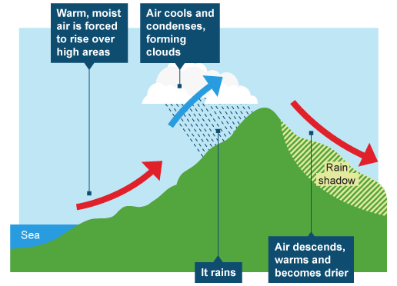
Relief - Hills and mountains play a decisive part in local weather patterns, especially where moist air is forced to rise and cool, forming precipitation.
Rock and soil type – Different vegetation can grow in the same ecosystem owing to different types of rock and soil.

Questions
Biodiversity is influenced by the interrelationship and interaction of biotic and abiotic factors.
Study Figure A below.
(i) Complete the line graph in Figure A using data from the table below.
(3)
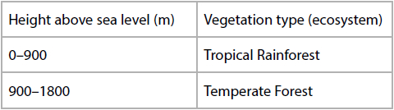
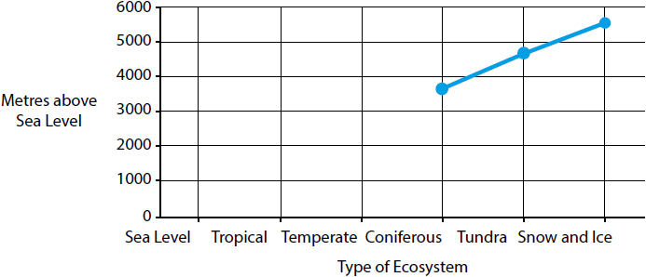
Figure A
Changes in large ecosystems up a mountain in South America
(ii) With reference to the line graph in Figure A, explain how changes in altitude affect the distribution of ecosystems.
Point, trend and evidence from the figure, explain, using the word ‘so’
(4)
.............................................................................................................................................
.............................................................................................................................................
.............................................................................................................................................
.............................................................................................................................................
.............................................................................................................................................
.............................................................................................................................................
.............................................................................................................................................
.............................................................................................................................................
.............................................................................................................................................
.............................................................................................................................................
Large-scale ecosystems are found in different parts of the world.
Explain one way climate can influence the distribution of large-scale ecosystems.
Explain = point so, so
(3)
.............................................................................................................................................
.............................................................................................................................................
.............................................................................................................................................
.............................................................................................................................................
.............................................................................................................................................
.............................................................................................................................................

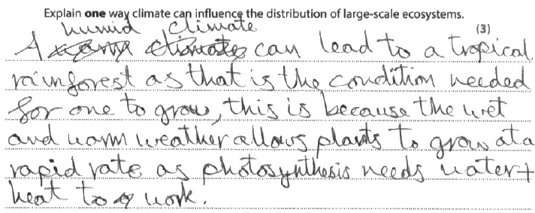
Results Plus: Examiner Comments
This response was awarded two marks.
The candidate has identified that tropical rainforests are found in areas with warm/wet climates (1) which leads to rapid rates of photosynthesis (1). However, the third mark was not awarded as they have not made the link to where the tropical rainforests are distributed (along the equator).

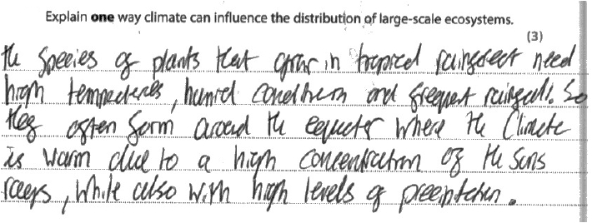
Results Plus: Examiner Comments
This response was awarded three marks.
The candidate has identified that tropical rainforest is distributed along the equator (1) and has then linked this to the climate being warm (1) due to the high concentration of the sun's rays (1).

Large-scale ecosystems are found in different parts of the world.
Explain one way that altitude may affect the distribution of the temperate forest ecosystem.
(2)
.............................................................................................................................................
.............................................................................................................................................
.............................................................................................................................................
.............................................................................................................................................
Large-scale ecosystems (global biomes) are found in different parts of the world.
(i) Study Figure 7b in the Resource Booklet.
Identify the continent with the smallest area of desert.
(1)
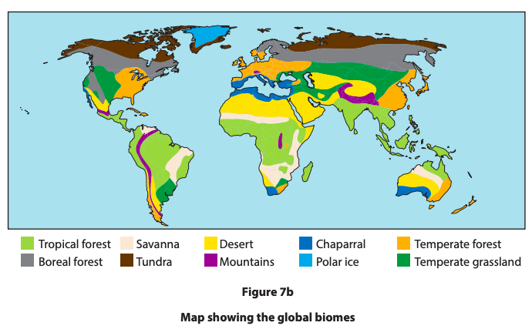
A Asia
B Europe
C North America
D Africa

(ii) Explain one way climate influences the distribution of deserts
This answer got 3/3 – how?
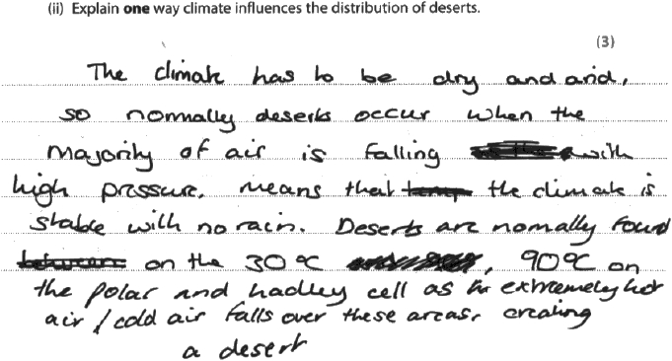

Q6.
Large-scale ecosystems (biomes), such as deserts, are found in different parts of the world.
Study Figure 7a in the Resource Booklet.

(i) Identify the correct statement.
(1)
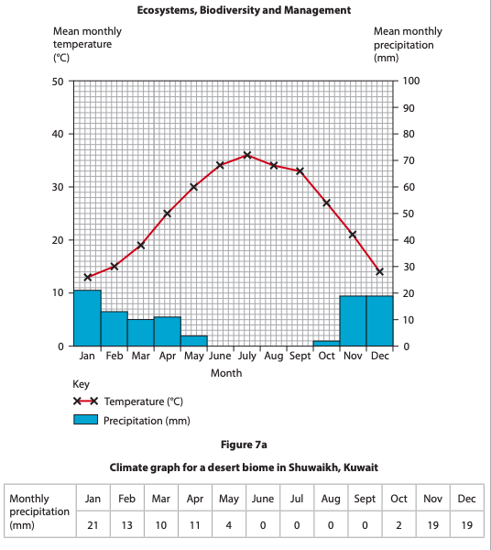
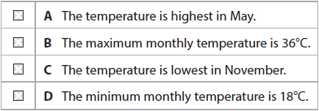

(ii) Calculate the mean monthly precipitation shown in Figure 7a.
You must show your working in the space below.
Answer to two decimal places.
(2)
........................................................... mm
Large-scale ecosystems are found in different parts of the world.
Study Figure 7a below.
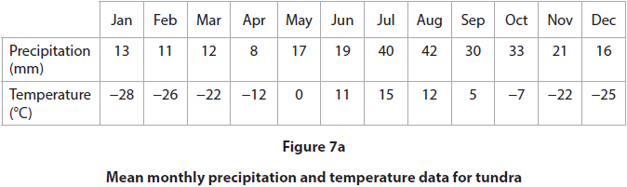
(i) Identify which one of the following months has the highest precipitation.
(1)
A February
B April
C July
D August
(ii) Calculate the median temperature shown in Figure 7a.
Answer to one decimal place.
You must show your working in the space below.
(2)
........................................................... °C

(Total for question = 3 marks)

Q8.
Large-scale ecosystems, such as tundra, are found in different parts of the world.
(i) State two characteristics of a tundra ecosystem.
(2)
1
.............................................................................................................................................
2
.............................................................................................................................................
(ii) Identify two countries where a tundra ecosystem is located.
(2)
A Australia
B Canada
C Libya
D Spain
E Norway

Q9.
Large-scale ecosystems are found in different parts of the world.
Identify which one of the following describes the climate in the tundra ecosystem.
(1)
A Low precipitation and high temperatures
B High precipitation and low temperatures
C Low precipitation and low temperatures
D High precipitation and high temperatures

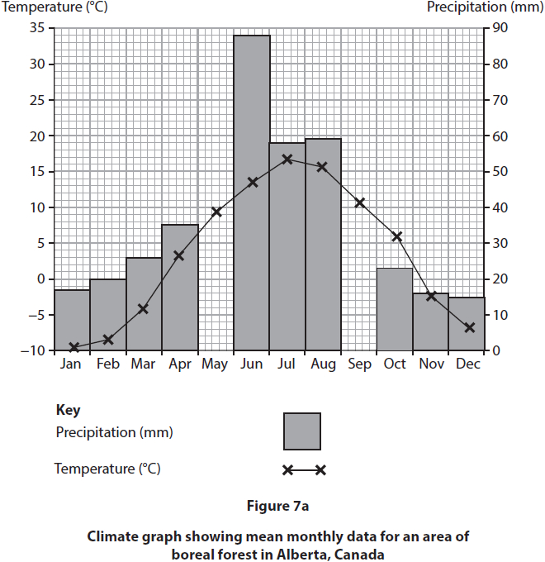
(i) Plot the precipitation data for May and September to complete Figure 7a.
(2)
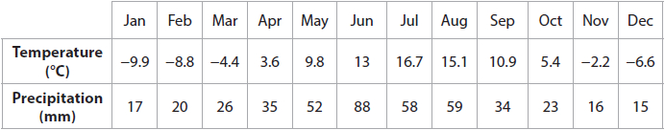
(ii) Calculate the median precipitation using the data table above.
You must show your working in the space below.
(2)


Remember to show your workings!

Results Plus: Examiner Comments
This response was awarded 1 mark.
They were awarded a mark for their workings but have not written the '-' sign next to their answer and so were not awarded this mark.
........................................................... mm

