Therapy Pack

Changing UK landscapes



Optional sub topic 1A: Coastal landscapes and processes

There are geological variations within the UK.
Geology means – rocks
Characteristics and distribution of the UK’s main rock types: sedimentary (chalk, sandstone) igneous (basalt, granite), metamorphic (schists, slates).
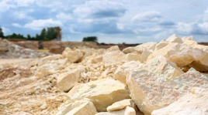
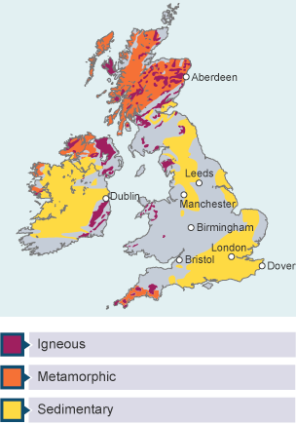
Sedimentary rocks are formed in layers called beds.
Examples include chalk (such as the South Downs) and limestone.
They contain fossils and are formed at the bottom of river or sea beds.
They are vulnerable to erosion so create low land areas like valleys and plains
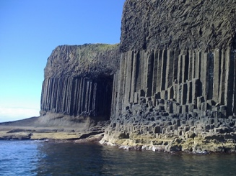
Igneous rocks are hard and formed of crystals, so they are resistant to erosion meaning that they form upland landscapes (mountains, hills)
If cooled intrusively, rocks will form large crystals as they have had longer to cool. If cooled extrusively (above ground) they will have smaller crystals in them.
Examples include granite and basalt (Northern Ireland, Giant’s Causeway).
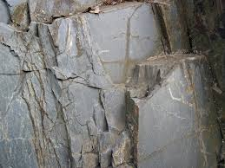
Metamorphic rocks are formed by heat and pressure.
Examples are schist and slate (such as the Lake District- an upland area).
Metamorphic rocks are hard to erode.

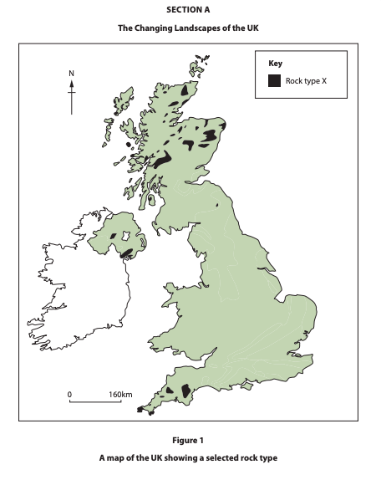
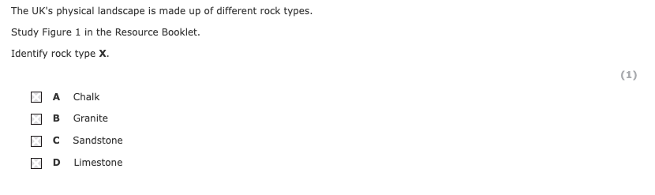

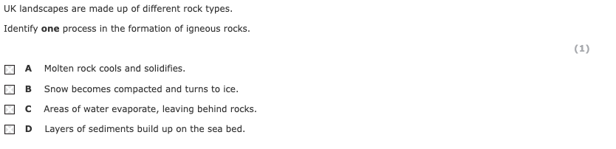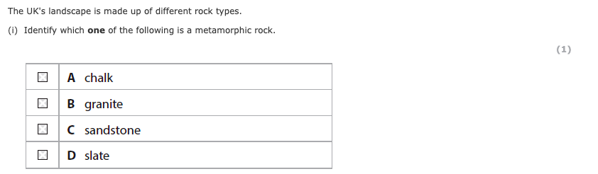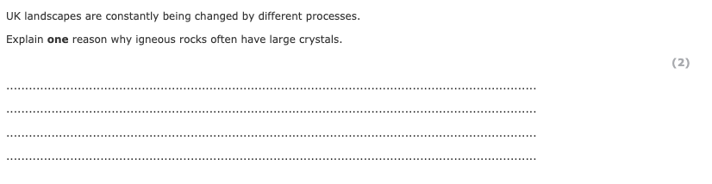
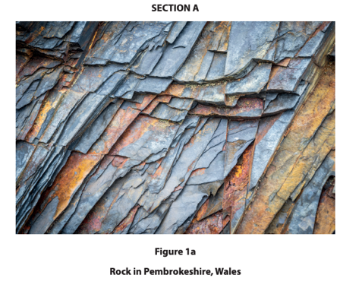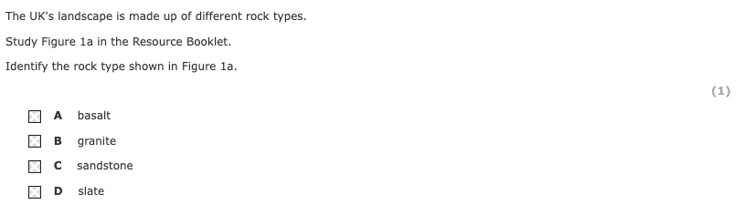
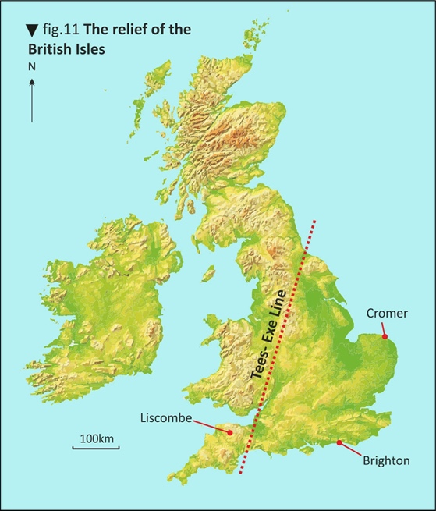
The role of geology and past tectonic processes in the development of upland (igneous and metamorphic rocks) and lowland (sedimentary rocks) landscapes.
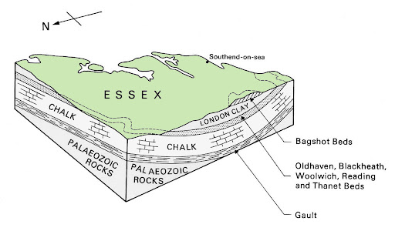
Geology – The UK is split into two halves geologically. The northwest of the UK is mainly harder igneous and metamorphic rocks, forming upland landscapes. The south-east of the UK is mainly softer sedimentary rocks, forming lowland landscapes. This geological cross section shows how the rock under Essex causes a flat landscape.
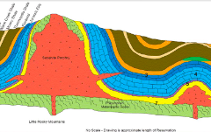
Plate tectonics – Millions of years ago, the UK was close to plate margins. Plate movements caused mountains (folds) and faults in the rocks. You can see how the faults and folds in this geological cross section (right) has caused molten rock/ magma to rise to the surface creating an igneous, upland area.
Geological cross sections to show relationship between rock type and relief
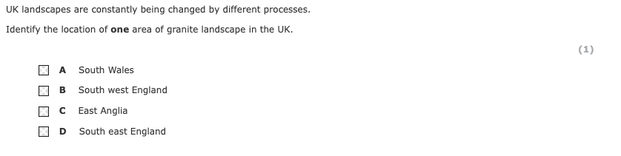
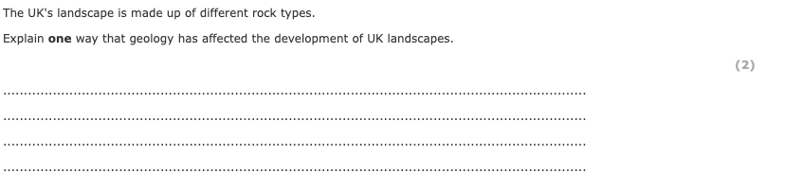
Distinctive upland and lowland landscapes result from the interaction of physical processes (glacial erosion and deposition, weathering and climatological, post-glacial river and slope processes).
Distinctive upland and lowland UK landscapes result from physical processes.
Weathering – Freeze-thaw action breaks off rock, which forms scree slopes.  Freeze = causes water in rocks to expand  Thaw (melt) = causes water to sink deeper into rocks  This process repeats, fracturing the rock creating scree slopes and small streams that run over impermeable rock | 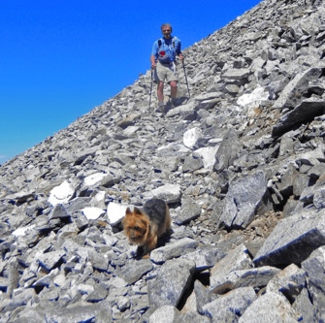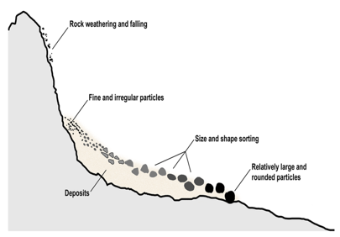
Glacial erosion and deposition – Glaciers carve out corries and U-shaped valleys. | 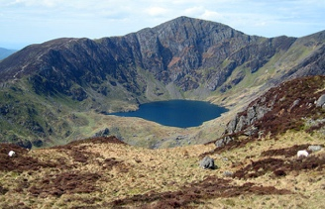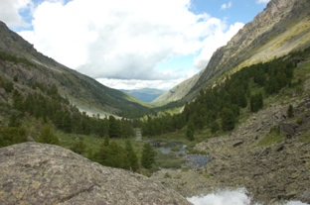
Climate – High levels of rain form streams over the impermeable rock surfaces. | 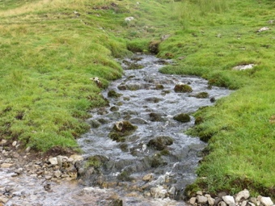
River erosion – Meandering rivers erode wide valleys. | 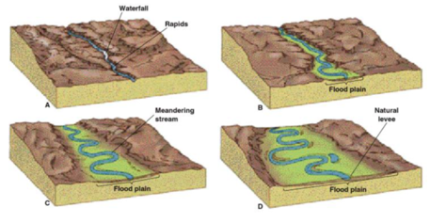
River deposition – Floods spread out over valley floors, depositing silt and forming floodplains.
Slope processes – Mass movement (landslides) and soil creep (gradual movement downhill) cause cliffs to collapse.
. 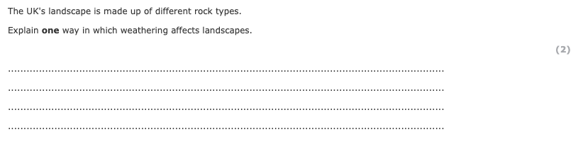

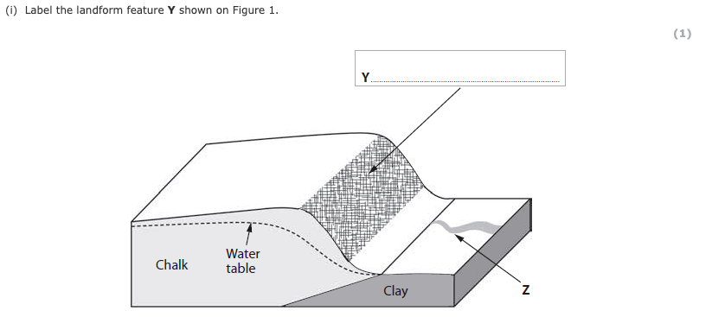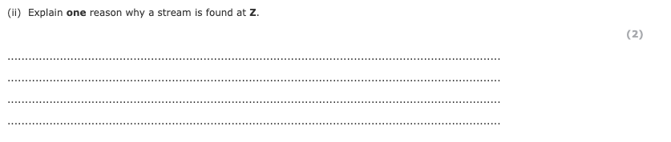

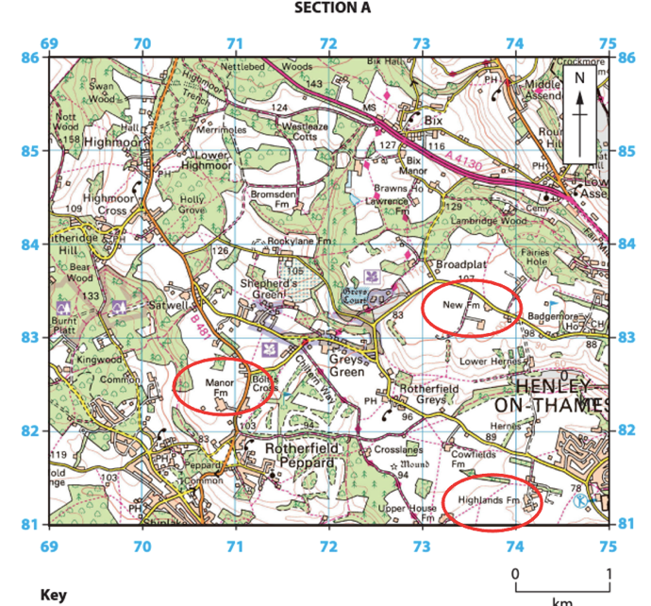
How distinctive landscapes result from human activity (agriculture, forestry, settlement) over time. These can be seen on OS maps of different scales. 1:25000 and 1:50000
Humans have changed almost all the landscapes of the UK through farming, such as hill sheep farming in upland areas and arable farming in fertile lowlands.
Forestry is managing woodland for timber.
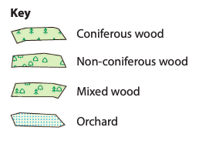
The UK would naturally be covered by deciduous woodland. Many UK upland landscapes have been planted with coniferous trees for forestry. Natural wooded areas have been deforested and polluted by decades of pesticides or overgrazed by an increasing number of non-native species or over-bread species such as deer resulting in them turning into heathland landscapes.
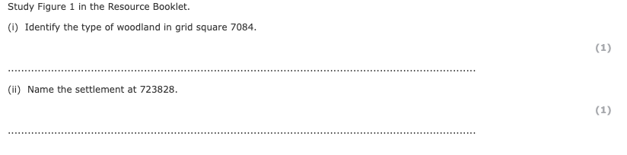
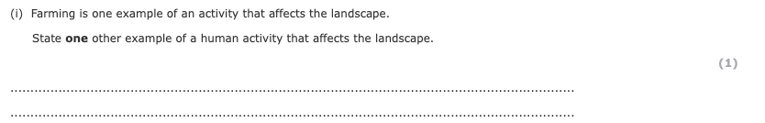
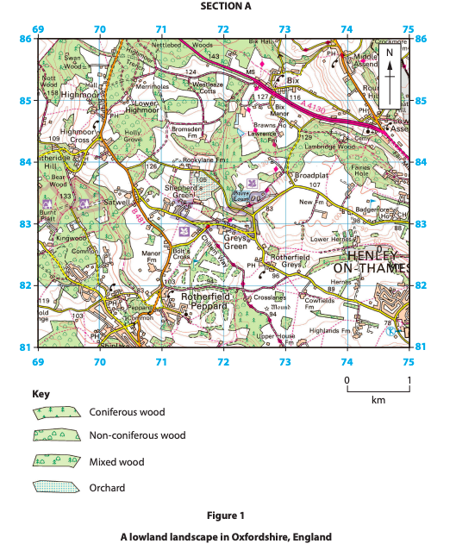
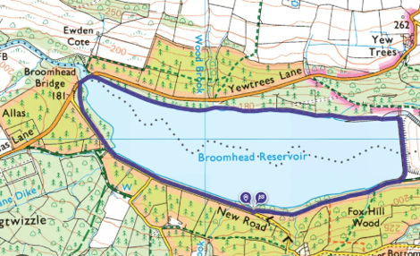
Settlements have influenced landscapes through deforestation to make way for buildings and roads. Wetland areas are sometimes drained, whilst valleys can be flooded to create reservoirs.

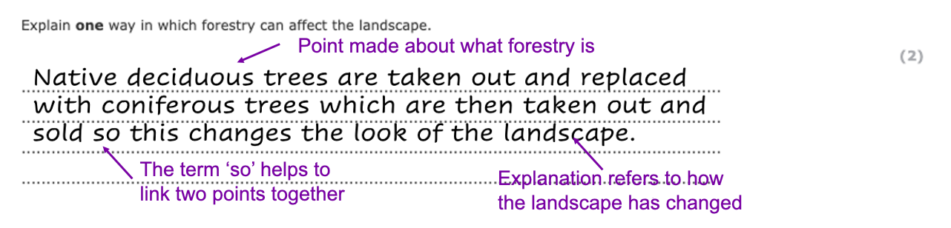
This model answer will help you to work on your skill of ‘explaining’ the impact of something.
Now try the same process, but with this question
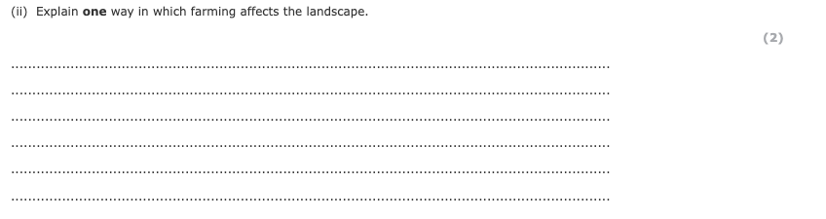

Optional sub topic 1B: River landscapes and processes

Weathering is the wearing away in situ of the river valley sides.
There are three types of weathering.

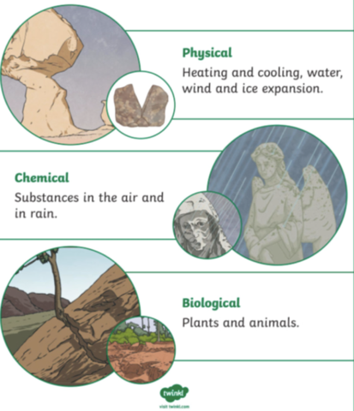
- Chemical – Rocks reacting with slightly acidic water (e.g. acid rain).
- Biological – Burrowing animals and tree roots widening cracks. This is more common in the middle course of the river where there is more vegetation due to a milder climate.
- Mechanical – Freeze-thaw action – water freezes in cracks, expands and causes the rock to break apart. This is more common in the upper course of the river where the relief is higher, making the climate cooler and increasing precipitation.

This can lead to mass movement and widening of rivers .
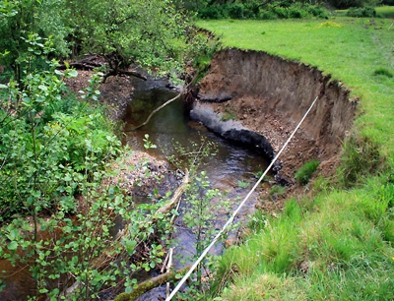
Mass movement is the downhill movement of material under the influence of gravity. Examples include; slumping (caused by saturated soil – see image to the right), rock falls (caused by freeze thaw weathering, create features like river cliffs), landslides and mudslides.

Water erodes the river causing change. There are four types of erosion.

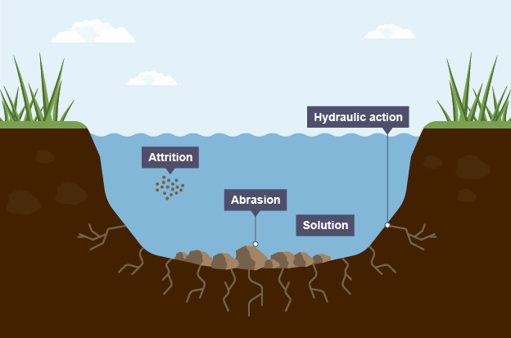
Abrasion - the current throws sediment against the side of the river (river bed), wearing it down.
It can scour the base of the river bed creating a leaving the overhanging rock unsupported

hydraulic action - strong currents compress air and water into cracks and joints in faults (remember sedimentary and metamorphic rock has more joints and faults in them) widening them, this is common during storms where rainfall levels are higher. Or when the water is travelling downslope.

Attrition - Rocks carried by the current that have fallen off in waterfall formation or slipped down the valley in rock falls due to weathering rub together and break into smaller pieces increasing the number thrown at the river bank which breaks it down (abrasion). The larger the sediment, the longer it has been in the water.

Solution/corrosion - The chemical reaction of water dissolves some rocks.

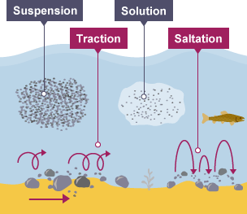
Transportation is the way in which the river carries eroded material.
The four main types of transportation are listed below.

- Traction – Large boulders are rolled along the riverbed.
- Saltation – Smaller pebbles are bounced along the riverbed.
- Suspension – Finer sediment is carried along in the flow.
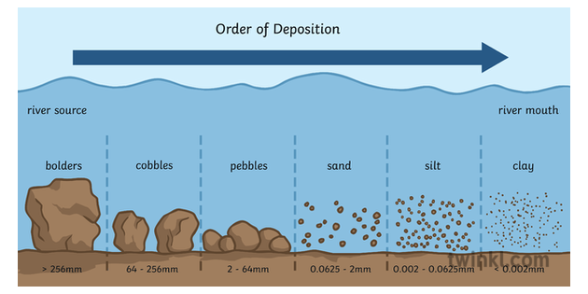
- Solution – Some minerals (such as chalk) are dissolved in the water and carried along. This material can be deposited onto a floodplain during a flood.

(ii) State one type of chemical weathering that might have an impact on a river landscape.
(1)
.........................................................................................................................................

.........................................................................................................................................

River landscapes are constantly being changed by different processes.
Define the term saltation.
(1)
.........................................................................................................................................

.........................................................................................................................................

Transport is a physical process that takes place along this river.
Name one transport process that might take place in this river.
(1)

.........................................................................................................................................

The UK's weather and climate affects river processes in river landscapes.
Explain one way the weather and climate can affect river erosion.
(2)

.........................................................................................................................................

.........................................................................................................................................

.........................................................................................................................................
River landscapes are constantly being changed by different processes.
Name one mass movement process.
(1)

.........................................................................................................................................

River landscapes are constantly being changed by different processes.
Name one type of erosion.
(1)

.........................................................................................................................................

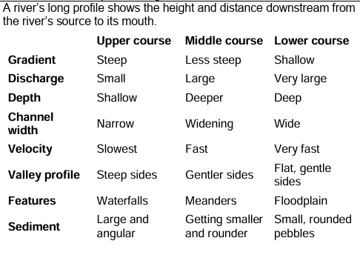
Upper course features | Middle course features | Lower course features
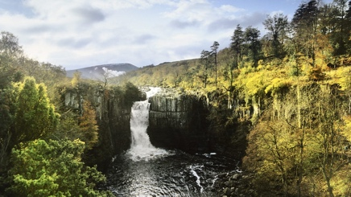 | 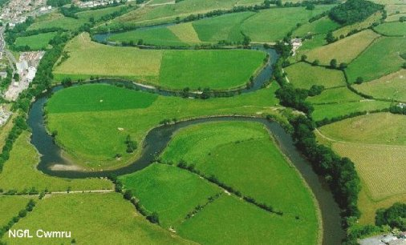 | 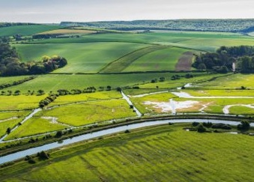

The UK has experienced some extreme weather in recent years. The factors listed below can increase the risk of flooding.

Frequency of storms – Greater periods of heavy, intense rainfall causing rivers to overflow.
Periods of hot, dry weather – Hardens the soil surface, meaning rain cannot soak in (infiltrate). This increases the surface runoff and river discharge.

The list below outlines the impact of climate on rivers.
- Discharge will be greater in wetter climates.
- Hotter temperatures mean greater evaporation, so less discharge.
- The erosion rate will be higher with greater discharge.
- The transport rate will be greater when the energy of the water is greater.
- The weathering of rocks will be greater where temperatures range from just above to just below freezing (freeze-thaw weathering).

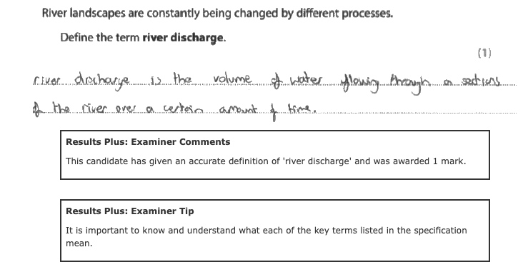
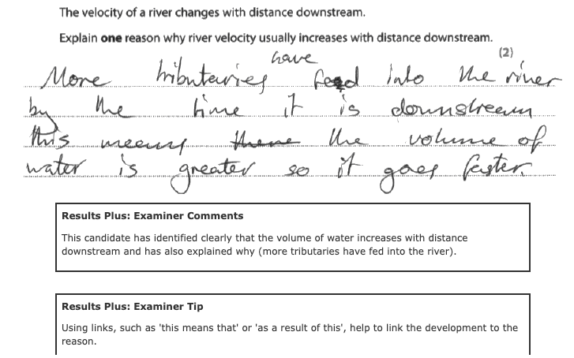

River landscapes are constantly being changed by different processes.
Explain one reason why river discharge changes along the course of a river.
(2)
.............................................................................................................................................
.............................................................................................................................................
.............................................................................................................................................
.............................................................................................................................................

Explain one reason why sediment shape usually becomes more rounded downstream.
(2)
.............................................................................................................................................
.............................................................................................................................................
.............................................................................................................................................
.............................................................................................................................................

River landscapes are constantly being changed by physical processes.
Explain one reason why sediment size usually decreases downstream.
(2)
.............................................................................................................................................
.............................................................................................................................................
.............................................................................................................................................
.............................................................................................................................................

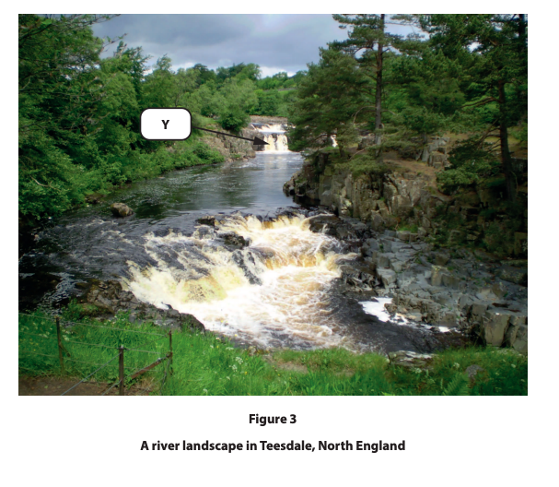
(i) Identify landform Y shown in this river landscape.
(1)
.............................................................................................................................................
(ii) Transport is a physical process that takes place along this river.
Name one transport process that might take place in a river.
(1)
.............................................................................................................................................
(iii) The UK's weather and climate affects river processes in river landscapes.
Explain one way the weather and climate can affect river erosion.
(2)
.............................................................................................................................................

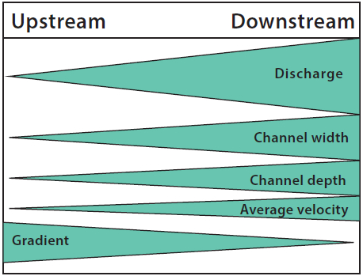
Figure 2 – A prediction of downstream changes in river channel characteristics.
Using Figure 2, describe the changes in gradient and velocity downstream.
(2)
.............................................................................................................................................
.............................................................................................................................................
.............................................................................................................................................
.............................................................................................................................................

Erosion and deposition interacting with geology create distinctive landforms in river landscapes.

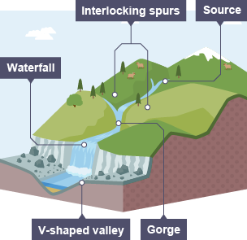
Erosional landforms

In the upper course, rivers erode vertically (downwards)
This forms three distinct landforms.

Interlocking spurs – At its source, a river has limited energy and naturally flows around ridges of more resistant rock.

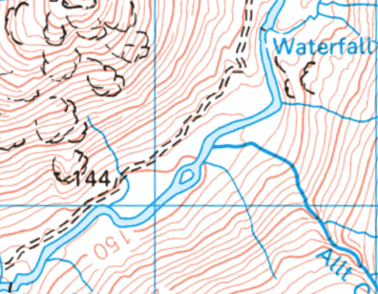
Waterfalls – Form where there is a layer of more resistant rock overlying a less resistant rock. The less resistant rock is eroded by hydraulic action and is undercut. The overhang eventually collapses to leave a waterfall.

Gorges – Over time, the continued undercutting and collapsing means that the waterfall retreats, forming a gorge.

Erosional and depositional landforms
In the middle course, a river erodes laterally (sideways) as the velocity increases.

This causes the channel to become wider and deeper. The river starts to bend, which is called a meander.

On the outer bend of a meander, where the velocity is greater, erosion forms a river cliff.

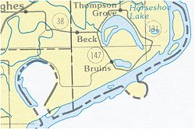
On the inside of a meander, the velocity is slower due to increased friction, and sediment is deposited. This forms a point bar (made up of sand, silt and pebbles).

Ox-bow lakes form as the neck of a meander narrows and eventually erodes through. The water now takes the quickest route, and deposition cuts off the old meander leaving behind an ox-bow lake.

Depositional landforms

Depositional processes in the lower course produces two distinctive landforms, listed below.

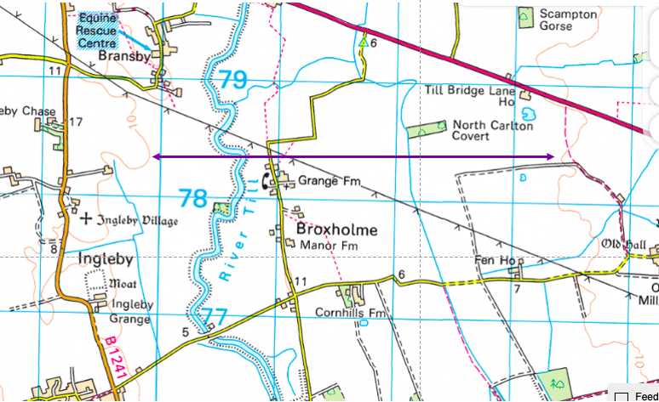
A floodplain is shaped by meanders and lateral erosion. You can see these on OS maps where the area around the river is flat (contour lines are far apart -see the purple lines)

During floods the river deposits sediment, forming the floodplain.
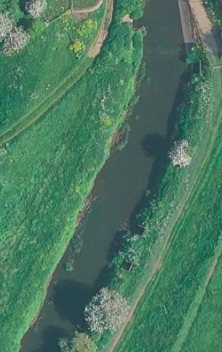
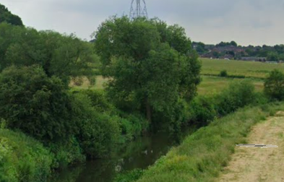
The deposition during flooding continues until eventually embankments are created at the side of the river, forming levees. You may be able to see the raised banks on the photos (left)

River landscapes are constantly being changed by different processes.
Explain one way that deposition leads to the formation of levees.
(2)
.............................................................................................................................................
.............................................................................................................................................
.............................................................................................................................................
.............................................................................................................................................

Study Figure 2a.
It shows how a waterfall changed between 1900 and 2000.
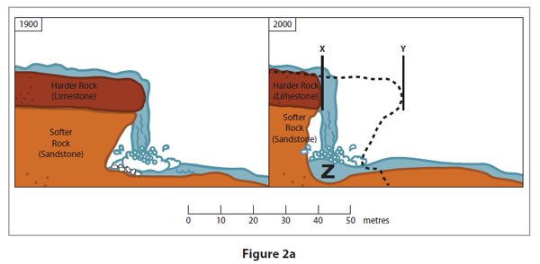
Explain how erosion will cause this waterfall to retreat.
Use evidence from Figure 2a in your answer.
(3)
.............................................................................................................................................
.............................................................................................................................................
.............................................................................................................................................
.............................................................................................................................................

Human activities lead to changes in river landscapes

Urbanisation | Agriculture | Industry
Increases impermeable surfaces, increasing surface run-off, increasing discharge | Deforestation and field drainage transports water more quickly into streams and rivers.  Water is extracted from rivers for irrigation. | Chemical waste can pollute rivers.
Physical causes of flooding can include the factors listed below.
• Rainfall intensity – Large amounts of rainfall reduces soil infiltration.
• Geology – Impermeable rocks means water cannot percolate from above.
• Snowmelt – During spring, snow melts adding more water to a river.
• Drainage basin – Steep-sided valleys carry water into a river system quicker.

Human causes of flooding include:
• urbanisation – more impermeable surfaces
• deforestation – less interception and greater surface run off.

The physical effects of flooding include soil erosion and loss of species/disruption to ecosystems.
The human effects include loss of life, economic damage/financial loss, damage to property, loss of jobs and disruption to farming and transport.
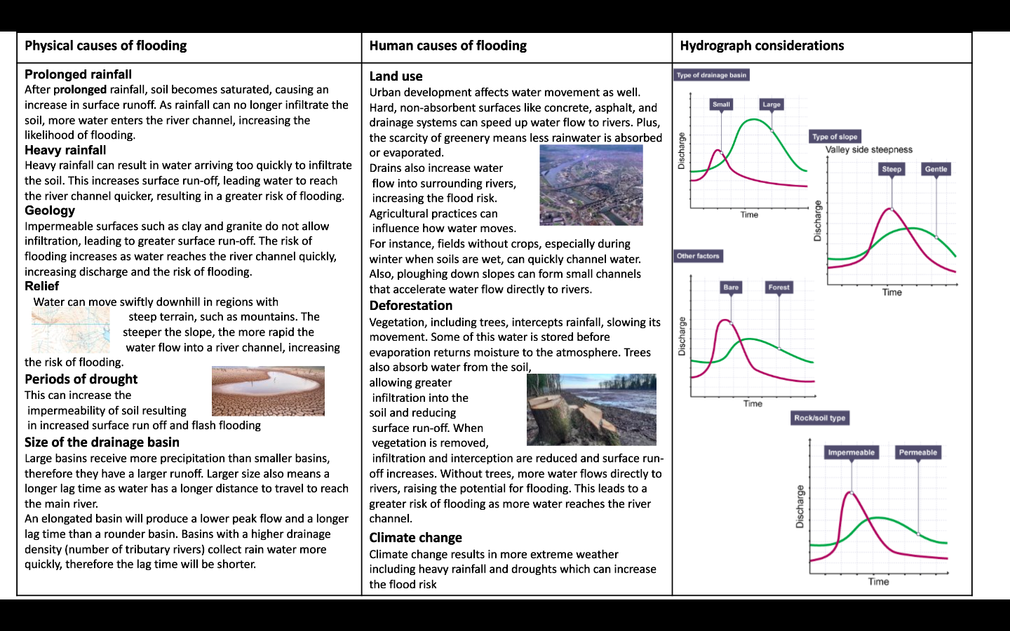

Explain how geology impacts flood risk (4) ​
.............................................................................................................................................
.............................................................................................................................................
.............................................................................................................................................
.............................................................................................................................................

Explain how relief impacts flood risk (4) ​
.............................................................................................................................................
.............................................................................................................................................
.............................................................................................................................................
.............................................................................................................................................

Explain how forest cover impacts flood risk (4)​
.............................................................................................................................................
.............................................................................................................................................
.............................................................................................................................................
.............................................................................................................................................

Explain two reasons why the lag time may be short on a hydrograph (4)
.............................................................................................................................................
.............................................................................................................................................
.............................................................................................................................................
.............................................................................................................................................

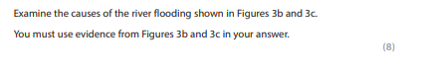
.............................................................................................................................................
.............................................................................................................................................
.............................................................................................................................................
.............................................................................................................................................
.............................................................................................................................................
.............................................................................................................................................
.............................................................................................................................................
.............................................................................................................................................
.............................................................................................................................................
.............................................................................................................................................
.............................................................................................................................................
.............................................................................................................................................
.............................................................................................................................................
.............................................................................................................................................
.............................................................................................................................................
.............................................................................................................................................
.............................................................................................................................................
.............................................................................................................................................
.............................................................................................................................................
.............................................................................................................................................
.............................................................................................................................................
.............................................................................................................................................
.............................................................................................................................................
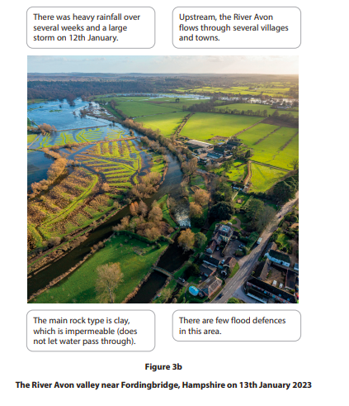
.............................................................................................................................................
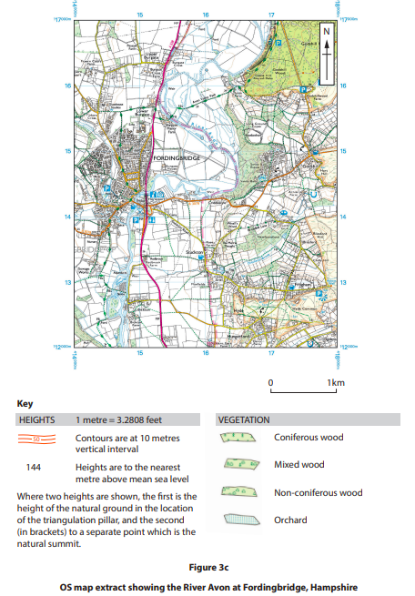

Hard engineering involves building structures as a defence against flooding.
Dams and reservoirs are barriers constructed to hold back water. They store large volumes of water until it is needed and can be used to generate hydro-electric power. However, they are expensive, and sediment can build up in reservoirs.

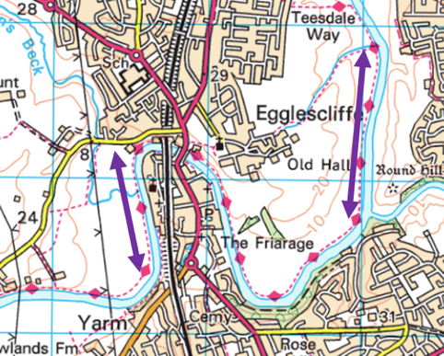
Channelisation straightens and/or widens the river channel allowing water to flow more quickly from the area at flood risk. However, water moves more quickly downstream, increasing the flood risk to other settlements. Can you see on the OS map (right) how the river has been straightened diverting past built up areas?

Soft engineering uses natural processes to protect against river flooding.

Floodplain zoning prevents development in areas most at risk to flooding. This reduces the number of homes at risks and allows infiltration to take place.

Washlands are areas adjacent to rivers that are deliberately flooded in order to avoid flooding of residential areas and important farmland.

Distinctive river landscapes are the outcome of the interaction between physical and human processes

Human factors causing change

Channelisation has improved navigation but has increased velocity and discharge.

A series of reservoirs has been constructed including in Cow Green
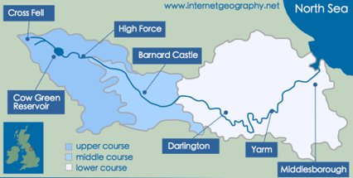
Flood walls in Yarm protect businesses and property

The Tees Barrage in Darlington has been set up to control the flow of water and to protect agricultural land and property.

Zoning has been made into law on some part s of the flood plains due to flood risk and the expensive of recovering from floods and wetlands have been created (managed retreat)

Physical factors causing change

Snow melt

Rising sea levels could replace freshwater marsh landscapes.

In the Tees Estuary, rising sea levels could destroy the landscape and habitats.

River Landscapes and Processes
River landscapes are constantly being changed by different processes.
Study Figures 3b and 3c in the Resource Booklet.
Examine the possible advantages and disadvantages of the reservoir and dam shown in Figures 3b and 3c.
You must use evidence from Figures 3b and 3c in your answer.
(8)

(Total for question = 8 marks)

Examiner's Report reading examiners reports help us understand what the people marking our exams are looking for.
Q1.
In this question most candidates focused on the textboxes below the map. While these did provide useful information to help answer the question, the tendency for some candidates was to simply copy the text and not develop it any further or to link it to evidence from the map. While some credit was given for selecting relevant information, these answers were often very limited. The map provided plenty of opportunities to show geographical skills. These could have included measuring the width or length of the washlands; providing the direction of flow of the stream and river; locating the key areas protected by the flood defences using compass direction and measuring distance.
In relation to the AO3 marks, the candidates were required to explain the advantages and disadvantages of the flood defences shown on the map. While some candidates were able to explain how washlands and flood plain zoning work, it was often the case that answers simply stated that washlands protect buildings without an explanation of how this defence mechanism actually works – and how this links to their advantages and disadvantages. Adding details such as these would have been useful development points for the information selected from the textboxes.

Q2.
This question focused on the advantages and disadvantages of the reservoir and dam shown in the two figures. The candidates who answered this question more effectively were able to obtain a range of evidence from the OS map and photograph and were able to use this to support their explanation. Some candidates were able to gain a limited number of AO4 marks by mainly focusing on the information in the text boxes, although their points were often not well developed. The candidates who gained 3-4 of the AO4 marks were likely to have used evidence from both resources with map evidence being used (eg the length of the dam/reservoir; using grid references to identify the location of features such as the hotel).
As mentioned above, one of the key discriminators between answers was the range of evidence extracted from the resources. However, it is also important that this evidence is used to support the answer, rather than simply being a list of features. Where these connections were made, candidates could put together a well-argued and supported answer which helped them access the higher levels. In terms of the AO3 marks, the candidates were required to explain the advantages and disadvantages of the reservoir and dam. This was done best when the candidates divided their answers up into paragraphs focusing separately on the advantages and disadvantages.
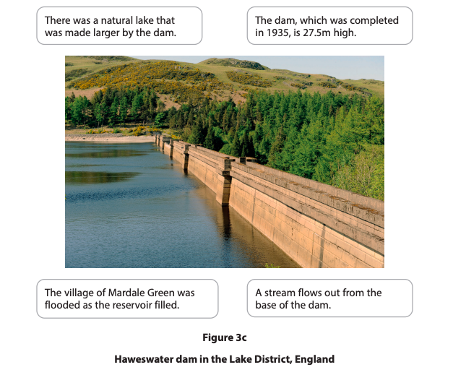

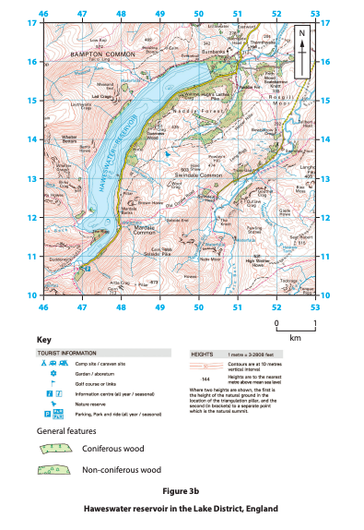

River landscapes are constantly being changed by different processes.
Study Figure 3b in the Resource Booklet.
Examine the advantages and disadvantages of the flood defences (washlands and floodplain zoning) shown in Figure 3b.
(8)
.............................................................................................................................................
.............................................................................................................................................
.............................................................................................................................................
.............................................................................................................................................
.............................................................................................................................................
.............................................................................................................................................
.............................................................................................................................................
.............................................................................................................................................
.............................................................................................................................................
.............................................................................................................................................
.............................................................................................................................................
.............................................................................................................................................
.............................................................................................................................................
.............................................................................................................................................
.............................................................................................................................................
.............................................................................................................................................
.............................................................................................................................................
.............................................................................................................................................
.............................................................................................................................................
.............................................................................................................................................
.............................................................................................................................................
.............................................................................................................................................
.............................................................................................................................................
.............................................................................................................................................
.............................................................................................................................................
.............................................................................................................................................
.............................................................................................................................................
.............................................................................................................................................
