Therapy Pack

Edexcel A GCSE Geography
Paper 1

Changing UK landscapes



Optional sub topic 1A: Coastal landscapes and processes

There are geological variations within the UK.
Geology means – rocks
Characteristics and distribution of the UK’s main rock types: sedimentary (chalk, sandstone) igneous (basalt, granite), metamorphic (schists, slates).
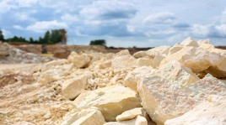
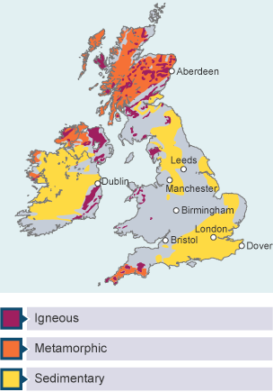
Sedimentary rocks are formed in layers called beds.
Examples include chalk (such as the South Downs) and limestone.
They contain fossils and are formed at the bottom of river or sea beds.
They are vulnerable to erosion so create low land areas like valleys and plains
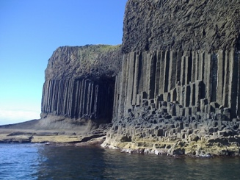
Igneous rocks are hard and formed of crystals, so they are resistant to erosion meaning that they form upland landscapes (mountains, hills)
If cooled intrusively, rocks will form large crystals as they have had longer to cool. If cooled extrusively (above ground) they will have smaller crystals in them.
Examples include granite and basalt (Northern Ireland, Giant’s Causeway).
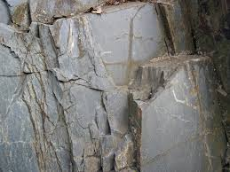
Metamorphic rocks are formed by heat and pressure.
Examples are schist and slate (such as the Lake District- an upland area).
Metamorphic rocks are hard to erode.

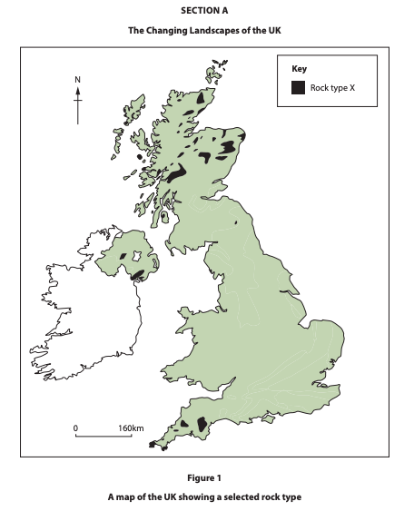
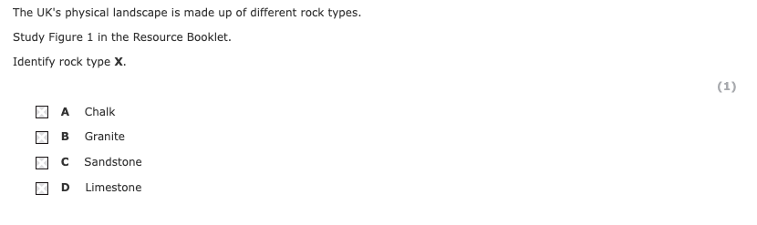

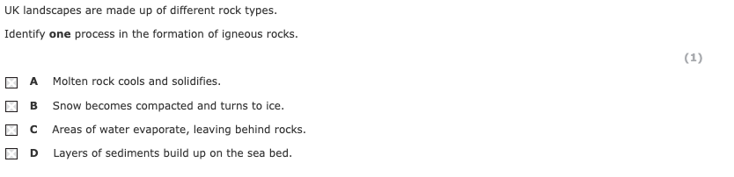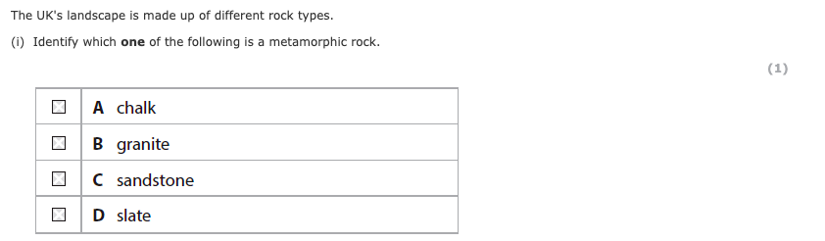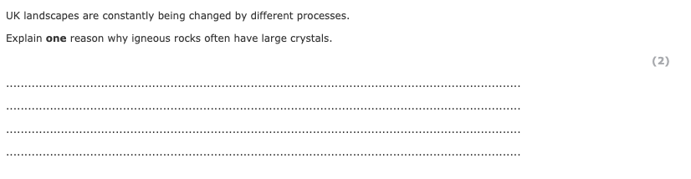
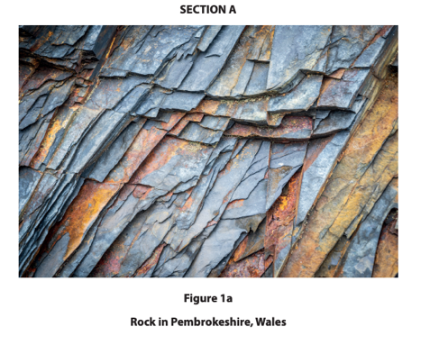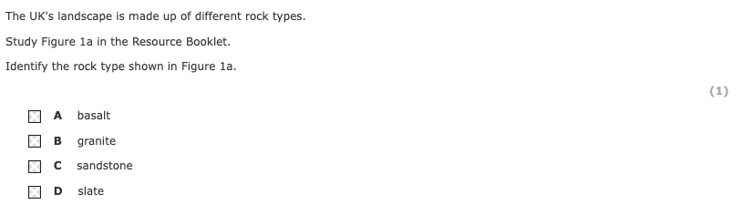
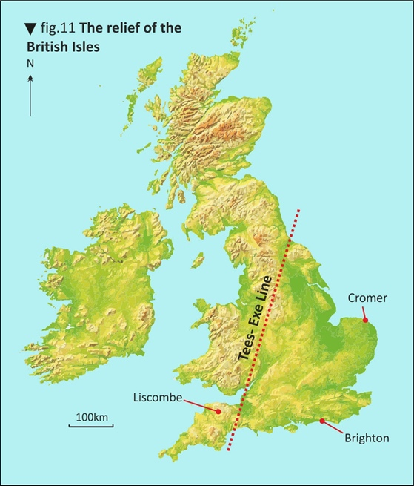
The role of geology and past tectonic processes in the development of upland (igneous and metamorphic rocks) and lowland (sedimentary rocks) landscapes.
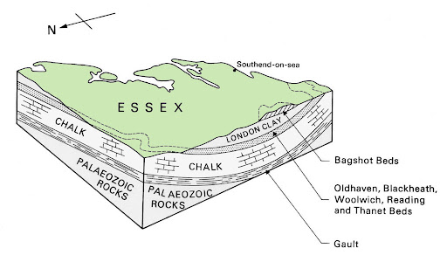
Geology – The UK is split into two halves geologically. The northwest of the UK is mainly harder igneous and metamorphic rocks, forming upland landscapes. The south-east of the UK is mainly softer sedimentary rocks, forming lowland landscapes. This geological cross section shows how the rock under Essex causes a flat landscape.
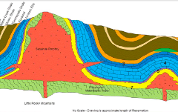
Plate tectonics – Millions of years ago, the UK was close to plate margins. Plate movements caused mountains (folds) and faults in the rocks. You can see how the faults and folds in this geological cross section (right) has caused molten rock/ magma to rise to the surface creating an igneous, upland area.
Geological cross sections to show relationship between rock type and relief
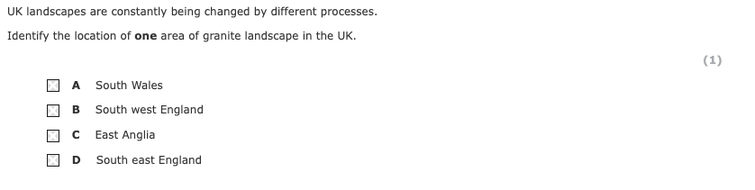
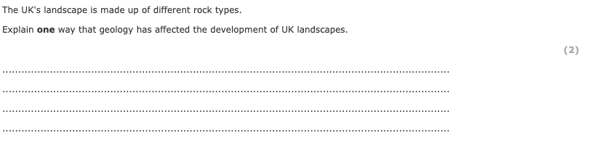
Distinctive upland and lowland landscapes result from the interaction of physical processes (glacial erosion and deposition, weathering and climatological, post-glacial river and slope processes).
Distinctive upland and lowland UK landscapes result from physical processes.
Weathering – Freeze-thaw action breaks off rock, which forms scree slopes.  Freeze = causes water in rocks to expand  Thaw (melt) = causes water to sink deeper into rocks  This process repeats, fracturing the rock creating scree slopes and small streams that run over impermeable rock | 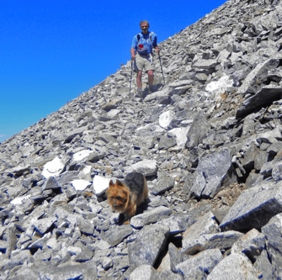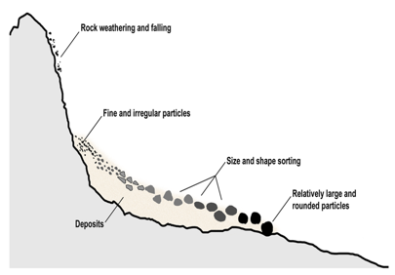
Glacial erosion and deposition – Glaciers carve out corries and U-shaped valleys. | 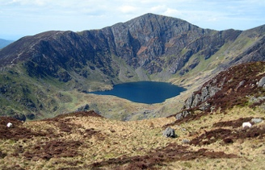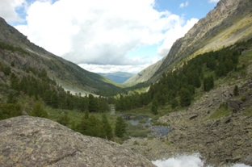
Climate – High levels of rain form streams over the impermeable rock surfaces. | 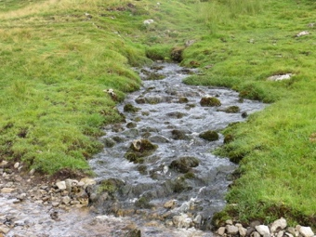
River erosion – Meandering rivers erode wide valleys. | 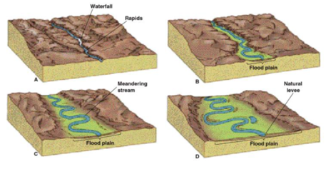
River deposition – Floods spread out over valley floors, depositing silt and forming floodplains.
Slope processes – Mass movement (landslides) and soil creep (gradual movement downhill) cause cliffs to collapse.
. 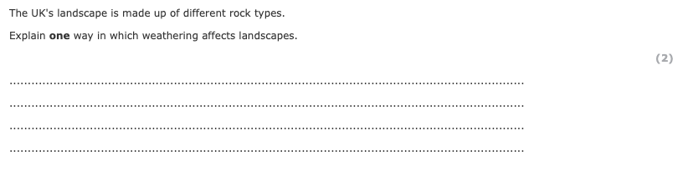

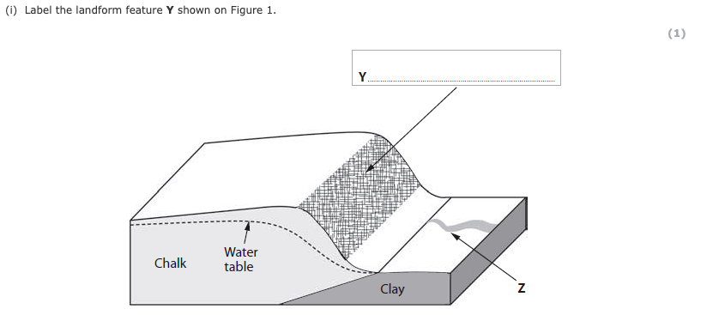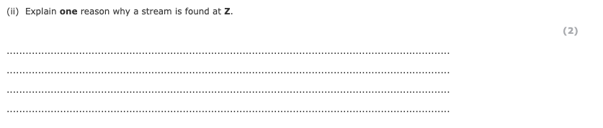

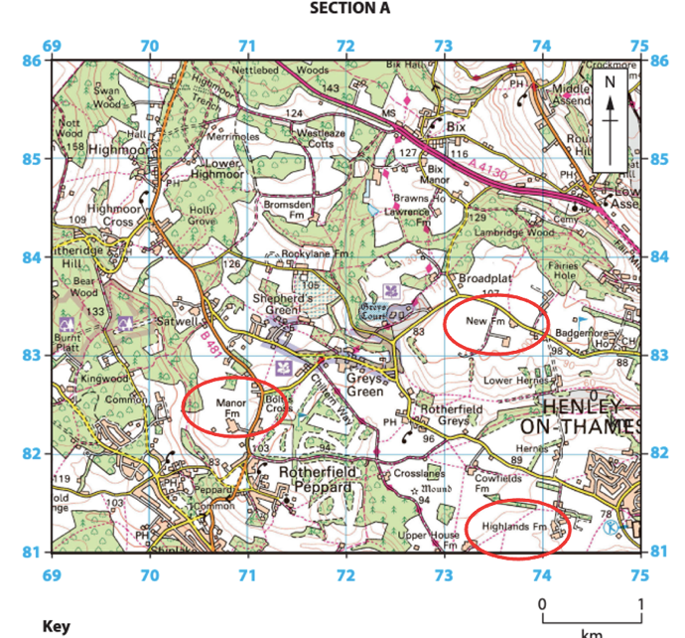
How distinctive landscapes result from human activity (agriculture, forestry, settlement) over time. These can be seen on OS maps of different scales. 1:25000 and 1:50000
Humans have changed almost all the landscapes of the UK through farming, such as hill sheep farming in upland areas and arable farming in fertile lowlands.
Forestry is managing woodland for timber.
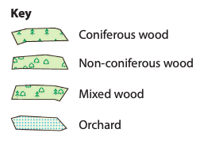
The UK would naturally be covered by deciduous woodland. Many UK upland landscapes have been planted with coniferous trees for forestry. Natural wooded areas have been deforested and polluted by decades of pesticides or overgrazed by an increasing number of non-native species or over-bread species such as deer resulting in them turning into heathland landscapes.
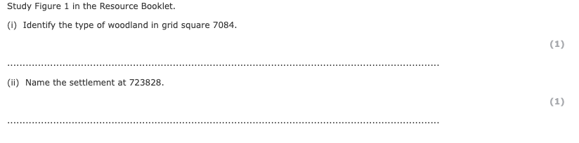
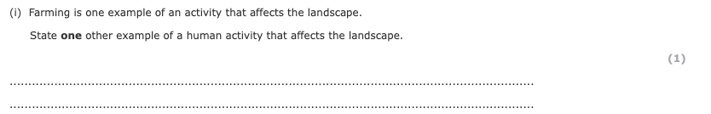
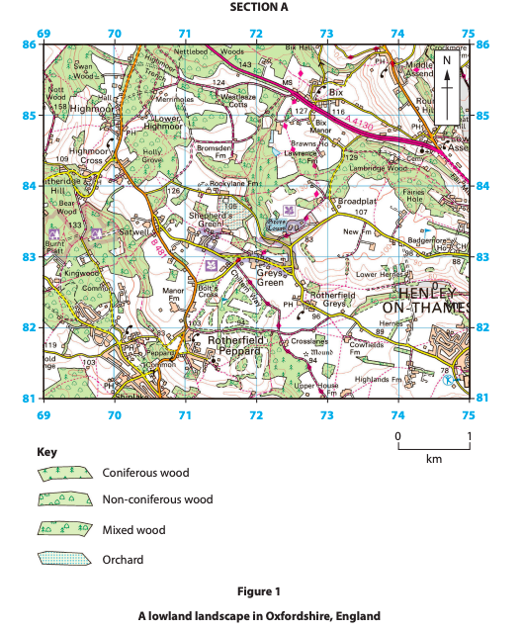
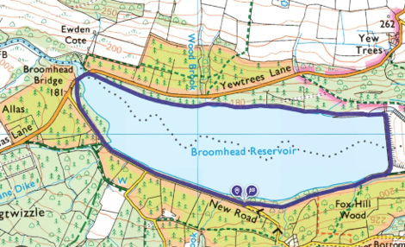
Settlements have influenced landscapes through deforestation to make way for buildings and roads. Wetland areas are sometimes drained, whilst valleys can be flooded to create reservoirs.

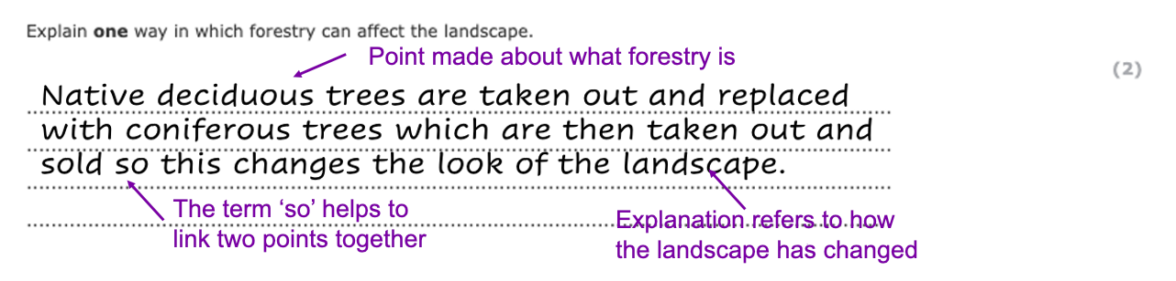
This model answer will help you to work on your skill of ‘explaining’ the impact of something.
Now try the same process, but with this question
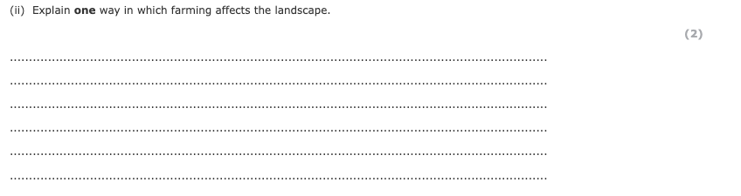

Optional sub topic 1A: Coastal landscapes and processes

The physical processes at work on the coast: weathering (mechanical, chemical, biological), mass movement (sliding and slumping), erosion (abrasion, hydraulic action, attrition and solution), transport (traction, saltation, suspension, solution and longshore drift) and deposition.
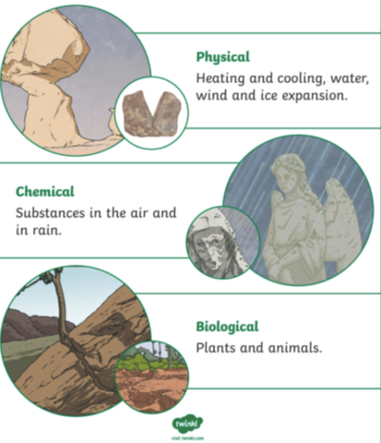
Weathering breaks down rocks but leaves the weathered material in situ. There are three types of weathering.
- Chemical – Rocks reacting with slightly acidic water (acid rain), such as limestone. This can create features like limestone pavements
- Biological – Burrowing animals and tree roots widening cracks.
- Mechanical – Freeze-thaw action – water freezes in cracks, expands and causes the rock to break apart.
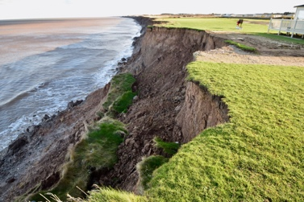
This can lead to mass movement and retreating cliffs.
Mass movement is the downhill movement of material under the influence of gravity. Examples include; slumping (caused by saturated soil – see image to the right), rock falls (caused by freeze thaw weathering, create features like scree slopes), landslides and mudslides.
Waves erode the coast causing change. There are four types of erosion.
Abrasion | 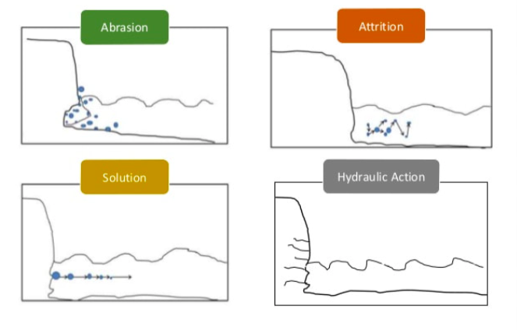  Waves throw sediment against the coast, wearing it down.  It can scour the base of the cliff creating a wave cut notch leaving the overhanging rock unsupported
Hydraulic action | Waves compress air and water into cracks and joints in faults (remember sedimentary and metamorphic rock has more joints and faults in them) widening them, this is common during storms which occur more commonly in the winter, creating destructive waves which are more erosive
Attrition | Pebbles carried by the waves that have fallen off the cliff face in mass movement or been transported from further along the coast rub together and break into smaller pieces increasing the number thrown at the cliff face which breaks it down (abrasion). The larger the sediment, the longer it has been in the water.
Solution/corrosion | The chemical action of sea water dissolves some rocks. Limestone reacts easiest with acid in the water, breaking these cliffs down easily.
Examiner's Report
Hint – reading the examiners reports help you to understand how marks are awarded, as well as see how responses by children your age are worded.


Results Plus: Examiner Comments
A clear impact on the coast is given by the candidate.1/1

Results Plus: Examiner Tip
Try to understand the difference between soil creep and slumping, and learn your processes.

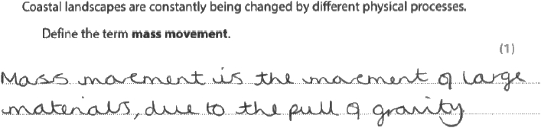
Results Plus: Examiner Comments
This candidate has identified the role of gravity (1 mark). There is no need to give an example of a mass movement process as the command word is define and the question has a 1 mark tariff.
Results Plus: Examiner Tip
It is important to focus on both the command word and the number of marks available.

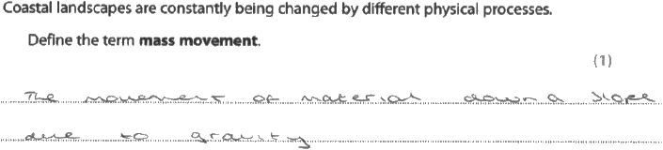
Results Plus: Examiner Comments
This candidate has clearly stated both that mass movement involves downward movement and also that it is due to gravity. Both of these points are in the mark scheme and are creditable. 2/2

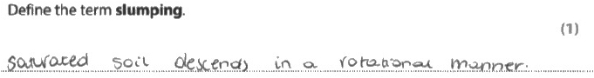
Results Plus: Examiner Comments
This response was awarded 1 mark.
The candidate has provided a correct definition with the idea of downward movement in a rotational manner.
Results Plus: Examiner Tip
Ensure that you can define all the key terms in the specification.
Explain one way in which weathering affects landscapes.
(2)
.............................................................................................................................................
.............................................................................................................................................
.............................................................................................................................................
.............................................................................................................................................
Explain one way seasonal changes in the UK's weather can affect rates of coastal erosion.
(2)
.............................................................................................................................................
.............................................................................................................................................
.............................................................................................................................................
.............................................................................................................................................

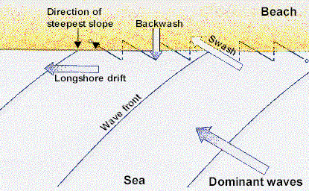
Longshore drift is the process by which sediment is transported up the beach at the same angle as the wave approach (swash) but is transported back to the sea at right angles to the coastline due to gravity (backwash).

Wave transport is influenced by wave energy and sediment size. Waves transport material in the ways listed below.
Traction – Large boulders are rolled along the seabed by waves (waves don’t have enough energy to pick them up)
Saltation – Medium sized appear to ‘bounce’ along the seabed (waves have some energy to pick these up, but not enough to keep hold of them)
Suspension – Sand and small particles are carried along in the flow.
Solution – Some minerals are dissolved in seawater and carried in the flow.
Which is which?

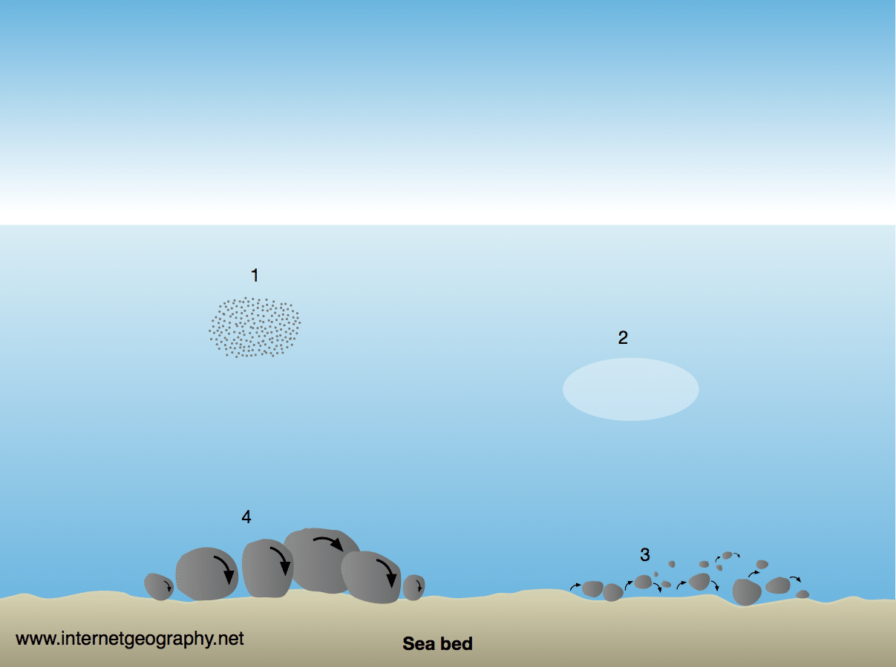
Deposition occurs when sediment is deposited as wave energy falls. This happens more when constructive waves are present.

Influence of geological structure (concordant/discordant, joints and faults), rock type (hard/soft rock) and wave action (destructive and constructive waves) on landforms
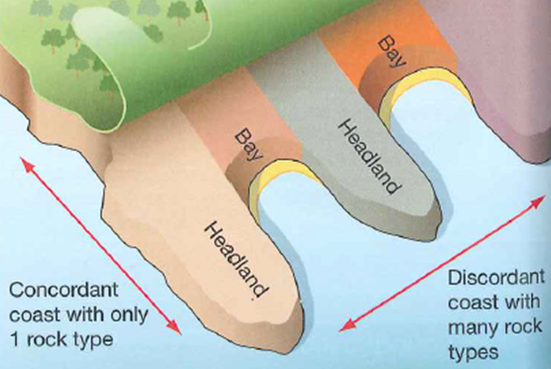
Concordant coasts are made up of the same rock type.
On discordant coasts, the rock type alternates, forming headlands and bays.
Joints and faults make rock more prone to erosion.
Joints are smaller cracks whereas faults are much larger weaknesses.
Coasts with more joints and faults are more likely to erode more quickly.
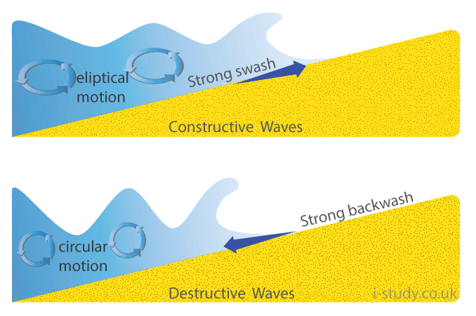
Constructive waves have a lower energy and occur in calmer conditions.
In a constructive wave, material is deposited, building up the coast and beaches.
Destructive waves have a higher energy. They occur where there is a longer fetch and stronger wind has been blowing for a greater duration.
In a destructive wave, the swash is weaker than the backwash. Sediment is pulled into the sea, eroding the coast.
Exam question – read this question, study the figures, then read the mark scheme.
Mark schemes are a useful tool to look at the key knowledge you need to answer a question. They have more points than you actually need to put down, but can form a good way to plan answers or they can be used to create flashcards for longer answer questions
AO3 marks are marks awarded for your own knowledge of processes and ideas AO4 marks are marks you get from interpreting the figure (this is not just copying details, but showing that you understand what the maps/graphs/charts show you.)
Coastal landscapes are constantly being changed by different processes.
Study Figures 2b and 2c in the Resource Booklet.
Examine the role of geology and physical processes in the formation of the coastal landforms shown in Figures 2b and 2c.(8)

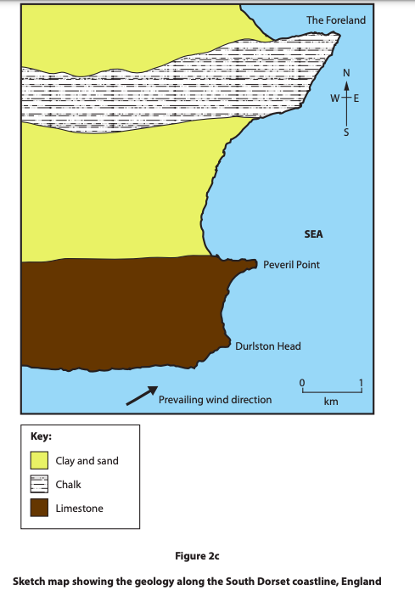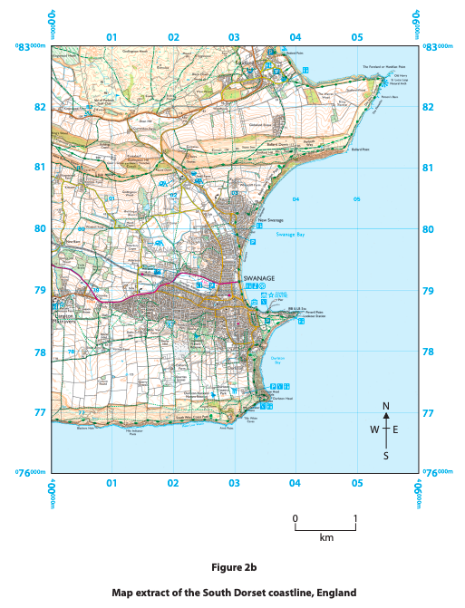
(8)
Mark Scheme
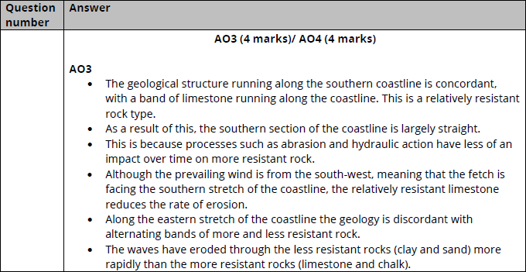
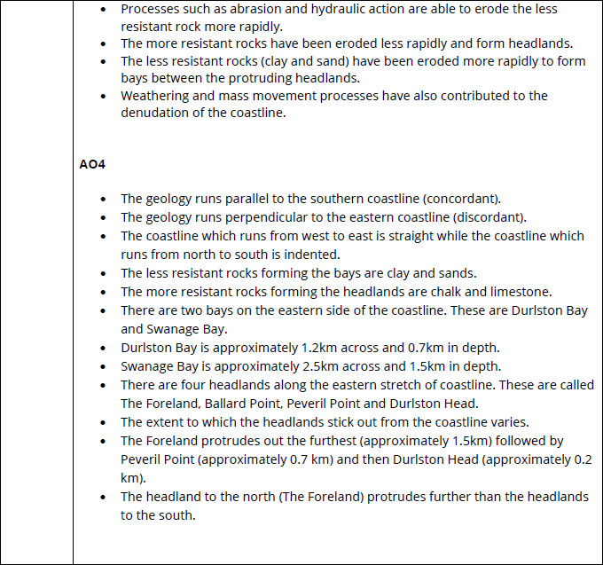
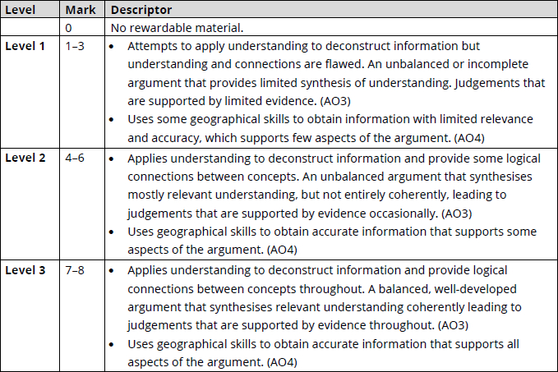

Coastal landscapes are constantly being changed by different processes.
Wave action is important along this stretch of coastline.
Explain one way in which destructive waves can increase the rate of coastal erosion.
(2)
.............................................................................................................................................
.............................................................................................................................................
.............................................................................................................................................
.............................................................................................................................................
Explain one way that constructive waves can affect beaches.
(2)
.............................................................................................................................................
.............................................................................................................................................
.............................................................................................................................................
.............................................................................................................................................

The UK’s four seasons (seasonality) have different impacts on coastal erosion. Colder temperatures in the winter lead to freeze-thaw weathering and stronger waves accelerate coastal erosion. Storm frequency is high in many parts of the UK, subjecting coasts to stronger winds and destructive waves. Heavy rainfall can saturate cliffs and cause slumping. Spits, sand dunes and beaches can all easily change during strong storms. The prevailing winds in the UK are from the south-west. This brings warm, moist air from the Atlantic Ocean and frequent precipitation, adding to weathering and mass movement, increasing erosion.
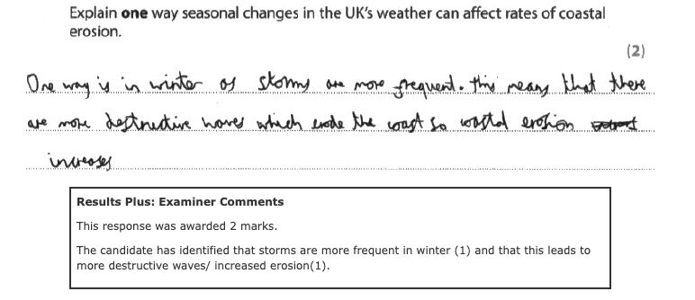

Explain one way seasonal changes in the UK’s weather can affect rates of coastal erosion.
(2)
The rate of erosion is lower in ................................................................(1) as storms are less frequent. (1)

Coastal erosion and deposition create distinctive landforms within the coastal landscape.
Erosional landforms
Headlands and bays develop on discordant coastlines that have a mixture of hard and softer rock. More resistant rocks like chalk are left protruding out in the sea, forming headlands. Softer rocks such as sand and clay are eroded more quickly, forming bays. Headland features include caves, arches, and stacks.
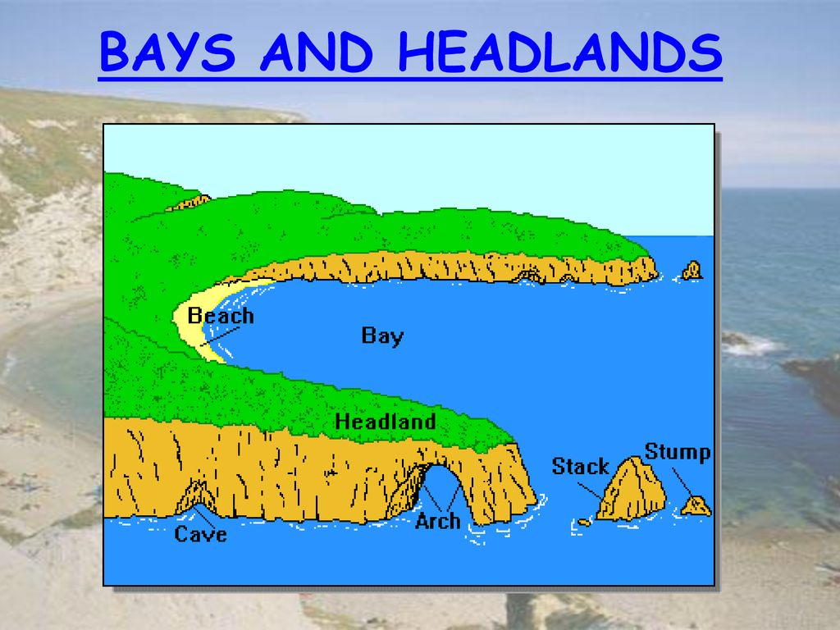
- Caves are formed when hydraulic action and abrasion erode a weakness in the headland such as a joint or fault.
- An arch forms when two caves erode from either side of a headland.
- A stack forms when an arch collapses due to continued erosion at the foot of the arch and weathering at the top.

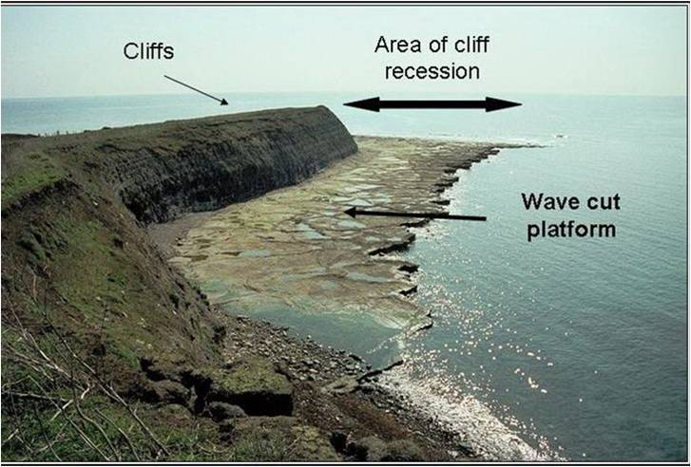
Cliffs are common coastal features. Cliffs are shaped through weathering and erosion. Softer rock erodes more easily to form gently sloping cliffs, whereas harder rock erodes more slowly forming steeper cliffs. Abrasion and hydraulic action can form a wave-cut notch making a cliff unstable. The erosion of cliffs can create wave-cut platforms – areas of flat rock at the base of the cliff which show recession (how far the cliff has moved backwards).

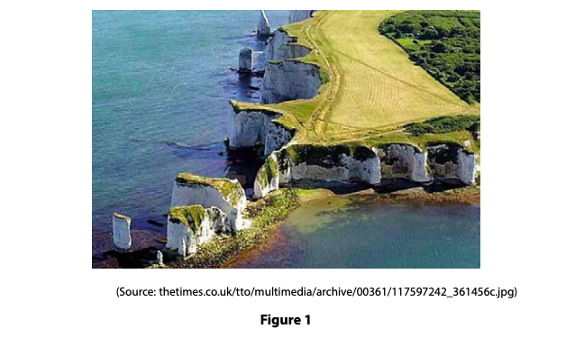
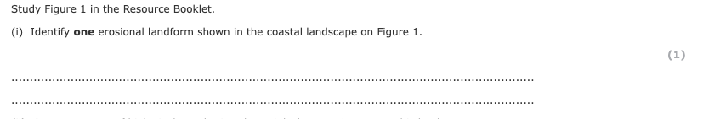
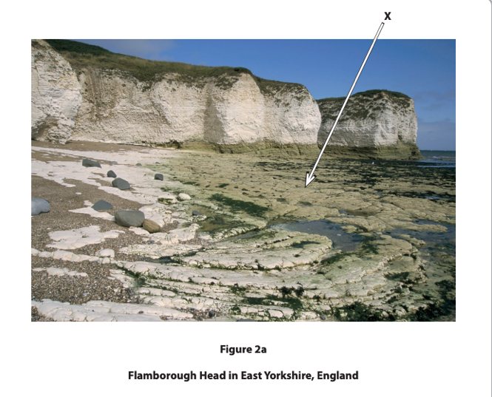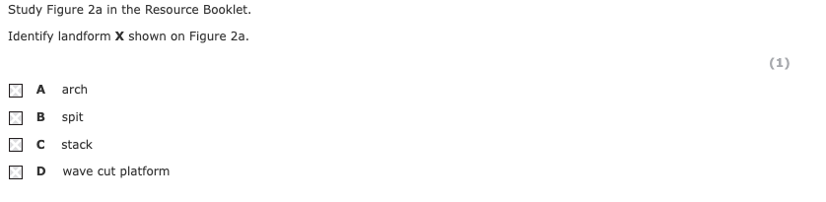
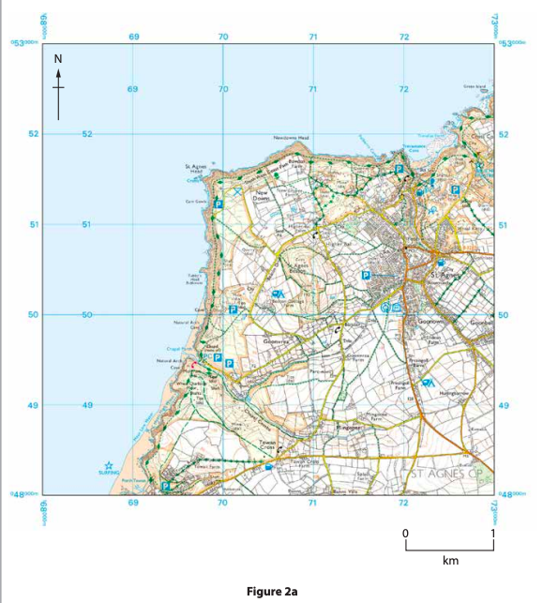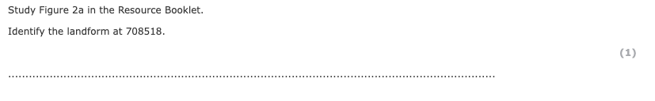

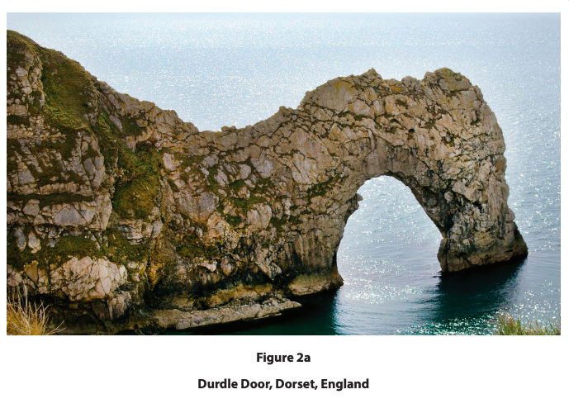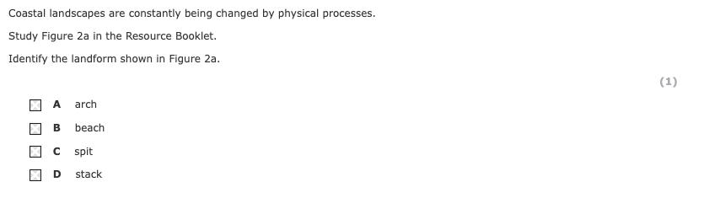
Explain the formation of a stack
You may use diagrams in your answer
(4)
.............................................................................................................................................
.............................................................................................................................................
.............................................................................................................................................
.............................................................................................................................................
.............................................................................................................................................
.............................................................................................................................................
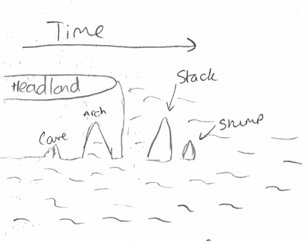
Look at the diagram (left) used by a candidate answering this question.
See how they have included ‘time’ in their sketch to show how over time the headline breaks down.
They could have added ‘destructive waves’ in their sketch or even labelled the types of erosion take are taking place here.
Remember that if you are using supporting diagrams you should still write sentences of your own knowledge in your response.
Depositional landforms (landforms created when transported sediment is dropped).
Beaches are deposits of sand and shingle and are shaped by erosion, transportation and deposition. Deposition occurs where an area of coastline is sheltered, and wave energy is lower.
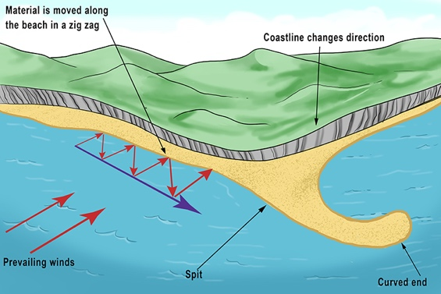
Spits are narrow beaches of sand or shingle that are attached to the land at one end. They often extend across a bay or estuary or where there is a change in the coastline direction. They are formed by longshore drift. Longshore drift is the zigzag movement of sediment along a beach. It is driven by prevailing winds, swash and backwash.
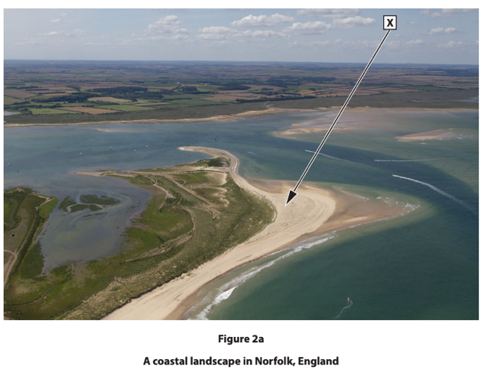
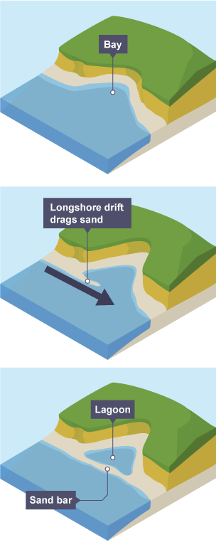
A bar forms in same way as a spit. Unlike a spit, however, a bar grows all the way across a bay connecting two headlands. It leaves an area of water called a lagoon between the bar and the mainland.

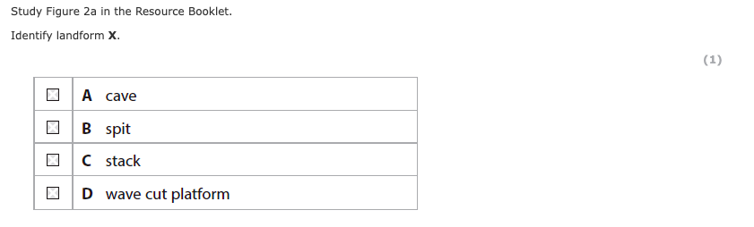

Describe the formation of a bar.
You may use a diagram to help with your answer.
(3)
.............................................................................................................................................
.............................................................................................................................................
.............................................................................................................................................
.............................................................................................................................................
Human activities can lead to changes in coastal landscapes, which affect people and the environment.
Human activities can change coastal landscapes
Urbanisation | Agriculture | Industry
Building weight makes cliffs more vulnerable.  Additional drainage decreases soil saturation.  Urbanisation, promotes the need for sea defences, reducing coastal recession. | Disrupts wildlife ecosystems.  Increases soil erosion (when the soil the gradual wearing away of the top layer of soil by water, wind, ice, snow, plants, and animals), decreasing its fertility, leading to less biodiversity.  Increases sedimentation (When soils erode, sediments are washed into streams and river, increasing the flood risk.) | Increases air, noise and visual pollution  Can destroy ecosystems for sea life and birds.  Creates employment opportunities.

Sort these into positive and negative impacts.
Explain how one human activity increases the chance of coastal flooding.
(2)

.........................................................................................................................................

.........................................................................................................................................

.........................................................................................................................................

.........................................................................................................................................
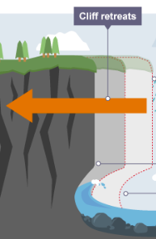
Coastal recession is when the coast retreats backwards.
The effects of coastal recession and flooding are:
- the loss of people’s homes and businesses (cafes)
- decreasing property values (makes insurance difficult)
- disruption to roads and railways lines (commuters)
- cliffs become dangerous for people
- ecosystems can be destroyed.
Sea defences
Hard engineering – coastal protection that uses artificial materials as a physical barrier to the sea - protects coastlines but spoils the landscape.
Soft engineering – coastal protection that works with natural processes/materials to reduce the impacts of erosion - maintains the coastline but is less effective.

Hard engineering | Soft engineering
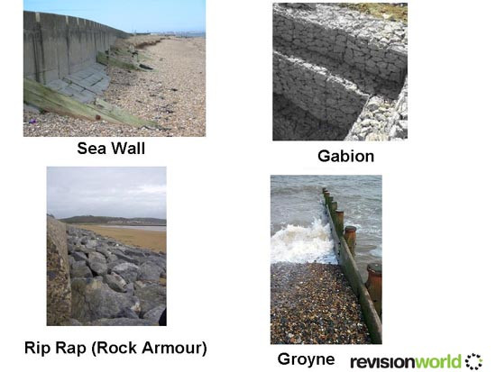  Sea walls (walls built at the base of the cliff to absorb the energy of the waves to prevent erosion) protect cliffs and buildings but are the most expensive option  Groynes (wooden barriers built perpendicular to the coastline) trap sand and build up beaches but lead to increased erosion downdrift as the process of longshore drift is slowed down.  Rip rap (rocks placed at the base of the cliff) absorb wave energy. It is less expensive than a sea wall but restricts beach access. | 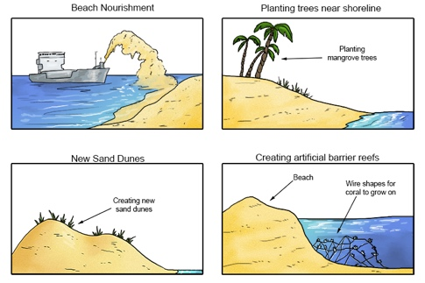  Beach nourishment (adding sand to the beach) reduces wave energy and is good for tourism.  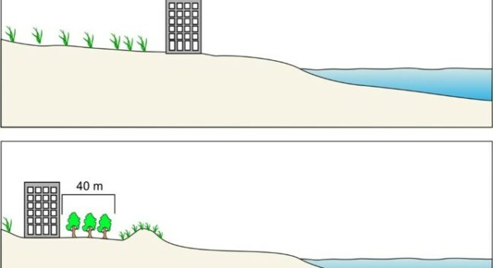  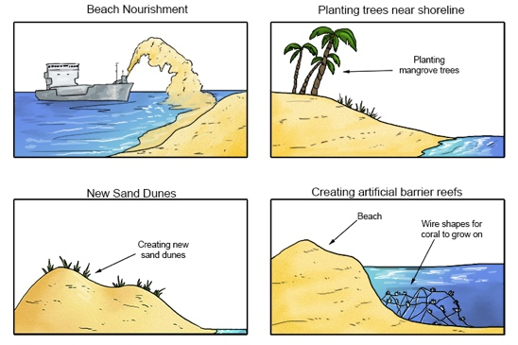  Managed retreat (leaving the coastline to erode, moving people and industry away if at risk) is expensive to compensate locals.  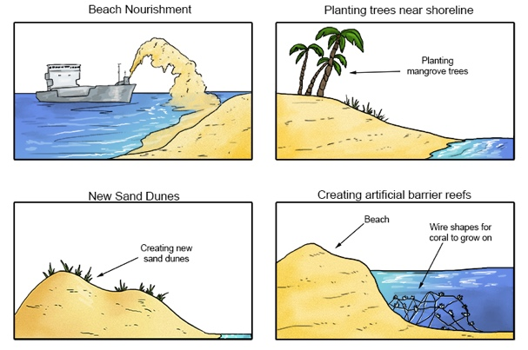  Afforestation – planting trees to stabilise the soil can disturb farmland.

Coastal landscapes are constantly being changed by different processes.
Groynes are an example of hard engineering.
Explain one disadvantage of using groynes to protect the coast.
(2)
.............................................................................................................................................
.............................................................................................................................................
.............................................................................................................................................
.............................................................................................................................................

Coastal landscapes are constantly being changed by different processes.
Study Figure 2 in the Resource Booklet.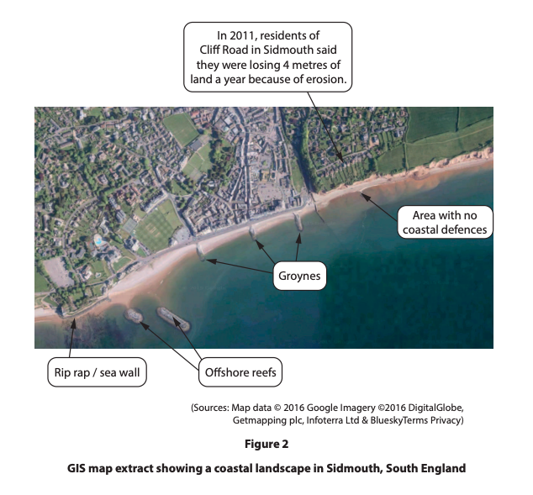
Examine how different coastal defences affect the rate of coastal erosion in the landscape shown in Figure 2.
(8)
.............................................................................................................................................
.............................................................................................................................................
.............................................................................................................................................
.............................................................................................................................................
.............................................................................................................................................
.............................................................................................................................................
.............................................................................................................................................
.............................................................................................................................................
.............................................................................................................................................
.............................................................................................................................................
.............................................................................................................................................
.............................................................................................................................................
.............................................................................................................................................
.............................................................................................................................................
.............................................................................................................................................
.............................................................................................................................................
.............................................................................................................................................
.............................................................................................................................................
.............................................................................................................................................
.............................................................................................................................................
.............................................................................................................................................

Coastal landscapes are constantly being changed by different processes.
Study Figure 2b in the Resource Booklet.
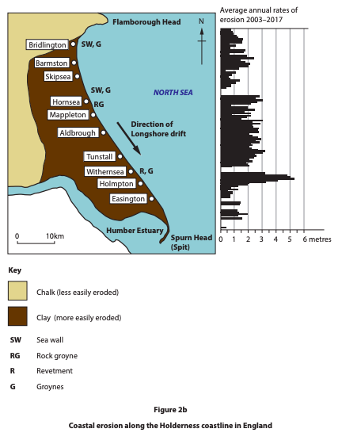
Examine the advantages and disadvantages of the different coastal defences shown in Figure 2b.
(8)
.............................................................................................................................................
.............................................................................................................................................
.............................................................................................................................................
.............................................................................................................................................
.............................................................................................................................................
.............................................................................................................................................
.............................................................................................................................................
.............................................................................................................................................
.............................................................................................................................................
.............................................................................................................................................
.............................................................................................................................................
.............................................................................................................................................
.............................................................................................................................................
.............................................................................................................................................
.............................................................................................................................................
.............................................................................................................................................
.............................................................................................................................................
.............................................................................................................................................
.............................................................................................................................................
.............................................................................................................................................
.............................................................................................................................................
.............................................................................................................................................
.............................................................................................................................................
.............................................................................................................................................
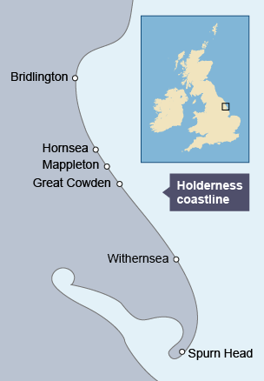
Distinctive coastal landscapes are the outcome of the interaction between physical and human processes.
The Holderness coast, East Riding of Yorkshire is changing.
Location:
Softer boulder clay is easily eroded and prone to slumping following heavy rainfall. Chalk is more resistant at Flamborough Head.
Physical processes:
Coastal erosion – Clay is easily eroded.
Mass movement – Clay slumps after periods of rainfall.
Transport – Destructive waves move sediment away from the coastline.
Human processes:
Hard engineering such as groynes at Hornsea have protected it from erosion, but is reducing longshore drift reading Spurn Head.
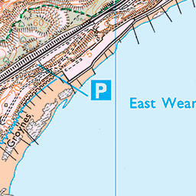
Hard engineering has prevented transportation, making erosion worse in other places.
Managed retreat at Barmston
Changes
Some parts of the coastline are retreating by nearly 2 metres per year.
Farmland, property and houses have been lost to the sea.

