Therapy Pack

Edexcel A GCSE Geography

Geography Skills



Contents

|  |  |
| --- | --- |
| Measuring distance | 3-6 |
| Grid references | 7 |
| Line graphs | 8-9 |
| Bar charts including population pyramids | 10-15 |
| Climate graphs | 16-17 |
| Pie charts | 17-18 |
| Hydrographs | 19 |
| Scatter graphs | 20-21 |
| Proportional symbols | 22 |
| Pictograms | 23 |
| Percentages | 24-27 |
| Averages  Mean, Median, Mode, Range, Interquartile range | 28-33 |
| Ratio | 34-35 |
| Calculate | 36 |

How do we measure distances on maps?

Being able to measure the distance between two points on a map is very important. It allows you to work out what distance is in real life and will give you a good idea of how long your journey will take.

Every OS map is printed with a scale bar that converts the distance you measure on a map (usually in centimetres or inches) into a real life distance (usually in kilometres or miles)

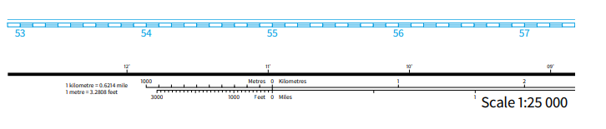

A quick way to measure distance is to count each square you cross on the map. On your OS map each grid square measures one kilometre from side to side and from top to bottom.

If you go diagonally across a square, the distance will be a bit longer – about 1.5 km.

Measuring in straight lines is sometimes called as the crow flies and can be useful over longer distances, for example, to find out how far one town or city is from another.

A method of measuring distance is to take a sheet of paper and place the corner of a straight edge on your starting point.

Now, pivot the paper until the edge follows the route that you want to take.

Every time the route disappears or moves away from the straight edge of your paper, make a small mark on the edge and pivot the paper so the edge is back on course.

Repeat this process until you reach your destination.

You should be left with a series of marks along the edge of your paper. You can now place the sheet against the scale bar on your map.

The last mark you made will tell you the real distance you need to travel.

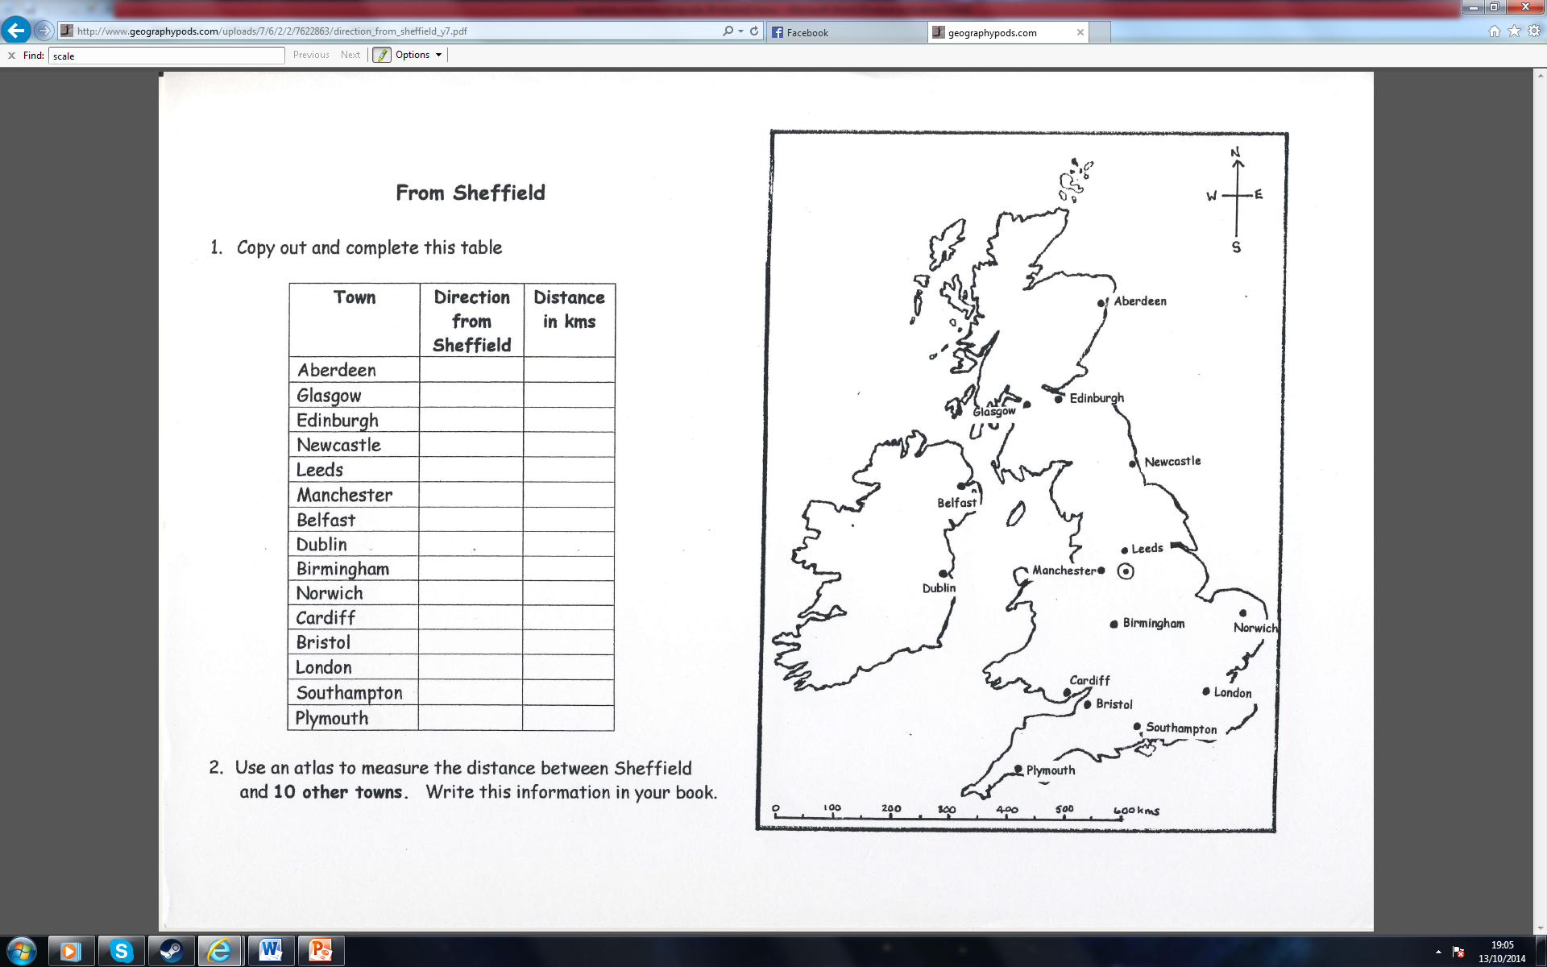

1. Complete the scale

100km _________cm

1. How far away is Cardiff from Bristol.
2. If I am travelling from Southampton to London, what direction am I travelling in and how far?
3. What is the distance between London and Norwich?
4. What is the distance between Manchester and Dublin?

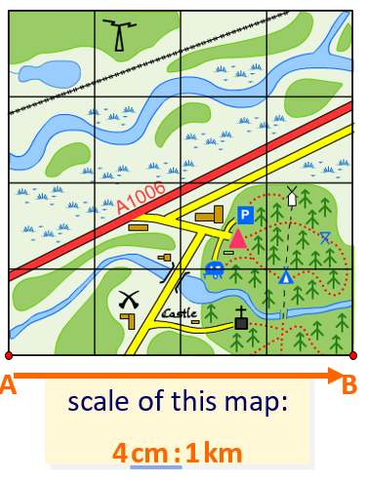

1. This distance is 12 cm on the map.

**How far is it between X and Y in real life?**

Extra questions:

Identify the human uses of this landscape

Describe the river – what course of the river is this?

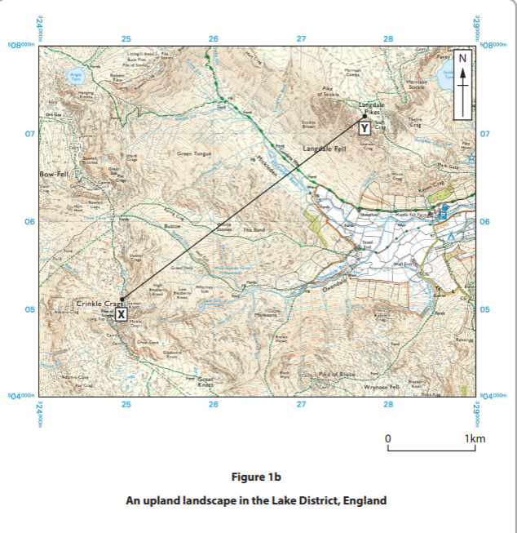

1. Identify the width of the valley between x and y.

First measure the distance between x and y _________

Then measure how many cm is 1km on the scale

____________

Divide the distance by the scale

____________

Answer ___________

Grid references

A grid of squares helps the map-reader to locate a place. The vertical lines are called **eastings**. They are numbered - the numbers increase to the east. The horizontal lines are called **northings** as the numbers increase in an northerly direction.

#### Things to remember:

* When you give a grid reference, always give the easting first: "**Along the corridor and up the stairs**".

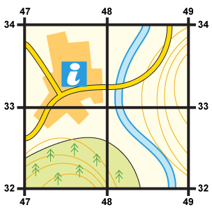**Four-figure grid references** can be used to pinpoint a location to within a square. To find the number of the square:

1. Start at the left-hand side of the map and go east until you get to the bottom-left-hand corner of the square you want. Write this number down.
2. Move north until you get to the bottom-left corner of the square you want. Look at the number of this grid line and add it to the two-digit number you already have. This is your four-figure grid reference.

In this case, the tourist information office is in grid square 4733.

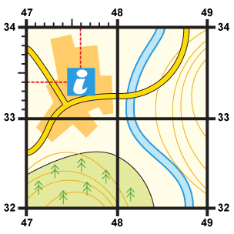

Sometimes it is necessary to be even more accurate. In this case you can imagine that each grid is divided into 100 tiny squares. The distance between one grid line and the next is divided into tenths.

1. First, find the four-figure grid reference but leave a space after the first two digits.
2. Estimate or measure how many tenths across the grid square your symbol lies. Write this number after the first two digits.
3. Next, estimate how many tenths up the grid square your symbol lies. Write this number after the last two digits.
4. You now have a six figure grid reference. In this instance, the tourist information office is located at 476334.

Line graphs

**Line graphs** show how data changes over time or space.

The x-axis shows time or distance.

A line chart could be used to show the changes in a country's employment structure over time.

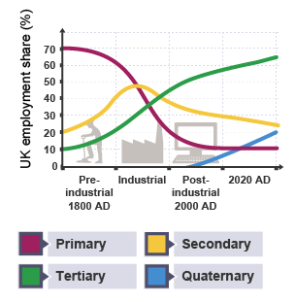This graph shows that in the **post-industrial** era approximately **11%** of employed people work in **primary industries,** 31% in secondary industries, 54 % in tertiary industries and 4 per cent work in quaternary industries. Note how the total adds up to 100 per cent.

In the industrial period

1. What % of people work in the primary industry?
2. What % of people work in the secondary industry?
3. What % of people work in the tertiary industry?

Check – does your total add up to 100?

1. Calculate the increase in people working in the tertiary sector since 1800 (take 65% from 10%)
2. Calculate the increase in people working in quaternary since 2000.
3. Calculate the **decrease** of people working in the primary sector since 1800 AD

Identify the year in which the amount of carbon dioxide in the atmosphere reached 400 parts per million (ppm).

(ii) Calculate the amount by which carbon dioxide (ppm) increased between 1960 and 2020. (1)

........................................................... ppm

**Bar charts**

Bar charts show grouped data as rectangular bars, eg the number of *tourists* visiting a resort each month. Divided bar charts split up each rectangular bar to break the information down further. A divided bar chart could be used to show the age breakdown of tourists visiting a resort. You can identify trends from bar charts such as the highest month of visits will be the highest bar. You can see trends on stack bar charts by subtracting from the total for example you can see that approximately 1000 1-18 year olds visited the resort in March. You are also able to calculate the range (subtracting the highest from the lowest) to show visitor numbers.

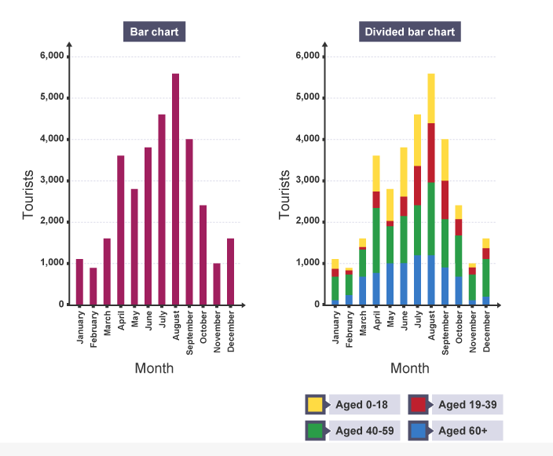

1. Identify the month with the highest number of visitors
2. Identify the month with the lowest number of visitors
3. Calculate the range of visits.
4. How many visits of people age 40-59 happened in April?
5. Identify the total number of visits of people aged 19-39 in August.

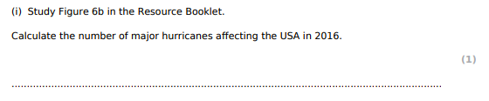

Population pyramids

Population pyramids are bar charts that show how many people of different ages are living in a place or country. Population pyramids show the bars arranged sideways, rather than upwards. The x-axis shows the number of people, the *y-axis* shows their ages. The bars on the left show the number of males and the bars on the right show the number of females. The wider the pyramid, the more people there are at the age (mode). The narrower the base of the pyramid, the lower the birth rate.

This pyramid is using absolute figures but population pyramids can also use percentage figures on the x-axis.

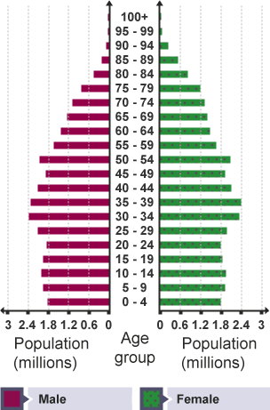

1. Identify the modal age.
2. 25 to 29
3. 10 to 14
4. 30 to 39
5. Is the birth rate high or low?
6. Calculate the total number of babies below 4 years.

Climate graphs

Bar charts and line graphs can be combined together. **Climate graphs** are an example of this. The x-axis shows the months of the year and there are two y-axes to show average temperature and total rainfall. The temperature is shown as a green line and the rainfall as bars.

Discrete bar graphs are required when the data to be presented is not continuous. Therefore discrete bar graphs will always have gaps (of equal distance) between them.

When reading climate graphs there are five readings which are standard:

* maximum temperature = the highest temperature recorded
* minimum temperature = the lowest temperature recorded
* range of temperature = the difference between the max and min
* total annual rainfall = total of the 12 months
* rainfall pattern = the variation throughout the year

**Interpreting climate graphs**

You may need to look at the information in a graph and describe the area's climate.

Look for patterns in the temperature data.

* Is the temperature the same all year round? If it is different, how many seasons does the location experience?
* Which season is the warmest? Is it warm (10 to 20°C), hot (20 to 30°C) or very hot (above 30°C)?
* Which season is the coolest? Is it mild (0 to 10°C), cold (-10 to 0°C) or very cold (below -10°C)?
* What is the range of temperature? (Subtract the minimum temperature from the maximum temperature).

Look for patterns in the rainfall data.

* Does the rainfall occur all year round?
* What is the pattern of the rainfall? Check which season(s) is/are drier or wetter than others.
* What is the total annual rainfall? Add each month's total together to get the annual total.
* Then put the rainfall and temperature information together - what does it tell you about this area?

Describe the patterns in temperature and rainfall, including how they relate to each other. You now have a description of the climate.

Now look again at the climate graph. What can you deduce about the climate?

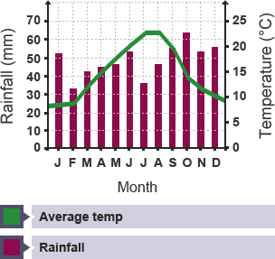

1. The UK's average temperature peaks in

_____________ and August at 23°C.

1. Rainfall happens all year round, peaking

in October at __________mm

Pie charts

**Pie charts** show percentages as a circle, divided into segments. A pie chart could be used to show how students travel to school. Each piece of data is shown as a proportion of 360, because there are 360 degrees in a circle. If 25 out of 100 students travel to school by car, the angle is worked out using the calculation: (25 ÷ 100) × 360 = 90 degrees.

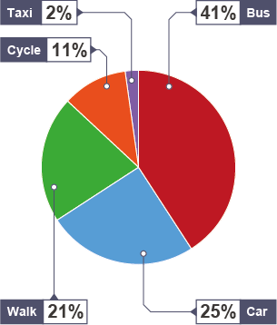The pie chart shows that 41 per cent of pupils travel by bus, 25 per cent by car, 21 per cent walk, 11 per cent cycle and 2 per cent travel in a taxi.

* 1. Identify the most common mode of transport
  2. Calculate the total percentage of people travelling sustainably.
  3. If 100 people are studied. Calculate the total NUMBER of people who walk or cycle to school?
  4. If 200 people were studied, calculate the total number of people who use cars or taxis as a mode of transport.

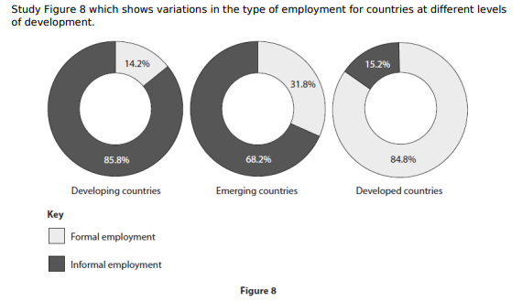

#### Hydrographs

A hydrograph shows two graphs - rainfall (in bars) and discharge (in a line).

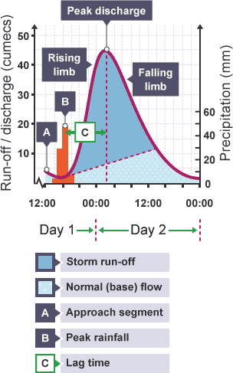

#### Interpreting a hydrograph

The **peak rainfall** is the time of highest rainfall. The **peak discharge** (the time when the river reaches its highest flow) is later because it takes time for the water to find its way to the river (**lag time**). The normal (**base**) flow of the river starts to rise (**rising limb**) when run-off, ground and soil water reaches the river. Rock type, vegetation, slope and situation (for example, is this an urban river?) affect the steepness of this limb. The **falling limb** shows that water is still reaching the river but in decreasing amounts. The run-off/discharge of the river is measured in cumecs - this stands for cubic metres per second. Precipitation is measured in mm - this stands for millimetres.

Peak discharge was 45 cumecs, peak rainfall was 50 mm, lag time was nearly 10 hours. The storm lasted just over 4 hours

1. What time did the river return to normal base flow?
2. What was the discharge of the river when peak rainfall was reached?
3. Identify the range of discharge (highest discharge in cumecs subtracted from lowest discharge in cumecs)

#### Scatter graphs

**Scatter graphs** show relationships between two sets of data. Points are located using the x and y-axis. Sometimes these points are arranged in a pattern. A scatter graph could be used to show how literacy is related to gross domestic product (GDP).

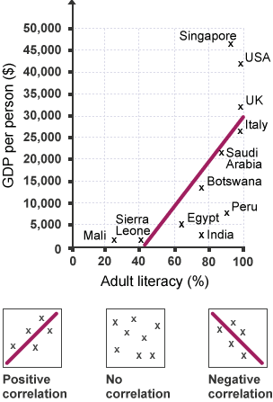

A line of best fit helps to show correlations, or patterns within the data. The line of best fit runs through the middle of points on the graph, ideally with an equal number of points on either side of the line.

* A **strong correlation** is when the points are very close to the line of best fit.
* A **weak correlation** is when the points are far away from the line of best fit.
* A *positive correlation* is when an increase in one factor causes an increase in another - the line of best fit goes from the bottom left to the top right.
* A *negative correlation* is when an increase in one factor causes a decrease in another - the line of best fit goes from the top left to the bottom right.

1. Identify the corelation
2. Describe the pattern
3. What is the literacy rate of Mali?
4. Identify the countries with the highest literacy rate (3)
5. Identify three countries with the lowest literacy rate.
6. Why is this not a strong corelation?
7. Explain why Peru is an anomaly.

An anomaly is something that is different to what is expected.

Identify the anomaly

________________________________

#### Proportional symbols

**Proportional symbols** can be added to maps or graphs to show information about different places. This graph plots life expectancy against income for each country. It also shows population size. Each country is shown as a circle, where the size of the circle is proportional to the population of the country, ie the bigger the circle, the bigger the population of that country. These work similar to trade or flow line graphs in which the thickness of the line corresponds to a higher frequency, this is usually shown on a scale.

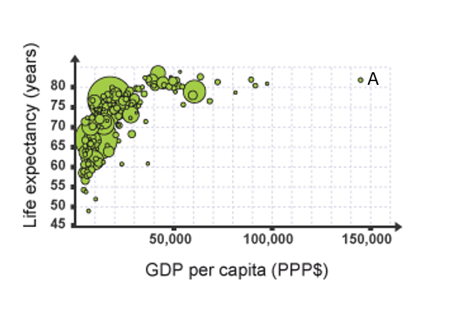

A proportional symbol graph can use shapes to show comparisons between data points, eg population size of countries plotted on a graph of life expectancy vs GDP per capita

* 1. Describe the relationship
  2. What is the GDP of country A
  3. What is the life expectancy of country A
  4. Describe the population of country A.

**Pictograms**

Pictograms are like bar charts, but they use small pictures or icons to show data instead of bars. Pictograms could be used to show the weather conditions experienced in a particular place.

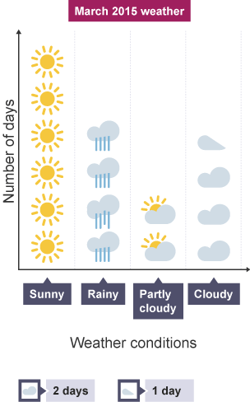

A pictogram uses symbols to stand in for data, eg in a weather pictogram a full symbol means that kind of weather happened for two days. Half a sun symbol would mean "One day of sunshine"

1. Calculate the number of days with sunshine
2. Calculate the number of cloudy days
3. What is the most common weather in this place?

Percentages

Percentage change

Calculating the percentage increase between two figures is achieved by:

* calculate the difference between the two numbers
* divide the increase (difference) by the first number
* multiply the answer by 100.

Percentage decrease

Mean

Add all of the numbers together and divide by the total

Median

The middle number when they are all in chronological order

If you have two middle numbers you divide them by 2 to give your median.

1. Identify the median deprivation score. (1)

Mode

The most common number in a set of data.

Range

The difference between the highest and lowest number

Interquartile range

We know that for a set of ordered numbers, the median Q2, is the middle number which divides the data into two halves.

Similarly, the lower quartile Q2 divides the bottom half of the data into two halves, and the upper quartile Q3 also divides the upper half of the data into two halves.

The interquartile range is the **difference** between the upper quartile and lower quartile.

To calculate the interquartile range (IQR):



Ratio

Is the number of one part compared to the number of one or more other parts. A ratio of an amount it can be similfied. E.g. If it’s 200:100 it could be simplified to 2:1

Ratios can be used to divide a quantity into parts or show how many times bigger something is.

To calculate this follow these 3 steps:

1. Find the total number of parts by adding the parts in each share.
2. Divide the amount by this total to find what 1 part is worth.
3. Multiply 1 part by the number of parts in each share to find each share.

Calculate

This is adding

Calculate the ‘difference’

This is subtraction.

