Therapy Pack

Edexcel A



Paper 2 – Global Development

GCSE Geography

**This GCSE requires you to:**

**AO1 15%** – Demonstrate knowledge of locations, places, processes, environments and different scales.

**AO2 25%** - Demonstrate geographical understanding of:

Concepts and how they are used in relation to places, environments and processes (e.g. trade, urbanisation)

Inter-relationships between places, environments and processes

**AO3 35%**– Apply knowledge and understanding to interpret, analyse and evaluate geographical information and issues and to make judgements

**AO4 25%** - Select, adapt and use a variety of skills and techniques to investigate questions and issues and communicate findings

The Global Development section of the paper will **always**:

* Be section B of paper 2
* Be worth 34 marks
* Have low mark questions (1m-4m)
* Have an 8m question at the end with an extra 4m SPAG

**How to guide.**

|  |  |  |
| --- | --- | --- |
| **Command word, marks and time.** | **What you need to include in your answer.** | **For example…** |
| State/identify  1 mark, 1 min | Name something, no detail needed, often a one-word answer | Name the country with the highest GDP on figure 2a. (1) USA |
| Describe  1,2,3 or 4 marks  No more than 4mins | Say **what** something is, no reason needed.  1 mark per correct statement | Describe the distribution of HDI shown in figure 2b. (3)  The **g**eneral pattern is uneven, for **e**xample the southern hemisphere is lower with the **o**dd one out being Australia with the **g**reatest being in Europe and North America. |
| Outline  2,3 or 4 marks  2 – 4mins | Same expectations as EXPLAIN – see below. | Outline one cause of global inequality (4)  One cause is the distribution of resources (1_, for example countries with resources such as coal or oil can trade (1) these for money (1) so become more developed than those with limited resources (1) |
| Explain  2,3 or 4 marks  2-4mins | Say why something is happening, using so or because.  An explain question for 3 marks needs 1 reason explained in depth  An explain question for 4 marks needs 2 reasons, both explained clearly. | Explain the effects of rapid development (4)  One effect is congestion (1) from more people so higher levels of air pollution in cities such as Delhi (1). Another effect is higher GDP (1) due to increased investment from TNCs (1). |
| Assess  8 marks  10-12mins | Paragraph 1 – you must use show breadth about the topic of the question. General information about this.  Paragraph 2/3 – Answer the question, including at least 2 ideas/options.  Paragraph 3/4 – Conclusion, a JUDGEMENT answering the question, which is the best/worst/most important. | Assess the impacts of rapid development in a named developing or emerging country you have studied. (8)  P1 – In India, rapid development was caused my…  P2/3 – One social impact is…so…for example...  However, an economic impact is…therefore…for example in…  P4 – In conclusion rapid development has been positive/negative because… |
| Evaluate  8 marks  10-12mins | Paragraph 1 – you must use show breadth about the topic of the question. General information about this.  Paragraph 2/3 – Answer the question, must include positives/negatives or costs/benefits.  Paragraph 3/4 – Conclusion, a JUDGEMENT answering the question, which is the best/worst and why. | Evaluate the success of strategies used to reduce global inequality.  P1 – Global inequality is… it has been caused by…  P2/3 – One strategy has been….so…for example…  Another strategy has been…. therefore…for example…  P4 – In conclusion I think the strategies have/have not been successful because… |

**Geographical Vocabulary:** using these words throughout you answers is essential for grade 7 and above

|  |  |  |  |
| --- | --- | --- | --- |
|  | **Geographical vocabulary** | **Definition** | **In a sentence** |
| Measuring development | Gross Domestic Product (GDP) per capita | The total value of goods and services made in a country in 1 year, divided per person. | The UK has a higher GDP than China due to more trade and a lower population. |
| Human Development Index (HDI) | A way of measuring development using health (life expectancy), wealth (GDP) and education (mean years of schooling) | HDI is better than GDP as it includes a range of factors as some countries have less money but good education. |
| Measures of inequality | Economic, social and environmental indicators used to compare a country’s development, for example GDP | Life expectancy, birth rate and infant mortality are all measures of inequality and help us understand how developed a country is. |
| Levels of development | Developed country | A more economically developed country with higher levels of wealth and health (e.g. UK, USA, Germany, Qatar) | The GDP of developed countries such as the UK is high. |
| Emerging country | Countries that are improving their levels od economic development through investment and trade e.g. BRICS and MINTS | BRICS are examples of emerging countries whose economies are growing, and GDP is increasing. |
| Developing country | Less economically developed countries with lower levels of health and wealth e.g. Niger, Chade | The life expectancy of people in developing countries is significantly lower than developed countries. |
|  | Geo-politics | Political and trading relationships with other countries through imports and exports. | India has poor geo-political relationships with Pakistan due to the historical factor of partition. |
|  | Demographics/ Demography | The changing size of populations due to births, deaths and migration. This is often displayed in a population pyramid. | The demographics of India have changed due to higher birth rates and lower death rates leading to a population of 1.2billion. |
|  | Trans-National Corporation (TNC) | A firm that owns or controls production in more than one country through foreign direct investment. | TNC’s such as Coca-Cola and HSBC have privately invested in India. |
|  | Historical factor | Things in the past that affect a country’s development now, for example the British Empire | One historical factor affecting the GDP of the UK is the British Empire. |
|  | Core and periphery | The core is at the centre for economic development and investment whilst the periphery falls behind and the gap grows. | Core areas of India such as Mumbai are more developed than periphery areas such as Uttar Pradesh which are based on agriculture and have low investment and wages. |
| Strategies to reduce inequality | International trade | The selling of goods between countries. | International trade between countries increases the GDP of them. |
| FDI (Foreign Direct Investment) or Private investment | Money invested by companies and organisations into a country. | Private investment such as Coca-Cola opening bottling factories in India can help a country develop. |
| Aid | The giving of resources to a country with no return, for example, money, doctors, water. This can be governmental or voluntary. | Voluntary aid is often given my NGO’s such as OXFAM after a disaster to help a country e.g., tents after a hurricane. |
| Secondary sector | Industry/Factories involved in the processing of raw materials e.g. manufacturing cars, bottling of Coca cola | More secondary sector jobs will increase a country’s GDP. |
| Bottom-up strategy | Projects that involve local people and communities in decision-making, often involving small-scale projects for the poorest. | Bio-gas and the Life-line express are 2 examples of bottom up approaches in India |
| Top-down strategy | Where decisions are made by governments or large companies with little thought for community needs; often large-scale and expensive. | Modi’s vision to develop smart cities and electrify all villages is a top-down approach to reducing inequality in India. |

**Use the core knowledge table below to RAG your understanding.**

|  |  |  |  |
| --- | --- | --- | --- |
| **Knowledge** | **Red** | **Amber** | **Green** |
| Ways of **defining** development, using economic (£), social and political factors including HDI and GDP. |  |  |  |
| Global pattern of development and **causes** of inequality (historical, physical, economic) |  |  |  |
| Impacts of uneven development on the quality of life globally; housing, health, education, employment, technology, food and water and security. |  |  |  |
| International strategies that try to reduce uneven development (trade, aid, FDI, including examples) |  |  |  |
| UK pattern of development and causes of inequality (historical, physical, human, economic |  |  |  |
| Strategies that try to reduce uneven development (trade, aid, including examples) |  |  |  |
| The difference between top down and bottom up projects to reduce uneven development. |  |  |  |
| **Named location: Pakistan** | | | |
| Location and context (religion, culture, environment, political) |  |  |  |
| Pattern and causes of uneven development (core and periphery) including examples |  |  |  |
| Impacts of uneven development on people, the environment and economic sectors (move from primary and secondary to secondary and tertiary) |  |  |  |
| Trade and TNC investment into and between countries. |  |  |  |
| Geo-political relationships with other countries (e.g. military pacts, foreign policy etc) including how connected it is to other countries through technology. |  |  |  |
| Impacts of rapid development (positive and negative) |  |  |  |
| Management of these impacts to improve status and quality of life. |  |  |  |

**Core knowledge:** Grade 7+ outstanding geography is highlighted

* **Ways of defining development, using economic (£), social and political factors including HDI**

Using a range of development indicators such as life expectancy, mean years of schooling, birth rate etc. Understanding that there are limitations of these and a composite measure like HDI is better than a single measure such as GNI.

* **Global pattern of development and causes of inequality (historical, physical, economic)**

Confident in describing the distribution of varying global/world maps. Historical factors such as the British Empire causing the development of the UK and other colonial countries (e.g. Spain and France). Physical causes such as being landlocked limits trade, climate limits the food which can be grown and in turn traded so limited development. Economic factors include in TNC investment, FDI and infrastructure development to encourage trade.

* **Impacts of uneven development on the quality of life globally; housing, health, education, employment, technology, food and water and security.**

Creation of informal housing in core areas such as Oranghi Town in Karachi which has significantly lower life expectancy than other areas of the city. Education levels are improving across the country with access to health care and education slowly improving in rural periphery areas such as Balochistan and Rural Sindh Province. Investment in technology such as call centresand TNC’s such as Coca Cola, UniLever and Nestle has increased the economy of areas such as Karachi. Investment from China in the non renewable and renewable sectors in Balochistan is a strategy to reduce uneven development by providing different levels of skilled employment.

* **International strategies that try to reduce uneven development (trade, aid, including examples)**

Trade is the buying and selling of products between countries. FDI supports this and allows for more money to be received by a country to support it becoming more developed. Aid is received in a range of forms, voluntary usually being short-term emergency aid after a natural disaster or through NGO’s such as Oxfam for long term development aid. Governmental aid also supports reducing the development gap.

* **UK pattern of development and causes of inequality (historical, physical, human, economic)**

Historically, deindustrialisation of the north in the 1980’s and 1990’s by closing of heavy industries such as coal mines and steel works means a lower GDHI and a north/south divide (2 speed economy). Physically, the flatter land in the south east of the UK allows for more farmland and the growth of the London and the south-east area. Economically, TNC investment in London as the capital city from tertiary sector jobs such as banking e.g. Citi bank. Tourism also brings economic gain to areas such as London causing this inequality.

* **Strategies that try to reduce uneven development (trade, aid, including examples)**

Trade is used to encourage economic development and connections, Aid is the provision of something for free in order to support another country’s development, for example teachers, money or food. This can be voluntary, governmental, long and short term or even emergency.

* **The difference between top down and bottom up projects to reduce uneven development.**

Top down will be more impactful in a shorter time but will cost more and often have more negative effects in the short term. Bottom up is more community based and so will take longer to have an impact but is likely to be more sustainable and consider the needs and views of the people. The Sindh water project (bottom up, Charity led) is enabling women to get an income as the time that they spent gathering water can now be used for making things to tell at market. The ‘tree tsunami’ a large, top down project attempts to provide employment for people in the desert regions whilst also reducing soil erosion, cleaning the air and providing a better water security for the region.

**Named location: Pakistan**

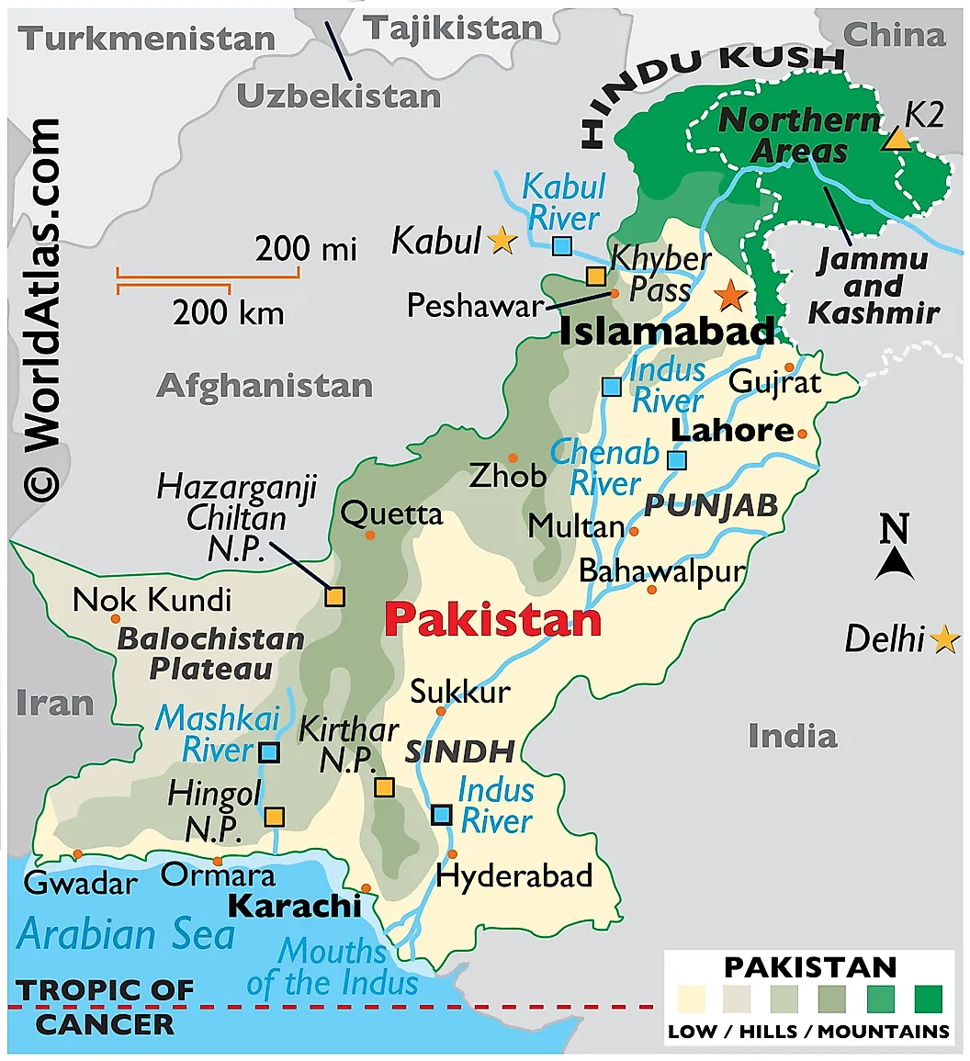

* **Location and context (religion, culture, environment, political)**

Pakistan is in Asia, to its south is the India Ocean, to the north is China and the east and West are India and Afghanistan, the northernmost part of Pakistan is mountainous. India borders Pakistan which until 1947 after the end of WW2 and collapse of empires when the ‘Partition’ occurred and Pakistan became it’s own country. It has a population of 247.5 million, the fifth most populous country in the world. Shehbaz Sharif is the Prime Minister and it is a mostly Muslim country. Environmentally, its cities have high levels of air pollution, there are mountainous and desert regions too.

* **Patterns and causes of uneven development (core and periphery) including examples.**

Core areas are mainly along the Indus river. They have developed rapidly due to investment by both the government and TNC’s such as Coca-Cola and Nestle. The location of Karachi and Islamabad means it is attractive to tourists. Balochistan and Sindh in the South West and East of Pakistan border Afghanistan and India respectively, they have a harsher climate which means trade and investment are much more limited.

* **Impacts of uneven development on people, the environment and economic sectors (move from primary and secondary to secondary and tertiary)**

*People* – life expectancy, access to running water, health care and education vary

*Environment* – air quality in core cities is poor and can compare in Karachi to smoking 50 cigarettes a day.

*Economy* – TNC investment and FDI has mean a movement to secondary and tertiary jobs in core areas, upskilling workers and increasing GDP and GNI. However, wages are still lower than cities in developed countries such as the UK.

* **Trade and TNC investment into and between countries.**

In 2024 India traded £29 billion of products with China This includes oil, rice, technological products. TNC’s like Coca-Cola and Nestle from the USA invested in core areas within Pakistan, such as the production factory plant in Lahore (in the Northern Punjab region).

* **Geo-political relationships with other countries (e.g. military pacts, foreign policy etc) including how connected it is to other countries through technology.**

The 1947 Partition of Pakistan and india caused a negative geo-political relationship between the countries, some of which is religion based. Military agreement between nearby Islamic countries (including Afghanistan, Saudi Arabia) to reduce terrorism in the area to attract investment in the region has been someone successful.

* **Impacts of rapid development (positive and negative)**

*Positive* – rapid increase in life expectancy (4 years in 4 years), access to healthcare, education and technology has increased the population. Increased GDP and GNI and improvements in the HDI. Greater investment of TNC’s moving jobs from primary to secondary and tertiary, including call centres and tourism.

*Negative* – greater disparity/divide between the richest and poorest of the country. High levels of atmospheric pollution due to more heavy industry and greater congestion. Higher % of people living in informal settlements. Dilution of culture to become more ‘Westernised’. Gender inequality and air quality is poor, high levels of unemployment.

* **Management of these impacts to improve status and quality of life.**

Top down and bottom up approaches

* Leave no girl behind (bottom up) - a charity set up to encourage girls to go to school, educating families on why it is important to send them
* Tree Tsunami (top down) - tree planting project in the north of the country aims to plant 10 million trees to improve air quality, provide employment, increase rainfall, reduce flood risk
* Tarbela Dam (top down) - hydroelectric power.
* CPEC coal investment (top down) - investment in the development of coal power plants from China to increase employment in Balochistan (an example of foreign direct investment)
* CPEC renewable investment (top down) - investment in hydropower in the northern, mountainous regions will increase employment, improve air quality, provide energy security, and lift rural communities out of poverty in Khyber Pakhtunkhwa.

Aid, trade and FDI (see previous)

**Core skills:** These are the skills you will be tested on in this section of the exam.

Here you are provided with an excerpt from a newspaper. **Always** read the summary so you understand the context of the information being provided. Next, read and highlight the text.

These types of questions are expecting you to identify some relevant information from the figure to answer the question and then develop this with your own knowledge.

***E.g. Calculate the increase in estimated mobile broadband connections between  
2017 and 2022.***

Interpolate data = completing a graph with some data that has been provided.

Extrapolate data = reading the graph, taking data from it to answer a question. This could be a single set of data or describing a trend.

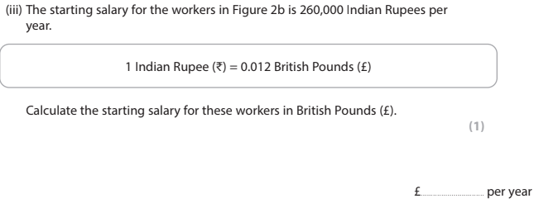

Data handling is broad in this paper and you will be expected to complete this sort of question. Skills you must have are:

* Range
* Mean
* Modal value (mode)
* Median
* Percentage
* Percentage increase
* Ratio/conversion

This is an example of the data you could be provided with Skills you must have are:

* Range
* Mean
* Modal value (mode)
* Median
* Percentage
* Percentage increase
* Compare
* Describe the trend (pattern)

This is an example of the data handling you will be questioned about.

To complete the pie chart you simply need to know what percentage each ‘notch’ represents. On this one (and usually) it is 5% for each one.

Therefore, to add in the data for Japan you count 5 sections (5 section at 5% each = 25%), draw the line to the center and label the section.

**Questions:** these are examples of question stems for this section

**Identify one**… way to measure development (1)

**Describe the** …changes in a named developing country you have studied (2)

**Outline one** …cause of rapid development in a named developing or emerging country that you have studied (3)

**Explain how/why/reasons/causes/effects**…some countries are more developed than others(4)

**Assess**…the effects of rapid development in a named developing or emerging country you have studies (8).

**Assess this statement**…’Economic investment is the most important cause of rapid development’ (8).

**Evaluate the views/approaches** …to managing rapid development in a named developing or emerging country you have studied (8)

**WAGOLLS**: these are examples of grade 7+ responses

The highlighted sections are examples of exceptional geography.

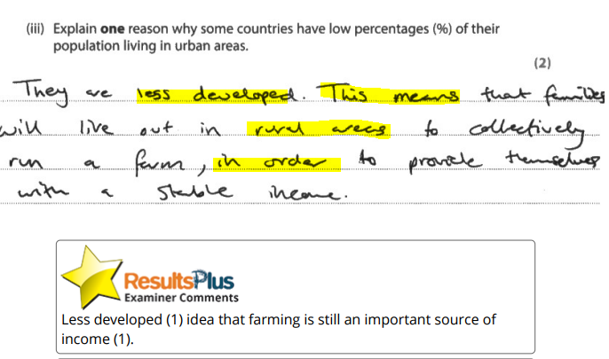

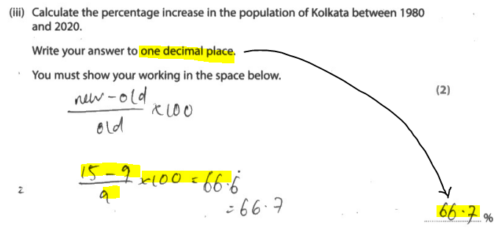

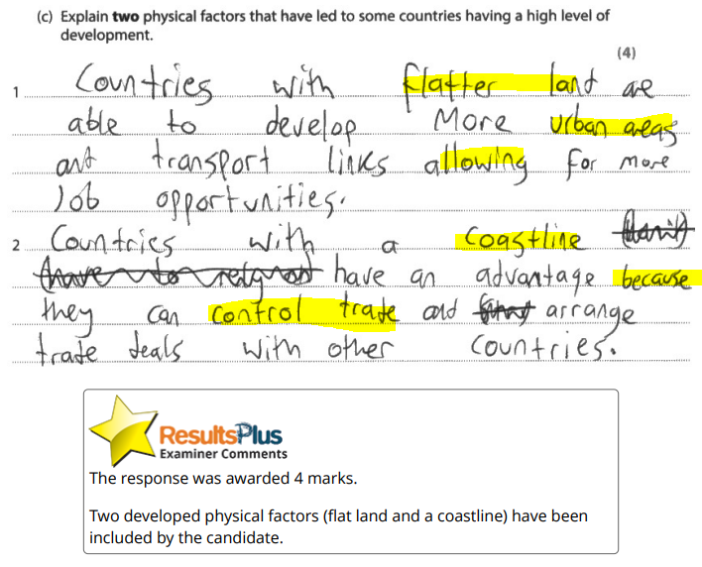

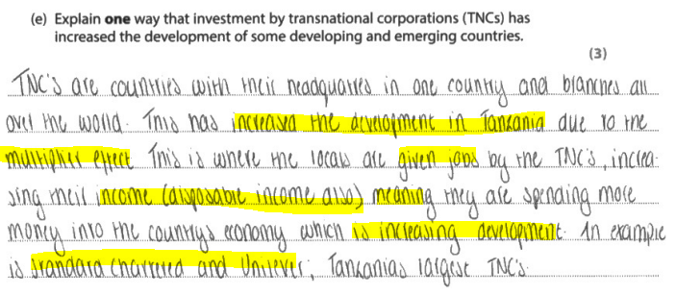

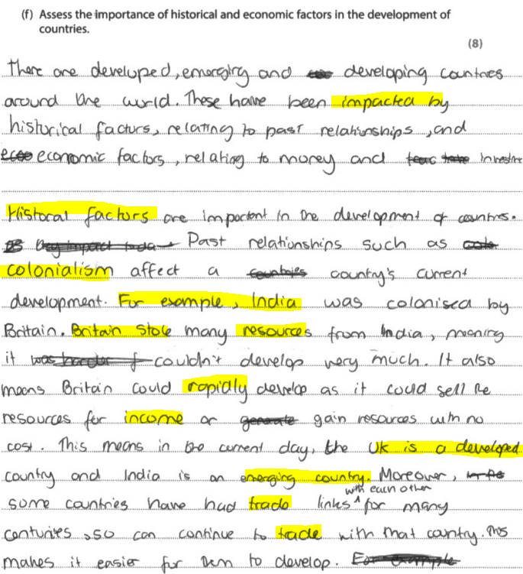

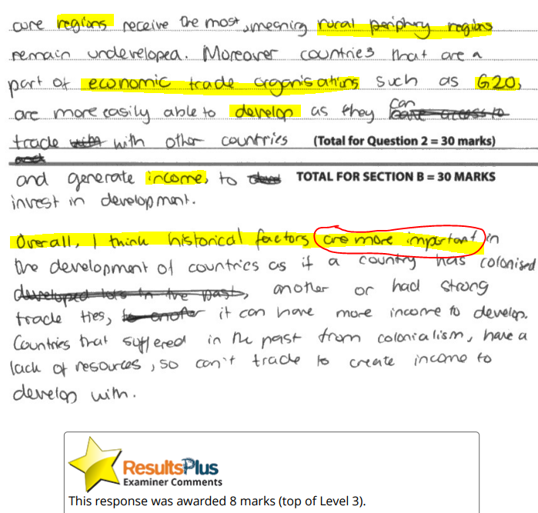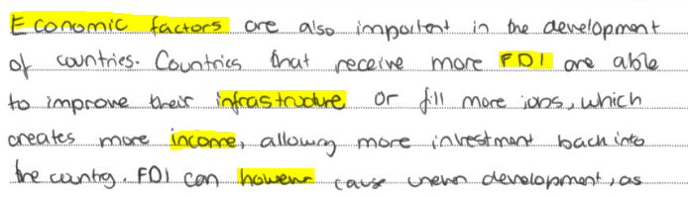

**Assess – the 8m question for this paper**

**This should include a balance in your answer, with a judgement in your conclusion. For example, a few factors causing something, or a range of opinions of an approach.**

You should always follow the 3 section structure:

1. General topic of the question e.g. resources, development etc
2. Answer the question with a balance (positive/negative, agree/disagree etc)
3. Conclude – this is a judgement -what you think is the most important/best and why? Which is most important and why?

**evaluate – the 8m question for this paper.**

**This should include a balance in your answer, with a judgement in your conclusion. For example, the advantages/disadvantages, how successful it has been.**

You should always follow the 3 section structure:

1. General topic of the question e.g. resources, development etc
2. Answer the question with a balance (positive/negative, etc)
3. Conclude – this is a judgement -what you think is the most important/best and why? Do you agree/disagree/somewhat & why?