**Content Area 9: Child Development – Planning in Early Years**



**Revision Workbook**

**Name:**

**Class:**

**Teacher:**

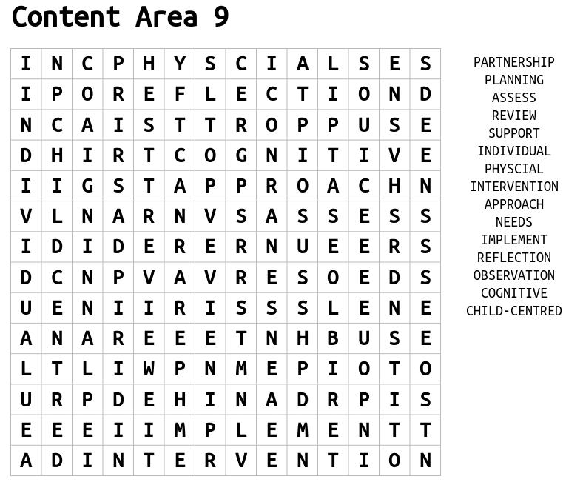



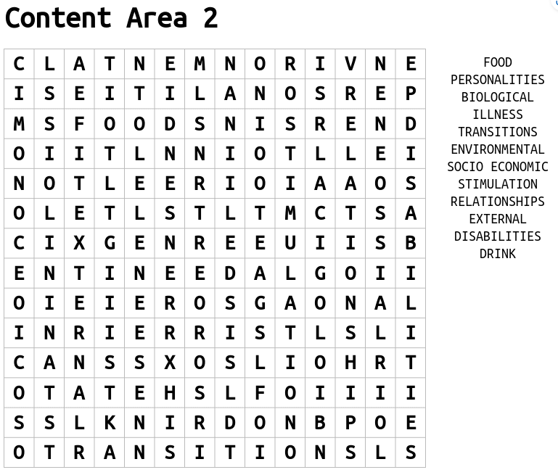

**Complete the diagram for the Planning Cycle**

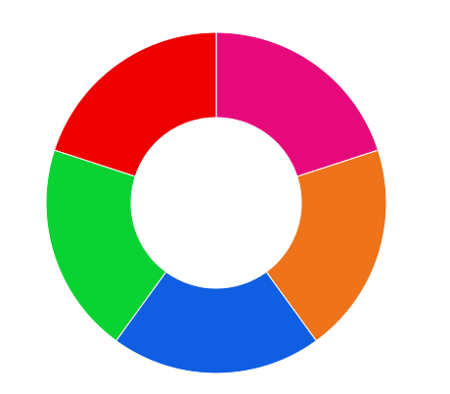

**Complete the questions**

1. **What is child-centred planning?**

------------------------------------------------------------------------------------------------------------------------------------------------------------------------------------------------------------------------------------------------------------------------------------------------------------------------------------------------------------------------------------------------------------------------------------------------------------------------------------------------------------------------------------------------------------------------------------------------------------------------------------------------------------------------------------------------------------------------------------------------

1. **What is the purpose of child-centred planning?**

------------------------------------------------------------------------------------------------------------------------------------------------------------------------------------------------------------------------------------------------------------------------------------------------------------------------------------------------------------------------------------------------------------------------------------------------------------------

**How can and EYP support child-centred planning?**

**What are the benefits of a child-centred approach?**

**What are the challenges of a child-centred approach?**

**How does the EYP put the child at the centre of their planning?**

**What is the purpose of the planning cycle?**

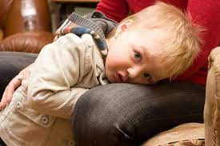**9. Scenario: Ronnie is 3 years old and is very shy and timid. He does not mix with other children without significant encouragement. He likes dinosaurs and water. Identify resources and activities that might to support Ronnie.**

----------------------------------------------------------------------------------------------------------------------------------------------------------------------------------------------------------------------------------------------------------------------------------------------------------------------------------------------------------------------------------------------------------------------------------------------------------------------------------------------------------------------------------------------------------------------------------------------------------------------------------------------------------------------------------------------------------------------------------------------------------------------------------------------------------------------------------------------------------------------------------------------------------------------------------------------------------------------------------------------------------------------------------------------------------------------------------------------------------------------------------------------------------------------------------------------------------------------------------------------

**10. Create an Outdoor area/activity plan for Ronnie:**

Success Criteria:

* Identified different areas for the setting
* Activity plan includes:
* Age range
* Location
* Step-by-step guide
* Resources
* Link to holistic development
* The reasons it is important