**Content Area 8: Child Development – Observations**

**Revision Workbook**

**Name:**

**Class:**

**Teacher:**

|  |  |
| --- | --- |
| What is formative assessment ? | What is summative assessment ? |
| What is the difference between subjective and objective observations of children? | Name 5 different observation methods…. |

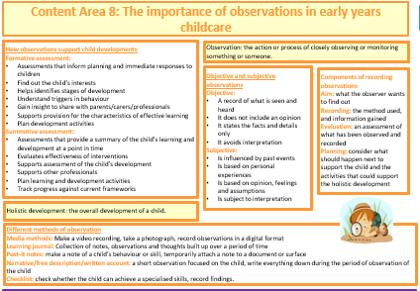

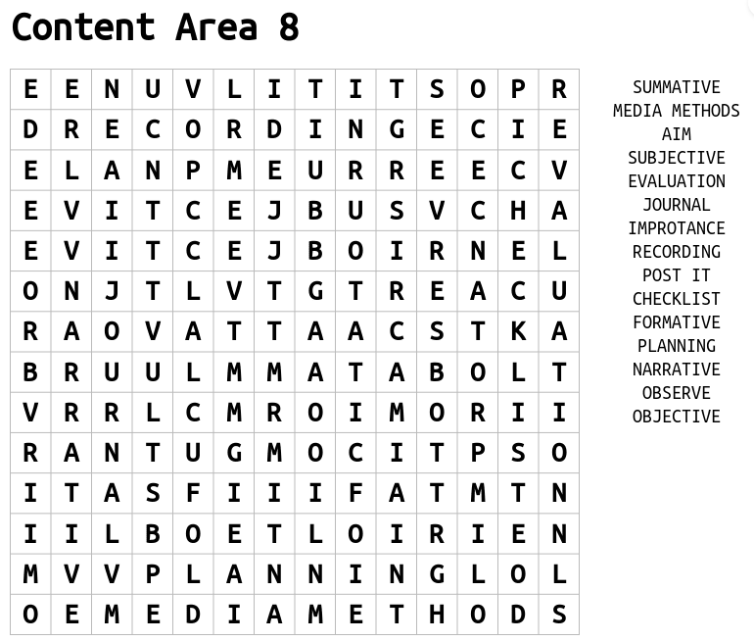



**Key Terms**

**Holistic development**

**Subjective observations**

**Objective observations**

**Observation**

**Formative VS Summative**

|  |  |
| --- | --- |
| **Key Term** | **Definition** |
| Formative Assessment |  |
| Summative Assessment |  |

**Different methods of observation**

**Media Methods**

Making a video recording

This allows the EYP to record details of what is seen and what is heard when observing a child. The EYP may set up an activity in one area of the room, that focusses on a particular area of development, and video record the child taking part in the activity.

|  |  |
| --- | --- |
| Advantages | Disadvantages |
|  |  |

Take a photograph

Photo observations are a good visual tool for capturing a child's learning during an experience and provide an insight into the child's development. A photograph can help to see development from different perspectives, if the EYP can change the angle of the camera. The EYP can also zoom in to show a particular aspect, such as how a child is holding a pair of scissors. The pictures are usually accompanied by a caption to explain what is being shown.

|  |  |
| --- | --- |
| Advantages | Disadvantages |
|  |  |



Record observations in a digital format

Many early years settings now record observations digitally. This means that each child will have documents of their development in an electronic format. As well as this, many early years settings also provide an app, where observations (photos, videos and written information) can be uploaded and shared with parents/carers.

|  |  |
| --- | --- |
| Advantages | Disadvantages |
|  |  |

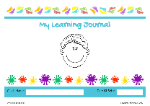Learning journals

This is a record of a child’s learning and development, throughout their time in an early year setting. The journal is based on the EYFS framework. It will be built up over the years and show the child’s achievements. The child’s key worker will often create activities and experiences to meet a child’s individual needs. Through the use of observations, this record can then be built.   
The journal will include:

* evidence from observations
* annotated photographs
* snapshots of significant achievements
* quotes from the child
* art work
* mark makings
* comments from parents/carers

The aim of the journal is to build a unique picture of what each child knows, feels and can do, as well as their particular interests and learning style.

It can also be used to pinpoint learning priorities, as well as plan appropriate future activities/learning experiences to meet the next steps in a child’s development.

|  |  |
| --- | --- |
| Advantages | Disadvantages |
|  |  |

Post-it Notes

This method is useful for capturing ‘magic moments’. They are the briefest observations the EYP will make. EYPs can record, for example, a child’s ‘firsts’, e.g., the first time they climb steps unaided. It is then easy for the EYP to put the post-it notes into the child’s learning journey (or record later if learning journey is electronic). The aim of this type of observation is to build a picture about children’s interests and development from many pieces of information.

|  |  |
| --- | --- |
| Advantages | Disadvantages |
|  |  |

Narrative methods

These types of observation are written methods. The method will describe what a child is doing or has done, for example "Jack is playing with wooden bricks. He is using one brick at a time to build a tower." Narrative observations may record what a child is doing over a few seconds or much longer. Sometimes photographs or film clips are used with narrative observations.

|  |  |
| --- | --- |
| Advantages | Disadvantages |
|  |  |

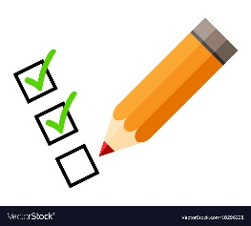Checklist/Tick chart

They are a simple way to assess children's skills. A list of statements is prepared, for example, 'Is able to put on coat without fastening it up', 'Is able to use spoon to feed'. The statements are normally based on milestones for children's development or outcomes from the early years’ curriculum.

How to do a 'checklist and tick chart’:

* Read and check understanding of all the statements
* EYP will decide whether to ask the child to show them the skill or keep watching to see whether they show the skill in the session (timely!)

|  |  |
| --- | --- |
| Advantages | Disadvantages |
|  |  |

**Why it is important that the EYP conducts observations on children?**