**Content Area 7: Child Development - Roles and Responsibilities**

**Revision Workbook**

**Name:**

**Class:**

**Teacher:**

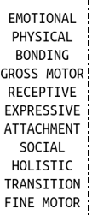

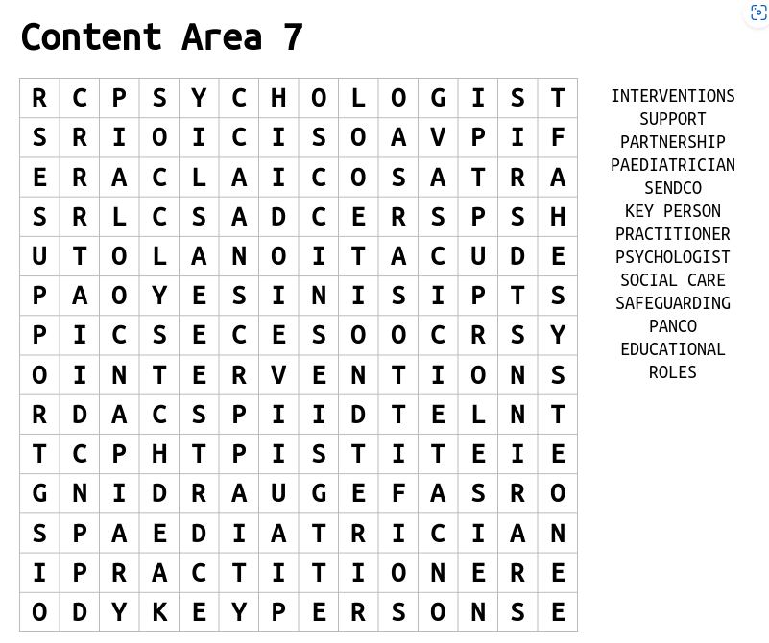



**Roles in an Early Years Setting**

|  |  |
| --- | --- |
| **Manager or person in charge of setting** | Required to create policies and procedures, build relationships with parents and carer's and manage practitioners to ensure that all workers are doing their best for the children. |
| **Early Years Practitioner** |  |
| **Room leader** | Responsible for the overall running of your assigned playroom in an early years setting. A room leader will work as part of the management team and supervise playroom staff. They will also be responsible for promoting high quality childcare. |
| **Key person** |  |
| **Childminder** |  |
| **Teaching assistant** | Required to get the classroom ready for lessons, supervise pupils and assist the classroom teacher. May be required to work with children in a small group, this can be called intervention work. |
| **Nanny** | Required to take care of one or multiple children within a home setting. Usually, will organise educational activities at home, prepare meals for children and support children by transporting them to school or activity clubs |

**Responsibilities of EYS**

**Keep children safe**

**Support healthy development**

**Responsibilities**

**Promote development**

**Work in partnership**

**Partnership Working**

|  |  |  |
| --- | --- | --- |
| **How partnership working benefits the child** | **How partnership working benefits the family** | **How partnership working benefits the early years practitioner (EYP)** |
| * **supports child-centred practice that meets children’s holistic needs** * **ensures supportive intervention is made when a child is not meeting age-expected milestones** * **promotes safeguarding to ensure that children are protected from harm** * **provides consistent care, giving emotional and physical security** | * **gains support from practitioners with a different perspective or experience** * **ensures shared goals can be achieved and everyone is united in approach** * **builds trust so that information can be shared to support the child** | * **access to advice and information which will inform planning of activities and routines to promote children’s development** * **builds trust and creates a supportive relationship where information can be shared** * **supports shared goals, and everyone can work to their strengths and support each other** |

**Definition -** ………………………………………………………………………………………………………………………………………………………………………………………………………………………………………………………………………………………………………………………………………………..………………………..

**Specialist roles within the setting**

|  |  |
| --- | --- |
| **Specialist** | **What is their role?** |
| SENDCO |  |
| DSL | Ensure individuals are kept safe and protected from harm. Is the named person who is responsible for all child protection meaning that other staff members will seek help and guidance from the DSL. DSL is also responsible for ensuring that policies and procedures are in place and up to date. Referrals will be made from the DSL to other agencies and professionals if additional support is required for the child. |
| PANCO | Champions best practice in physical activity and nutrition and acts as the agent for change. They lead positive change to ensure an environment and ethos that supports the prevention of obesity and health and wellbeing of children, families, and staff. |
| Key Person |  |

**Specialist roles outside the setting**

|  |  |
| --- | --- |
| **Specialist** | **What is their role?** |
| Physiotherapist | Support individuals who are affected by injuries, disabilities and illnesses. Support can be given through movement and exercises, manual therapy, education and advice. Physiotherapists work with the child to ensure they are supported and can continue with day-to-day tasks. Provide advice to school staff where needed and provide training to help staff to develop skills to support children with specific needs and enhance all children’s learning. |
| Educational psychologist |  |
| General practitioner (GP) | A general practitioner (GP) is a health care professional who works with all individuals within society. A GP’s main role is to diagnose and treat medical conditions. They aim to treat all common conditions and refer patients onto more specialised care services or services which can provide urgent medical treatment. |
| Health visitor |  |
| Family support worker | Family support workers are likely to work in partnership with children’s social workers. They aim to provide practical or emotional advice and support to individuals and families who are in need of help due to a range of issues. Support may be offered particularly when difficulties arise around parenting and the wellbeing of a child. |
| Social worker |  |

**Complete the questions below**

1. Identify a possible role within the early years

[1 mark]

------------------------------------------------------------------------------------------------------------------------------------------------------------------------------------------------------------------------------------------------------

2. Explain two (2) ways that early year’s practitioners can keep children safe.

[2 marks]

------------------------------------------------------------------------------------------------------------------------------------------------------------------------------------------------------------------------------------------------------------------------------------------------------------------------------------------------------------------------------------------------------------------------------------------------------------------------------------------------------------

3. Explain 2 benefits of partnership working for the Early Years Practitioner (EYP)

[2 marks]

----------------------------------------------------------------------------------------------------------------------------------------------------------------------------------------------------------------------------------------------------------------------------------------------------------------------------------------------------------------------------------------------------------------------------------------------------------------------------------------------------------------------------------------------------------------------------------------------

4. Discuss the role of a designated safeguarding lead (DSL)

[3 marks]

--------------------------------------------------------------------------------------------------------------------------------------------------------------------------------------------------------------------------------------------------------------------------------------------------------------------------------------------------------------------------------------------------------------------------------------------------------------------------------------------------------------------------------------------------------------------------------------------------------------------------------------------------------------------------------

5. Explain how SEND teams benefit the child and the family

[6 mark]

------------------------------------------------------------------------------------------------------------------------------------------------------------------------------------------------------------------------------------------------------------------------------------------------------------------------------------------------------------------------------------------------------------------------------------------------------------------------------------------------------------------------------------------------------------------------------------------------------------------------------------------------------------------------------------------------------------------------------------------------------------------------------------------------------------------------------------------------------------------------------------------------------------------------------------------------------------------------------------------------------------------------------------------------------------------------------------------------------------------------------------------------------------------------------------------------------------------------------------------------------------------------------------------------------------------------------------------------------------------------------------------------------------------------------------------------------------------------------------------------------------------------------------------------------------------------------------------------------------------------------------------------------------------------------------------------------------------------------------------------------------------------------------------------------------------------------------------------------------------------------------------------------------------------------------------------------------------------------------------------------------------------------------------------------------------------------------------------------------------------------------------------------------------------------------------------------------------------------------------------------------------------------------------------------------------------------------------------------------------------------------------------------------------------------------------------------------------------------------------------------------------------------------------------------------------------------------------------------------------------------------------------------------------------------------------------------------------------------------