**Content Area 5: Child Development - Legislation, policies and procedures in the Early Years**

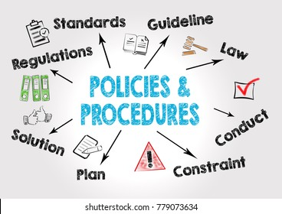

**Revision Workbook**

**Name:** …………………………………………………

**Class:** …………………………………………………

**Teacher:** ……………………………………………..

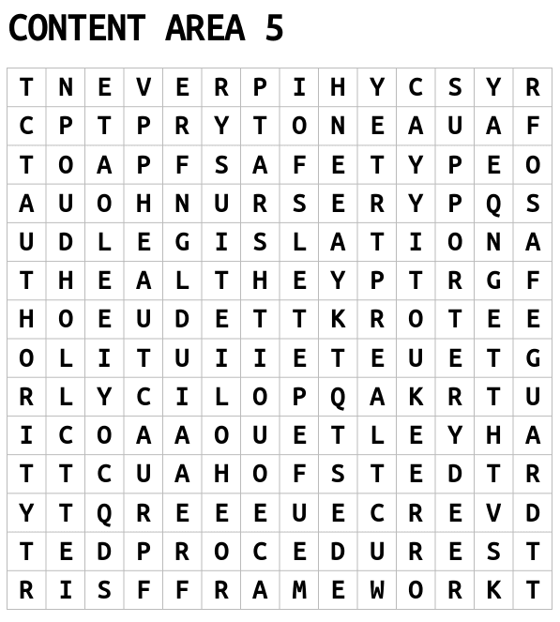

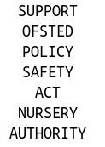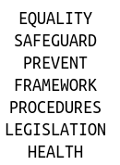

**Key Terms**

|  |  |
| --- | --- |
| Legislation |  |
| Framework |  |
| Policy |  |
| Procedure |  |

**OFSTED**

OFSTED is a ……………………………………… organisation. OFSTED inspects and ………………………………. early years and social care services that care for children and young people. They also ……………………. services that provide childcare, education and skills training such as nurseries, child minders, school, colleges, adoption and fostering agencies. They ensure ………………………. are suitable for children and vulnerable young people. They complete ………………………………… visits and produce ……………….. on care services. Following an inspection, the setting is given a …………………………

OFSTED Ratings

|  |  |
| --- | --- |
| Outstanding |  |
| Good | ‘Good’ providers will usually be inspected within five years of the publication of their previous inspection report. This will normally be a short inspection but may be a full inspection if information suggests that this is the most appropriate way forward, for example, if the provider’s performance has declined |
| Requires improvement | Providers judged to require improvement will normally receive a full inspection within 12 to 30 months of the publication of their previous inspection report. These providers will be subject to a monitoring visit before the full re-inspection, normally 7 to 13 months after the publication of their previous inspection report. |
| Inadequate |  |

**Health and Safety at Work Act (1974)**

………………………………………………………………………………………………………………………………………..……………………………………………………………………………………………………………………………………………………………………………………………………………………………………………………………………………………………………………………………………………………………………………………………………………………………………………………………………………………………………………………………………………………………………………………………………………………………………………………………………………………………………………………………………………………………………………………………………………………………………………………………………………………………………………………………………………………………………………………………………………………………………………………………………………………………………………………………………………………………………………………………………………………………………………

|  |  |
| --- | --- |
| What the employer must do | What the employee must do |
| 1. Decide what could cause harm and the precautions to stop it. This is part of risk assessment.  2. Explain how risks will be controlled and who is responsible for this.  3. Consult and work with health and safety representatives in protecting everyone from harm in the workplace.  4. Free of charge, provide health and safety training to employees to enable them to do their job.  5. Free of charge, provide equipment and protective clothing needed, and ensure it is properly looked after.  6. Provide toilets, washing facilities and drinking water.  7. Provide adequate first-aid facilities.  8. Report major injuries and fatalities at work to our Incident Contact Centre. Report other injuries, diseases and dangerous incidents online at www.hse.gov.uk.  9. Have insurance that covers employees in case they get hurt at work or ill through work. Display a hard copy or electronic copy of the current insurance certificate.  10. Work with any other employers or contractors sharing the workplace or providing employees (such as agency workers), so that everyone’s health and safety is protected | 1. Follow the training received when using any work items, the employer has given them.  2. Take reasonable care of their own and other people’s health and safety.  3. Co-operate with your employer on health and safety.  4. Tell someone (employer, supervisor, or health and safety representative) if they think the work or inadequate precautions are putting anyone’s health and safety at serious risk |

|  |  |
| --- | --- |
| Policies linked to HASAWA | Procedures linked to HASAWA |
|  |  |

**Health and Safety Procedures**

|  |  |
| --- | --- |
| Risk Management | The practitioner should ensure the environment is safe for the children and staff. A risk assessment should be carried out to highlight any potential hazards (indoors and outdoors). Risk assessments should also check that equipment is safe to use.  Risk assessments should also be in place when children are taken off-site (e.g., on a trip/visit/walk). |
| Accident and Incident | When there is an accident in the workplace, with either an employee or service user, it is important that the accident is logged. Services will have a policy that explains their required procedure for logging accidents (e.g., an accident book/form).  RIDDOR (Reporting of Injuries, Diseases and Dangerous Occurrences Regulations 2013) puts duties on employers, the self-employed and people in control of work premises (the Responsible Person) to report certain serious workplace accidents, occupational diseases and specified dangerous occurrences (near misses). It is also important that EYPs follow the setting’s procedures for first aid. |
| Evacuation Procedures | It is also vital that the services have evacuation procedures in place, so that if an incident occurs (e.g., a fire) service users and employees can safely leave the premises and all can be accounted for. Around services, such as hospitals, posters will be displayed to direct people to the nearest evacuation point. |
| Infection Prevention and Control | * Use and disposal of personal protective equipment (PPE) * Disposal of waste and bodily fluids * Ensure correct and hygienic hand washing, nappy changing, and toileting routines are followed |
| Security | Providers must take all reasonable steps to prevent unauthorised persons enter the premises.   * All visitors should sign in and out and show identification * Visitors should be provided with a visitor badge/lanyard * Visitors should not be left alone with the children at any time * Regular visitors and workers will be DBS checked |
| Manual Handling | * Do not pick children up unless necessary. * Do not lift or move heavy resources or furniture. * If you need to pick children up, ensure you bend from your knees not your back. * If you need to carry children, try to take their weight with your arms rather than your back. |
| Meal Times | * Ensure food hygiene is maintained * Respond to dietary needs and requirements * Use of PPE * Age-appropriate food served |

**United Nations Convention on Rights of the Child (1989)**

In 1989, world leaders made a historic commitment to the world’s children by adopting the United Nations Convention on the Rights of the Child – an international agreement on childhood. The UNCRC sets out children’s rights and how governments should work together to make them available to all children. Under the terms of the convention, governments are required to meet children’s basic needs and help them reach their full potential. Central to this is the acknowledgment that every child has basic fundamental rights.

|  |  |
| --- | --- |
| Policy linked to UNCRC | Procedures linked to the UNCRC |
|  |  |

**Safeguarding Procedures**

Safeguarding – protecting individuals from harm and abuse

The EYP would be expected to know different categories and indicators of abuse and understand how the procedures they need to follow to deal with suspected abuse in line with the setting’s policy.

Categories and Indicators of Abuse

|  |  |
| --- | --- |
| Physical (someone deliberately harming a child)  -  -  - | Emotional (constant verbal  instructs, ridiculing, mocking)  -  -  - |
| Sexual (inappropriate sexual contact, involvement or behaviour harming a child)  -  -  - | Neglect (not providing for or meeting a child’s needs)  -  -  - |

Follow guidance, policies, and procedures for child protection

Maintain professional boundaries

Ensure other professionals provide immediate protection

How the EYP should respond to suspected abuse

Observe and record

Put into action lines of reporting

**The Equality Act (2010)**

Previously, in the UK we had the Sex Discrimination Act, the Race Relations Act and the Disability Discrimination Act. The Equality Act 2010 was created to simplify these acts to create one new piece of legislation that covers all aspects of possible discrimination.

Protected Characteristics

Direct and indirect discrimination on the basis of a protected characteristic is illegal.

**Direct discrimination** – when you are treated differently or worse than someone else for certain reasons.

**Indirect discrimination** – when there’s a practice, policy or rule which applies to everyone in the same way, but it has a worse effect on some people than others.

|  |  |
| --- | --- |
| Policy linked to the Equality Act | Procedures linked to the Equality Act |
| - | -  -  - |

**Equality and Inclusion Procedures**

**Equality** - Individuals are not treated less favourably.

|  |  |
| --- | --- |
| **What can an EYP do to support equality in their setting?** | |
| Explanation | Example |
|  | Providing a range of play activities. For example, having the option of quiet areas or areas for chatting. |
|  | Ensuring any activities have enough open space and is accessible (for example, having ramps) |
|  | Having pictures alongside the rules and demonstrating what the rules are |

**Diversity** – The difference in values, attitudes, cultures and beliefs of people.

|  |  |
| --- | --- |
| **What can an EYP do to support diversity in their setting?** | |
| Explanation | Example |
|  | Celebrating festivals from different religions (for example, Eid, Christmas, Diwali, Hanukah) |
|  | Being a positive role-model and demonstrating good behaviours which the children will copy. |
|  | Taking part in training to have up-to-date knowledge and skills regarding anti-discriminatory practice. |
|  | Having books and toys that are representative of all ethnicities and cultures. |

**Inclusion** – Every child is given equal access to education and care.

|  |  |
| --- | --- |
| **What can an EYP do to support inclusion in their setting?** | |
| Explanation | Examples |
| Provide access to appropriate resources and environment |  |
| Make reasonable adjustments for physical or emotional needs |  |
| Adapt materials and activities to meet the individual neds of the child and families/carers |  |
| Provide extra time for activity completion |  |
| Follow procedures to support children for whose English is an additional language (EAL) |  |

**The Data Protection Act (2018)**

The act defines data protection principles which require fair, lawful, and transparent handling and processing of personal information. The act controls how your personal information is used by organisations, business or the government. The Data Protection Act 2018 is the UK’s implementation of the **General Data Protection Regulation (GDPR).**

Data collected in early-years settings

General Data Protection Regulation (GDPR) - A set of rules to protect data, now brought in as part of UK law under the Data Protection Act (2018). GDPR sets out 7 key principles:

|  |  |
| --- | --- |
|  | People have a right to know and view any information being held about them and how it’s being used. |
|  | Information should only be collected for the specific purpose. |
|  | Organisations and settings must not collect any information that is not relevant to them. |
|  | Data found to be inaccurate should be destroyed or corrected. |
|  | Information should be kept for no longer than necessary. |
|  | Information should be held and processed securely, with access restricted, using locked filing cabinets and passwords. |
|  | Settings must have appropriate systems in place to demonstrate they are complying with the regulations. They must be able to demonstrate how they gained individual’s consent for processing their information. If there is a serious breach of data, they must inform the individual straight away. |

Summary of individual rights provided by GDPR

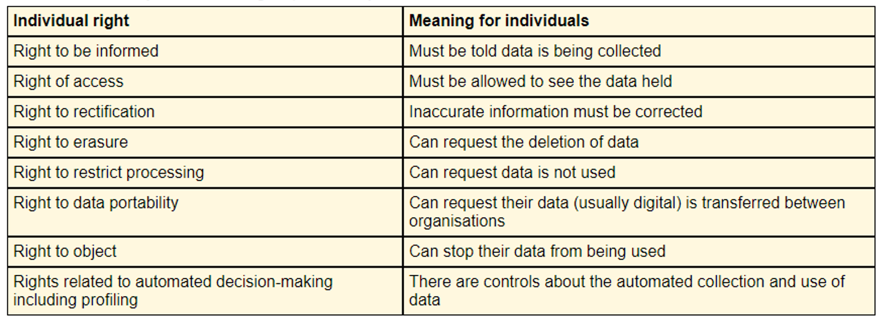

|  |  |
| --- | --- |
| Policy linked to GDPR | Procedures linked to GDPR |
| - | -  -  - |

Breaking Confidentiality

It is sometimes acceptable to break confidentiality, but it can only be done in a situation where it is deemed to be for the safety of the child or someone else. Even in these situations, the information must only be shared on a “need to know” basis. You must only tell the minimum number of people needed to keep the child safe.

Examples of when it is acceptable to break confidentiality are:

* If the child is at risk of harm from themselves or someone.
* If the child is a risk to others.
* If the child is at risk of being involved in a crime or is a victim of a crime.
* If the information is vital to the child’s wellbeing – allergies, medical needs, illnesses, educational needs.

**Confidentiality Procedures**

**Maintain secure environment:**

* Fob access to classrooms, etc.
* Office doors kept locked
* Computers not left logged on
* Staff complete cyber safety training
* Staff complete training on Data Protection
* ID badges on staff so that only the correct people have access to records/data.

**Password protected computers/IT systems:**

Safe storage of information

**Locked filing cabinets:**

**The Early Years Foundation Stage Statutory Framework (EYFS)**

According to the Department for Education (DfE), the purpose of the statutory framework for the early years foundation stage (EYFS) is to set ‘the standards for learning, development, and care for children from birth to 5’. The statutory framework for the EYFS is a mandatory document that facilitates the provision of consistent, high-quality teaching in England for children between the ages of 0-5.

There are four key concepts that the EYFS aims to deliver:

* Quality and consistency in all early year’s settings, so that every child makes good progress, and no child gets left behind.
* A secure foundation through planning for the learning and development of each individual child and assessing and reviewing what they have learned regularly.
* Partnership working between practitioners and with parents and/or carers.
* Equality of opportunity and anti-discriminatory practice, ensuring that every child is included and supported.

Key worker

According to the Statutory Framework for the EYFS, the key person’s role is to ‘help ensure that every child’s care is tailored to meet their individual needs … to help the child become familiar with the setting, offer a settled relationship for the child and build a relationship with their parents’. The key person approach in early years is important as it allows one dedicated practitioner to support the child in all aspects of their education and well-being.

|  |  |
| --- | --- |
| Policy linked to EYFS | Procedure linked to EYFS |
| -  -  - | -  -  - |

**Past Paper Questions**

1. Define the term legislation (1 mark)

…………………………………………………………………………………………………………………………………………………………………………………………………………………………………………………………………………………………………………….…………………………………………………………………………………

1. Give an example of legislation relevant to early years setting (1 mark)

…………………………………………………………………………………………………………………………………………………………………………………………………………………………………………………………………………………………………………….…………………………………………………………………………………

1. Which one is not a protected characteristic under the Equality Act (2010) (1 mark)
2. Age
3. Culture
4. Disability
5. Sex

Answer ……………….

1. What is the importance of confidentiality? Explain 2 reasons why a practitioner needs to apply it when working with children and families in early years settings. (4 marks)

…………………………………………………………………………………………………………………………………………………………………………………………………………………………………………………………………………………………………………….……………………………………………………………………………………………………………………………………………………………………………………………………………………………………………………………………………………………………………………………………………………………………………………………………………….……………………………………………………………………………………………………………………………………………………………………………………………………………………………………………………………………………………………………………………………………………………………………………………………………………….…………………………………………………………………………………………………………………………………………………………………………………………………………………………………………………………………………………………………………………

1. Identify 2 policies a nursery setting uses to ensure the health, safety and wellbeing of the children in the setting. (2 marks)

…………………………………………………………………………………………………………………………………………………………………………………………………………………………………………………………………………………………………………….…………………………………………………………………………………

1. Identify 4 categories of abuse. (4 marks)

…………………………………………………………………………………………………………………………………………………………………………………………………………………………………………………………………………………………………………….…………………………………………………………………………………………………………………………………………………………………………………………………………………

1. Describe 2 ways that the practitioner can promote inclusive practice within an early year setting or classroom. (4 marks)

…………………………………………………………………………………………………………………………………………………………………………………………………………………………………………………………………………………………………………….……………………………………………………………………………………………………………………………………………………………………………………………………………………………………………………………………………………………………………………………………………………………………………………………………………….……………………………………………………………………………………………………………………………………………………………………………………………………………………………………………………………………………………………………………………………………………………………………………………………………………….…………………………………………………………………………………………………………………………………………………………………………………………………………………………………………………………………………………………………………………