**Content Area 4: Child Development - Early Years Provisions**

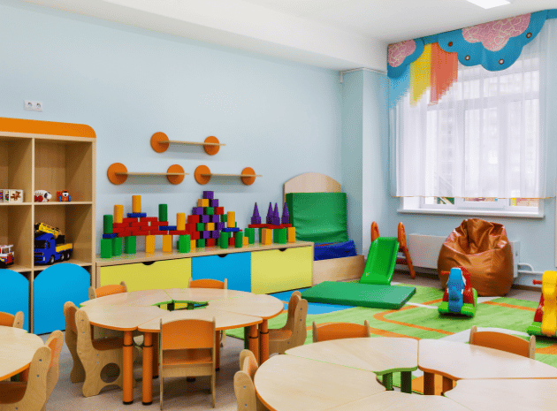

**Revision Workbook**

**Name:**

**Class:**

**Teacher:**

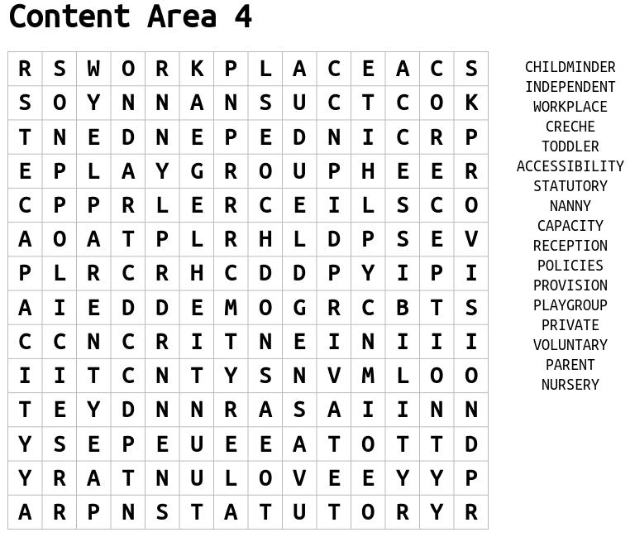



**Types of Early Year Provision**

|  |  |
| --- | --- |
| **Statutory** |  |
| **Private** |  |
| **Voluntary** |  |

**Types of Early Years Settings**

|  |  |  |  |
| --- | --- | --- | --- |
| **Early Years Setting** | **Setting/Location** | **Age Group** | **P/S/V** |
| Crèche | Parent/carer stay on premises (e.g., shopping centre) |  |  |
| Childminder | Practitioner’s own home |  |  |
| Nursery | Nursery |  |  |
| Pre-school | Community Venues |  |  |
| Nursery class | Connected to Primary School |  |  |
| Primary school | Primary School |  |  |

**Purpose of Early Years Provision – why are the settings required?**

|  |  |  |  |
| --- | --- | --- | --- |
| **Purpose:** | **Support parents and carers** | **Promote holistic development** | **Promote learning** |
| Examples |  |  | Promote learning through the prime and specific areas of learning in the EYFS |
|  |  | **Prime:** • communication & language  • physical development  • personal, social and emotional development |
|  |  |
|  |  | **Specific:** • literacy  • mathematics  • understanding the world  • expressive arts and design |

The Early Years Foundation Stage (EYFS) sets the standards that all early year’s providers must meet to ensure that children learn and develop well and are kept healthy and safe.

It promotes teaching and learning to ensure children’s ‘school readiness’ and gives children the broad range of knowledge and skills that provide the right foundation for good future progress through school and life.

**Early Years Foundation Stage (EYFS)**

|  |  |
| --- | --- |
| **EYFS** | Early Years Foundation Stage – the curriculum that children learn 0 – 5 years. |
| **Prime** | Areas of learning that are particularly important for building a foundation for igniting children’s curiosity, enthusiasm for learning, forming relationships and thriving. |
| **Specific** | Providers must also support children in four specific areas, through which the three prime areas are strengthened and applied. |

|  |  |
| --- | --- |
| **Areas of Learning and Development** | **Aspect** |
| **Prime Areas** | |
| **Personal, Social and Emotional Development** |  |
| **Physical Development** |  |
| **Communication and Language** |  |
| **Specific Areas** | |
| **Literacy** |  |
| **Mathematics** |  |
| **Understanding the World** |  |
| **Expressive Arts and Design** |  |

All early year’s provisions need to promote learning to meet the early years learning goals within the statutory framework; The Early Years Foundation Scheme

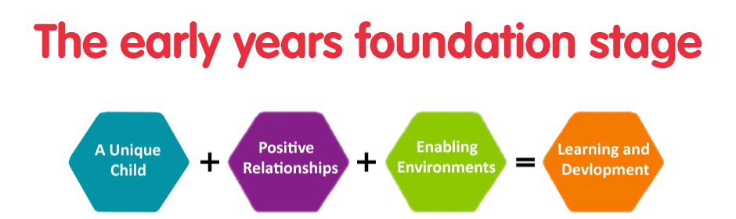

|  |  |  |
| --- | --- | --- |
|  | **Description** | **What an EYP can do** |
| **Unique Child** |  | * **understand and observe each child’s development and learning, assess progress, plan for next steps** * **support babies and children to develop a positive sense of their own identity and culture** * **identify any need for additional support** * **keep children safe** * **value and respect all children and families equally** |
| **Positive Relationships** |  | * **Help foster a sense of belonging** * **Be sensitive and responsive to the child’s needs, feelings and interests** * **Be supportive of the child’s own efforts and independence** * **Be consistent in setting clear boundaries** * **Create a stimulating learning environment** * **Build on key person relationships in early years settings** |
| **Enabling Environment** |  | **Enabling Environments are created by the provision if they:**   * **value all people** * **value learning** |
| **Learning & Development** |  | **Practitioners teach children by ensuring challenging, playful opportunities across the prime and specific areas of learning and development.**  **They foster the characteristics of effective early learning:**   * **Playing and exploring** * **Active learning** * **Creating and thinking critically** |

**Factors that can influence parental choice:**

* Cost
* Resources and activities available
* Location
* Staff
* Recommendations from other parents
* OFSTED reports

Approach

Facilities

Capacity

Accessibility

**Variation in early years provision**

**(Variation – change or slight difference)**

**)**

**PPQs**

1. State what is meant by statutory provision [1 mark]

………………………………………………………………………………………………………………………………………………………………………………………………………………………………………………………………

1. List four types of early years settings. [4 mark]

1……………………………………………………………………………………………………………………………2……………………………………………………………………………………………………………………………3……………………………………………………………………………………………………………………………4……………………………………………………………………………………………………………………………

1. Explain how can opening times of an early years setting influence parental choice? [2 mark]

………………………………………………………………………………………………………………………………………………………………………………………………………………………………………………………………………………………………………………………………………………………………………………………………………………………………………………………………………………………………………………………………………………………………………………………………………………………………………………………………………………………………………………………………………………………………………………………………

1. As a qualified early years worker Sarah could work in a nursery school. Name three (3) other early years settings that Sarah could work in as a qualified early years worker. [3 marks]

1……………………………………………………………………………………………………………………………2……………………………………………………………………………………………………………………………3……………………………………………………………………………………………………………………………

1. (a) List two ways a setting can vary which may influence parental options for childcare. [2 mark]

………………………………………………………………………………………………………………………………………………………………………………………………………………………………………………………………

1. (b) Choose one variation from 5a. Explain how or why this may affect parental decision. [2 marks]

………………………………………………………………………………………………………………………………………………………………………………………………………………………………………………………………………………………………………………………………………………………………………………………………………………………………………………………………………………………………………………………………………………………………………………………………………………………………………………………………………………………………………………………………………………………………………………………………………………………………………………………………………………………………………………………………………………………………………………………………………………………………………………………………