**Content Area 3: Child Development - Care routines, play and activities to support the child**

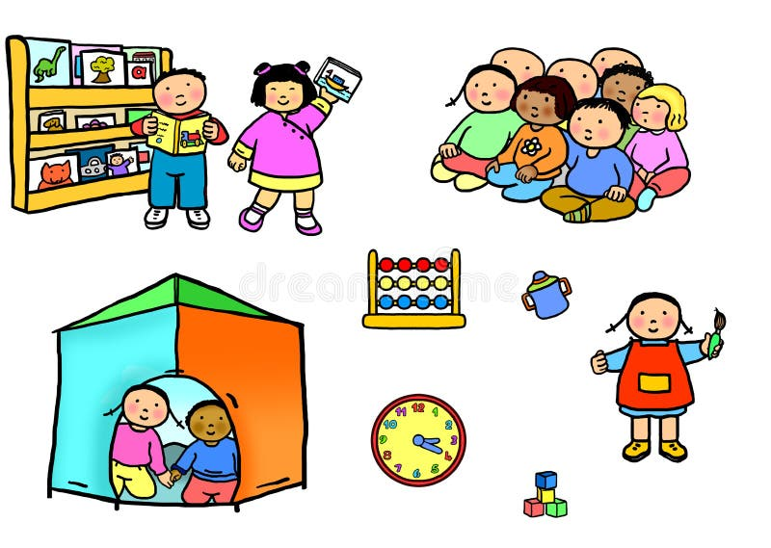**Revision Workbook**

**Name:**

**Class:**

**Teacher:**

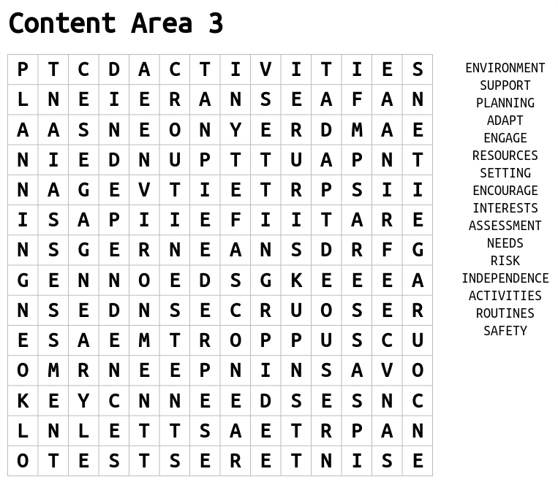



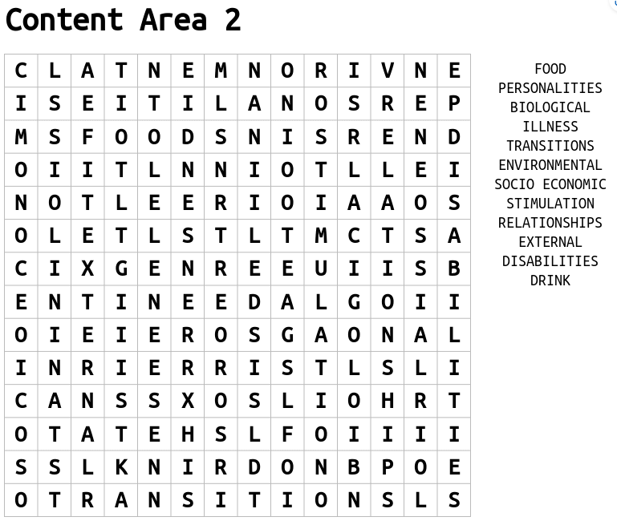

**Maslow’s Hierarchy of Needs**

Definition - A motivational theory where individuals are motivated by their needs. When individual’s basic needs are not met, they may not be able to progress to meet their more complex needs.

|  |  |
| --- | --- |
| Self-actualisation |  |
| Esteem |  |
| Love and belonging |  |
| Safety needs |  |
| Physiological needs |  |

**Basic and Psychological Needs**

|  |  |  |
| --- | --- | --- |
|  | Basic Needs | Psychological Needs |
| Definition |  |  |
| Examples | * Food and drink * Fresh air * Rest and sleep * Exercise * Physical safety * Emotional safety * Shelter | * Sense of belonging * Affection * Sense of achievement * Feeling valued * Establishing emotional boundaries |

How can an early year’s practitioner support basic needs?

|  |  |
| --- | --- |
| **Food and drink** |  |
| **Fresh air** | * Plan regular opportunities for outdoor play. * Provide trips outside the setting. |
| **Rest and sleep** |  |
| **Exercise** |  |
| **Physical safety** | * Check equipment for faults. * Make sure doors and gates are locked. * Do not use physical punishment. |
| **Emotional safety** | * Provide a consistent key person. * Arrange small group play. * Be a caring practitioner. * Ensure bullying is not tolerated. |
| **Shelter** | * Provide a warm and welcoming environment, * Provide areas shaded from the sun. |

How can an early year’s practitioner support psychological needs?

|  |  |
| --- | --- |
| **Sense of belonging** | * Respond to the child’s interests. * Encourage the child to join in. * Provide opportunities to interact with others. |
| **Affection** |  |
| **Sense of achievement** |  |
| **Feeling valued** | * Display the child’s artwork. * Show an interest in the child’s culture. * Listen attentively to the child. * Recognise their needs. |
| **Establishing emotional boundaries** |  |

How will meeting children’s needs support their holistic development?

**How can these routines promote the independence, health, safety, and wellbeing of a child?**

|  |  |  |  |
| --- | --- | --- | --- |
| **Getting dressed** | **Mealtimes** | **Toileting/washing** | **Bedtime** |
|  |  |  |  |

How can an EYP support the child to establish routines?

**Child-initiated Play and Adult-led Play**

|  |  |  |
| --- | --- | --- |
|  | Child-initiated Play | Adult-led Play |
| Definition |  |  |
| Strengths | * Follows the child’s interests. * Provides independence as the child is in control. * Develops children’s creativity and imagination. * Supports natural development. * Increases concentration as the activity is chosen by the child. | * Provides structure to the activity. * Can focus on specific areas of development. * Can support children to use new resources safely. * Often encourages participation from all children. * Provides guidance for the children |
| Weaknesses |  |  |

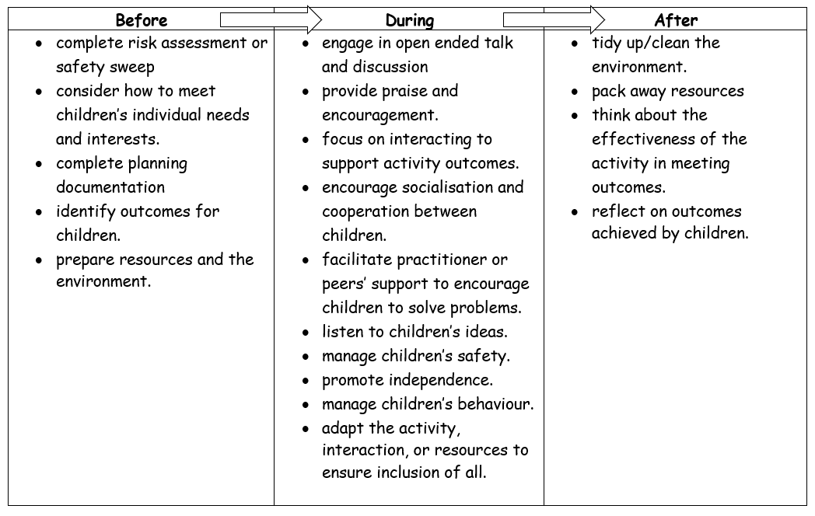**Role of the early year practitioner during play activities (before, during and after)**

**Stages of Play**

|  |  |  |
| --- | --- | --- |
|  |  | This is when babies are exploring their surroundings by moving their arms and legs. |
|  |  | This is when children play by themselves and seem to ignore others. |
|  |  | This is when children play by themselves but watch others playing. |
|  |  | This is when children play alongside each other but do not interact very much. |
|  |  | This is when children start to interact with each other but there is no organisation to the play. |
|  |  | Children play with each other in an organised manner where they all have roles and responsibilities in the activity. |

**Types of Play**

|  |  |  |
| --- | --- | --- |
|  | Description | Benefits |
| Physical Play |  | * Develop balance and co-ordination. * Learn control of fine movements – hand-eye co-ordination. * Learn new concepts – testing out their ideas. * Increase their confidence. * Explore a healthy wellbeing – physically and mentally. |
| Creative Play |  | * Encourages creativity and freedom of thought. * Increases logical thinking. * Allows children to explore their emotions * Develops confidence. * Allows children to express themselves without complex vocabulary. * Develops new vocabulary. |
| Imaginative Play |  | * fosters creativity by providing a safe space for children to act out scenarios of their choosing * promotes physical development in a fun way * practice and develop their language and social skills * boosts the development of problem-solving and self-regulation skills |
| Sensory Play |  | * Explore different textures, tastes and smells. * Allows children to express their emotions. * Develop their confidence. * Explore new concepts. * Support fine motor skills through small muscle movement. * Extend vocabulary and communication skills. |

**Exam Question Practice**

1. What is a basic care need and give an example (2 marks)

………………………………………………………………………………………………………………………………………………………………………………………………………………………………………………………………………………………………….…………………………………………………………………………………………………………………………………………………………………………………………………………………………….

1. Identify 4 basic care routines (4 marks) ………………………………………………………………………………………………………………………………………………………………………………………………………………………………………………………………………………………………….…………………………………………………………………………………………………………………………………………………………………………………………………………………………….
2. What is Maslow’s hierarchy of needs? (3 marks)

………………………………………………………………………………………………………………………………………………………………………………………………………………………………………………………………………………………………….…………………………………………………………………………………………………………………………………………………………………………………………………………………………….………………………………………………………………………………………………………………………………………………………………………………………………………………………………………………………………

1. Discuss the role of the EYP before, during and after play activities (6 marks)

………………………………………………………………………………………………………………………………………………………………………………………………………………………………………………………………………………………………….…………………………………………………………………………………………………………………………………………………………………………………………………………………………….………………………………………………………………………………………………………………………………………………………………………………………………………………………………………………………………………………………………….…………………………………………………………………………………………………………………………………………………………………………………………………………………………….………………………………………………………………………………………………………………………………………………………………………………………………………………………………………………………………………………………………….…………………………………………………………………………………………………………………………………………………………………………………………………………………………….………………………………………………………………………………………………………………………………………………………………………………………………………………………………………………………………………………………………….…………………………………………………………………………………………………………………………………………………………………………………………………………………………….

1. Identify and describe the different play types (8 marks)

………………………………………………………………………………………………………………………………………………………………………………………………………………………………………………………………………………………………….……………………………………………………………………………………………………………………………………………………………………………………………………………………………………………………………………………………………………………………………………………………………………………………………….…………………………………………………………………………………………………………………………………………………………………………………………………………………………….……………………………………………………………………………………………………………………………….………………………………………………………………………………………………………………………………………………………………………………………………………………………………………………………………………………………………….…………………………………………………………………………………………………………………………………………………………………………………………………………………………….…………………………………………………………………………………………………………………………………………………………………………………………………………………………………………………………………………………………….…………………………………………………………………………………………………………………………………………………………………………………………………………………………….………………………………………………………………………………………………………………………………………………………………………………………………………………………………………………………………………………………………….…………………………………………………………………………………………………………………………………………………………………………………………………………………………….………………………………………………………………………………………………………………………………………………………………………………………………………………………………………………………………………………………………….…………………………………………………………………………………………………………………………………………………………………………………………………………………………….………………………………………………………………………………………………………………………………………………………………………………………………………………………………………………………………………………………………….…………………………………………………………………………………………………………………………………………………………………………………………………………………………….………………………………………………………………………………………………………………………………………………………………………………………………………………………………………………………………………………………………….…………………………………………………………………………………………………………………………………………………………………………………………………………………………….…………………………………………………………………………………………………………………………………….