**Content Area 2: Child Development - Factors that influence the child’s development**

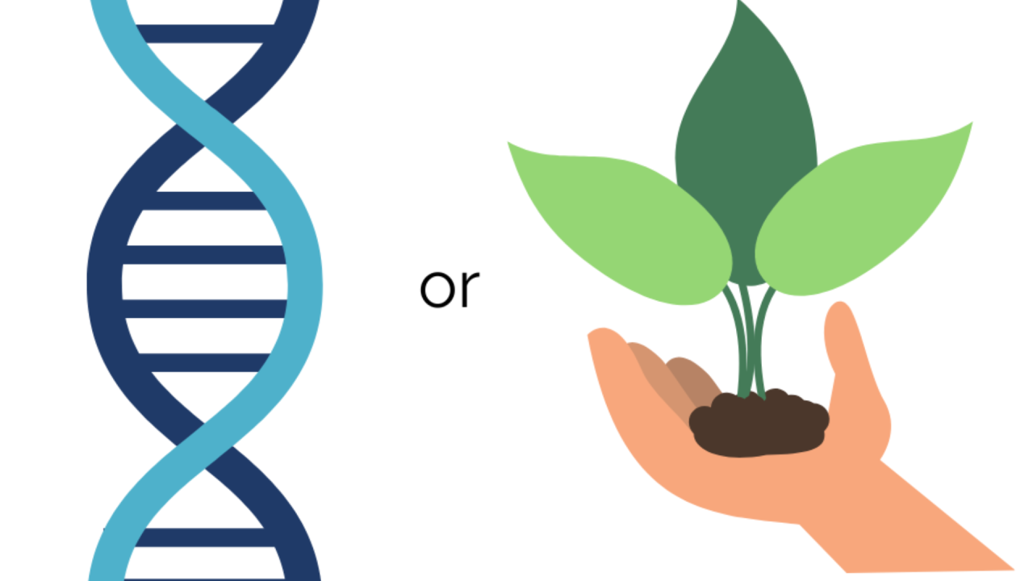**Revision Workbook**

**Name:**

**Class:**

**Teacher:**

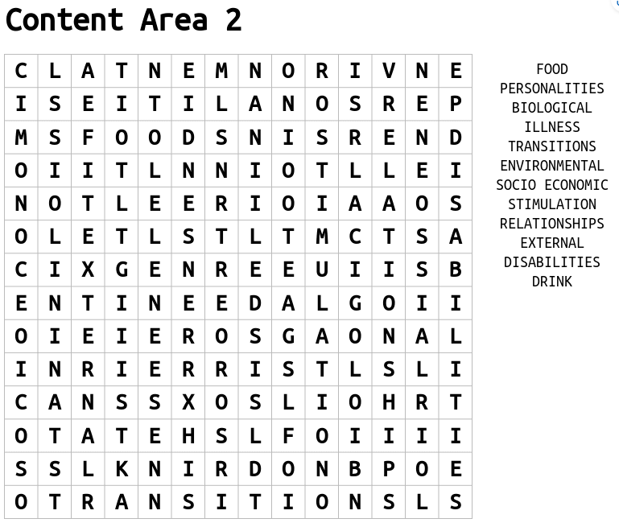

**Transitions**

**Environmental factors**

**Family Lifestyle factors**

**Nature**

**Biological factors**

**Nurture**

**Key terms**

**Socio-economic factors**

|  |  |  |  |
| --- | --- | --- | --- |
| **Nature - Biological** | | **Nurture - Environmental** | |
| **Biological factors** | **Example** | **Environmental factors** | **Example** |
| **Physical traits – some are linked to genetic inheritance.** |  | **Love & interaction – children thrive if they feel loved & have plenty of positive attention from the adults who care for them.** |  |
| **Medical conditions - most are linked to genetic inheritance.** |  | **Stimulation & play –opportunities to play, talk and do different things.** |  |
| **Learning difficulties – are most likely as a result of genetic inheritance.** |  | **Physical conditions/ socio-economic –shelter, warmth and room to move and explore.** |  |
| **Disabilities – some are linked to genetic inheritance, whilst others may occur during pregnancy and birth** |  | **Food & drink – children need food & drink that is nutritious and healthy – provides energy to explore, move and learn.** |  |
| **Personality & temperament** |  | **Family Lifestyle** |  |
| **Pregnancy & birth – how healthy a mother is during pregnancy can affect a child’s development** |  | **Personal factors are about inherited traits and also what happened before and immediately after you were born.**  **External factors are about where and how you grew up. They also include the events and experiences that you have had.** | |

**Transitions**

**Definition of transitions -** ……………………………………………………………………………………………………………………………………………………………………………………………………………………………………………………………………………………………………………………….

Examples of transitions

**Impacts of transitions on a child’s development**

|  |  |
| --- | --- |
| **Area of development** | **Impact from transition** |
| **Language development** |  |
| **Cognitive development** |  |
| **Social and emotional development** |  |
| **Physical development** |  |

**Support strategies for transitions**

**Support strategies**

|  |  |
| --- | --- |
| **Transition** | **Support strategies** |
| Starting a new childcare setting | * Visits to the setting prior to starting * Key worker visits the child at home * Read books about starting school * Use role play to play ‘schools’ |
| Birth of a new baby | * Play with toy dolls and prams * Read books about the birth of a new baby * Visit a family where they have a new baby * Help choose toys or clothes for the new baby |
| Planned hospital admission | * Visit the hospital prior to admission * Watch a children’s TV programme about a hospital * Use doctors or nurses’ costumes for dressing-up and play * Look at the hospital website to see pictures of staff and facilities |
| Bereavement of a friend or family member | * Read books about bereavement * Create a memory box with special objects and photographs * Sensitively talk about the person who has died |
| Change to family circumstance | * Give an opportunity for discussion * Create a family tree together * Read books about different families |
| Parents separating | * Access help from professionals * Read books about the situation * Spend time together as a family |



**Liam is a 5-year-old boy who lives with his single mother, Sarah, in a lower-income neighbourhood. Sarah works two jobs to support the family, and while she does her best to provide for Liam, she often feels overwhelmed by  
 the demands of work and parenting. Liam spends a lot   
of time at his grandmother’s house, where he receives   
extra care and attention. Liam is generally healthy, but   
he has been struggling in school. He finds it difficult to   
focus in class, often acts out, and has trouble making   
friends. His teacher has expressed concerns that Liam   
may not be reaching his full potential, and there are   
signs that he may be facing some emotional challenges.   
Liam’s mother is worried about his behaviour and feels unsure about how to best support him.**

1. **What factors in Liam's life could be influencing his development? Consider both environmental and socioeconomic factors.**

………………………………………………………………………………………………………………………………………………………………………………………………………………………………………………………………………………………..……………………………………………………………………………………………………………………………………………………………………………………………………………………………………………………………………………………………………………………………………………………………………………………………………………………………………………………………………………………………………………………………………………………………………………………………………………………………………………………………………………………………………………………………………………………………………………………………………………………………………………………………………………………………………………………………………………………………………………………………………………………………………………………………………………………………

1. **How might Sarah’s long work hours and financial stress impact Liam’s emotional development? (Hint: sense of security, attachment, and emotional well-being)**

………………………………………………………………………………………………………………………………………………………………………………………………………………………………………………………………………………………..…………………………………………………………………………………………………………………………………………………………………………………………………………………………………………………………………………………………………………………………………………………………………………………………………………………………………………………………………………………………………………………………………………………………………………………………………………………………………………………………………………………………………………………………………………………………………………………………………………………………………………………………………………………………………………………………………………………………………………………………………………………………………………………………………………………………………………………………………………………………………………………………………………………………………

1. **Based on the information in the case, suggest two strategies Sarah or Liam’s teacher could use to support his emotional and cognitive development.**

………………………………………………………………………………………………………………………………………………………………………………………………………………………………………………………………………………………..……………………………………………………………………………………………………………………………………………………………………………………………………………………………………………………………………………………………………………………………………………………………………………………………………………………………………………………………………………………………………………………………………………………………………………………………………………………………………………………………………………………………………………………………………………………………………………………………………………………………………………………………………………………………………………………………………………………………………………………………………………………………………………………………………………………………

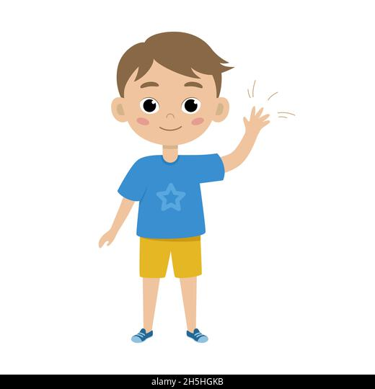

**Charlie is 5 years old; his parents have decided to move house to a new area. This will also mean moving schools**

**Describe the transition**

----------------------------------------------------------------------------------------------------------------------------------------------------------------------------------------------------------------------------------------------------------------------------------------------------------------------------------------------------------------------------------------

**Explain how holistic development can be affected by the transition**

--------------------------------------------------------------------------------------------------------------------------------------------------------------------------------------------------------------------------------------------------------------------------------------------------------------------------------------------------------------------------------------------------------------------------------------------------------------------------------------------------------------------------------------------------------------------------------------------------------------------------------------------------------------------------------------------------------------------------------------------------------------------------------------------------------------------------------------------------------------------------------------------------------------------------------------------------------------------------------------------------------------------------------------------------------------------------------------------------------------------------------------------------------------------------------------------------------------------------------------------------------------------------------------------------------------------------------------------------------------------------------------------------------------------------------------------------------------------------------------------------------------------------------------------------------------------------------------------------------------------------------------------------------------------------------------------------------------------------------------------------------------------------------------------------------------------------------------------------------------------------------------------------------------------------------------------------------------------------------------------------------------------------------------------------------------------------------------------------------------------------------------------------------------------------------------------------------------------------------------------------------------------------------------------------------------------------------------------------------------------------------------------------------------------------------------------------------------------------------------------------------------------------------------------

**Explain how parent/carer can support the child with this transition**

------------------------------------------------------------------------------------------------------------------------------------------------------------------------------------------------------------------------------------------------------------------------------------------------------------------------------------------------------------------------------------------------------------------------------------------------------------------------------------- --------------------------------------------------------------------------------------------------------------------------------------------------------------------------------------------------------------------------------------------------------------------------------------------------------------------------------------------------------------------------------------------------------------------------------------------------------------------------------------------------------------------------------------------------------------------------------------------------------------------------------------------------------------------------------------------------------------------------------------------------------------------------------------------------------------------------------------------------------------------------------------------------------------------------------------------------------------------------------------------------------------------------------------------------------------------------**Explain how an Early Years Practitioner can support the child with this transition.**

-------------------------------------------------------------------------------------------------------------------------------------------------------------------------------------------------------------------------------------------------------------------------------------------------------------------------------------------------------------------------------------------------------------------------------------------------------------------------------------------------------------------------------------------------------------------------------------------------------------------------------------------------------------------------------------------------------------------------------------------------------------------------------------------------------------------------------------------------------------------------------------------------------------------------------------------------------------------------------------------------------------------------------------------------------------------------------------------------------------------------------------------------------------------------------------------------------------------------------------------------------------------------------------------------------------------------------------------------------------------------------------------------------------------------------------------------------------------------------------------------------------------------------------------------------------------------------------------------------------------------------------------------------------