**Content Area 1: Child Development**

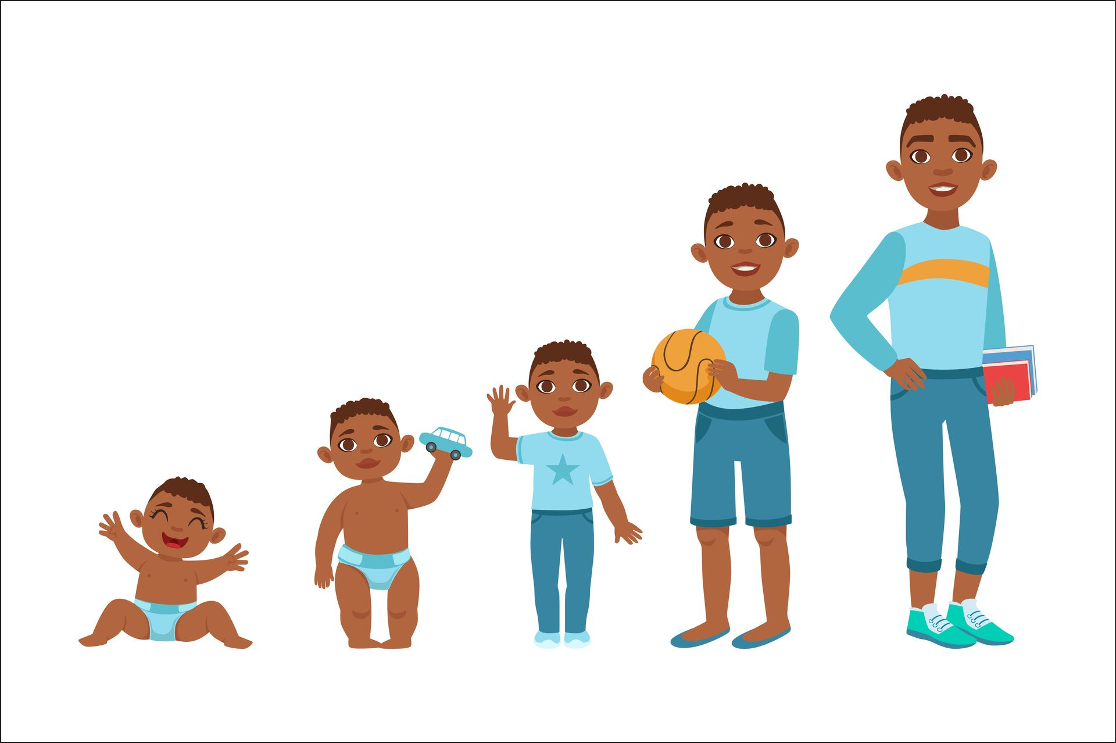**Revision Workbook**

**Name:**

**Class:**

**Teacher:**

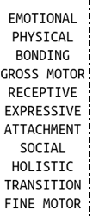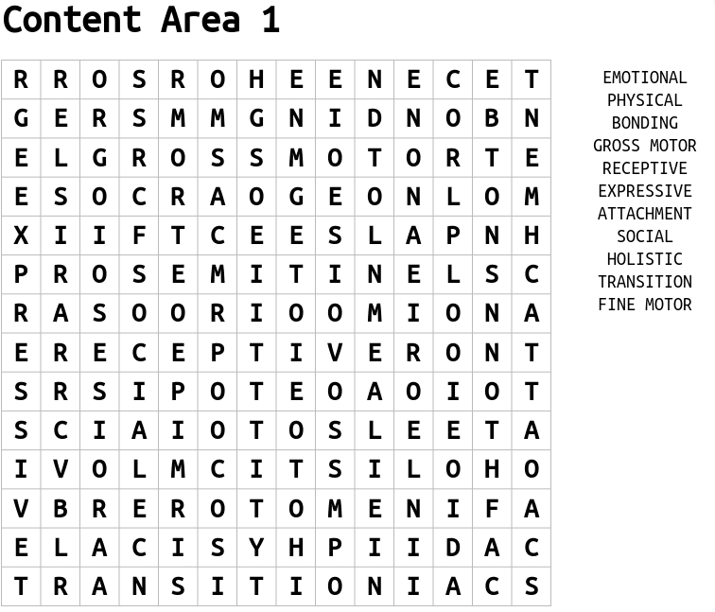

**Key Terms**

**Key terms for areas of development**

|  |  |  |  |
| --- | --- | --- | --- |
| Physical Development | Communication and Language development | Social & emotional development | Cognitive development |
| Fine motor – small movements often made using hands, such as picking up a spoon or using a pencil | Receptive language – what children can understand | Attachment – a close bond between the child & their parents | Object permanence – the ability to understand that objects when placed out of sight are still in existence |
| Gross motor – large movements such as running balancing & throwing. | Expressive language – what children can say | Bonding – the process by which children & parents develop a strong loving relationship | Trial by error – seeing what happens after an action has been made & learning from it. |

|  |  |  |  |  |  |  |
| --- | --- | --- | --- | --- | --- | --- |
|  | **Birth** | **1 year** | **2 years** | **3 years** | **4 years** | **5 years** |
| **Physical development (fine motor skills)** |  |  |  |  |  |  |
| **Physical development (gross motor skills)** |  |  |  |  |  |  |
| **Communication and language development** |  |  |  |  |  |  |
| **Social and Emotional development** |  |  |  |  |  |  |
| **Cognitive development** |  |  |  |  |  |  |



**Munira has been walking without assistance since she was 14 months old. She understands simple instructions and responds using gestures.**

1. Explain the expected sequence and key milestones Munira will meet by her 5th birthday.

------------------------------------------------------------------------------------------------------------------------------------------------------------------------------------------------------------------------------------------------------------------------------------------------------------------------------------------------------------------------------------------------------------------------------------------------------------------------------------------------------------------------------------------------------------------------------------------------------------------------------------------------------------------------------------------------------------------------------------------------------------------------------------------------------------------------------------------------------------------------------------------------------------------------------------------------------------------------------------------------------------------------------

2. Identify how Munira’s parents could support her to meet these milestones

------------------------------------------------------------------------------------------------------------------------------------------------------------------------------------------------------------------------------------------------------------------------------------------------------------------------------------------------------------------------------------------------------------------------------------------------------------------------------------------------------------------------------------------------------------------------------------------------------------------------------------------------------------------------------------------------------------------------------------------------------------------------------------------------------------------------------------------------------------------------------------------------------------------------------------------------------------------------------------------------------------------------------

3. Why is it important that an early year’s practitioner understands the pattern of cognitive development?

------------------------------------------------------------------------------------------------------------------------------------------------------------------------------------------------------------------------------------------------------------------------------------------------------------------------------------------------------------------------------------------------------------------------------------------------------------------------------------------------------------------------------------------------------------------------------------------------------------------------------------------------------------------------------------------------------------------------------------------------------------------------------------------------------------------------------------------------------------------------------------------------------------------------------------------------------------------------------------------------------------------------------------------------------------------------------------------------------------------------

1. What resources would you expect to see in an Early Years setting, to support the development of cognitive development? Explain your reasons for each resource.

------------------------------------------------------------------------------------------------------------------------------------------------------------------------------------------------------------------------------------------------------------------------------------------------------------------------------------------------------------------------------------------------------------------------------------------------------------------------------------------------------------------------------------------------------------------------------------------------------------------------------------------------------------------------------------------------------------------------------------------------------------------------------------------------------------------------------------------------------------------------------------------------------------------------------------------------------------------------------------------------------------------------------------------------------------------------------------------------------------------------------------------------------------------------------------------------------------------------------------------------------------------------------------------------------------